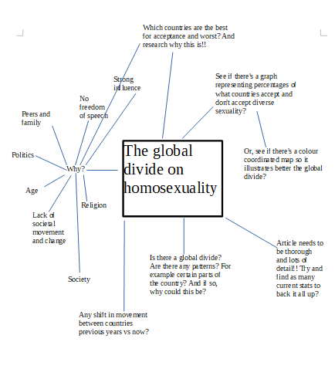

DRAFT

The global divide on homosexuality

In the west, the LGBTQ+ movement has made serious strides over the past few years. Despite this, the question of acceptance of homosexuality in society still varies drastically across countries around the world.
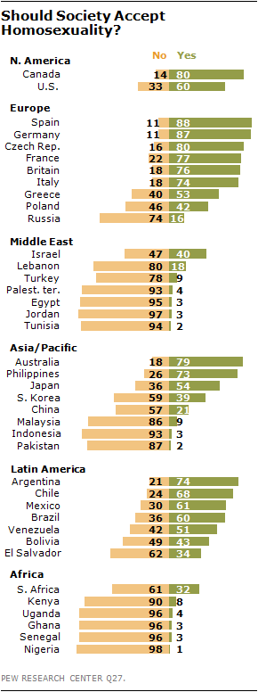
This creates an atmosphere of 'us and them' – a global divide over whether LGBTQ+ rights are a matter of human equality and dignity, or the moral failing of the decadent western society.

A survey by Pew Research Centre, demonstrates the significant variance on whether homosexuality should be accepted or rejected by society. The study surveyed a total of 37,653 individuals in 39 countries.
The survey shows that predominately Muslim nations and in Africa, Russia and Asia, there’s an equal widespread of rejection.

Africa is the most homophobic continent in the world with same-sex relations being illegal in 36 of Africa's 55 countries. Despite the South of Africa legalising same-sex marriage, majority of those who live in the South still strongly disapprove of homosexuality.
This attitude of homophobia is an indicative of widespread social norms and laws across the continent.

Yahya Jammeh, the Gambian president, declared; ''we will fight these vermin’s called homosexuals or gays the same way we are fighting malaria-causing mosquitoes, if not more aggressively''.
Due to the political power in Africa, politicians make such statements as the result will strike a popular chord in swaths of Africa and will keep all attitudes the same.
Africans believe that homosexuality is unnatural, abnormal and 'strange' to their cultures and believe that it is a disease which can be cured.

In recent surveys, attitudes regarding homosexuality have remained stable expect in South Korea, the United States and Canada. In these countries, the percentage saying homosexuality should be accepted by society has grown by at least ten percentage points since 2007. This shows the slow but steady growth of acceptance and also the start of individuals breaking away from tradition cultural values.
In addition, the survey shows that countries where religion is less central in peoples lives, finds that the acceptance of homosexuality is more widespread. On the other hand, countries with high levels are religiosity have fewer individuals who believe homosexuality should be accepted by society.
Age is also a factor in several countries where younger respondents offer more tolerant views that older individuals.
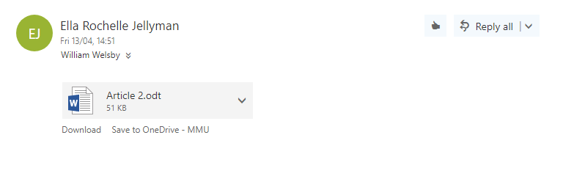
Despite the positive movements of the acceptance of the LGBTQ+ community in society, the survey ultimately shows a global divide of acceptance still exists and therefore a fight for global acceptance still continues.
Emailed for edits

Final

The global divide on homosexuality

In the west, the LGBTQ+ movement has made serious strides over the past few years. Despite this, the question of acceptance of homosexuality in society still varies drastically across countries around the world.

This creates an atmosphere of 'us and them' – a global divide over whether LGBTQ+ rights are a matter of human equality and dignity, or the moral failing of the decadent western society.

A survey by Pew Research Centre, demonstrates the significant variance on whether homosexuality should be accepted or rejected by society. The study surveyed a total of 37,653 individuals in 39 countries.
The survey shows that predominately Muslim nations and in Africa, Russia and Asia, there’s an equal widespread of rejection.

Africa is the most homophobic continent in the world with same-sex relations being illegal in 36 of Africa's 55 countries. Despite the South of Africa legalising same-sex marriage, majority of those who live in the South still strongly disapprove of homosexuality.
This attitude of homophobia is an indicative of widespread social norms and laws across the continent.

Yahya Jammeh, the Gambian president, declared; ''we will fight these vermin’s called homosexuals or gays the same way we are fighting malaria-causing mosquitoes, if not more aggressively''.
Due to the political power in Africa, politicians make such statements as the result will strike a popular chord in swaths of Africa and will keep all attitudes the same.
Africans believe that homosexuality is unnatural, abnormal and 'strange' to their cultures and believe that it is a disease which can be cured.

In recent surveys, attitudes regarding homosexuality have remained stable expect in South Korea, the United States and Canada. In these countries, the percentage saying homosexuality should be accepted by society has grown by at least ten percentage points since 2007. This shows the slow but steady growth of acceptance and also the start of individuals breaking away from tradition cultural values.
In addition, the survey shows that countries where religion is less central in peoples lives, finds that the acceptance of homosexuality is more widespread. On the other hand, countries with high levels are religiosity have fewer individuals who believe homosexuality should be accepted by society.
Age is also a factor in several countries where younger respondents offer more tolerant views that older individuals.
Despite the positive movements of the acceptance of the LGBTQ+ community in society, the survey ultimately shows a global divide of acceptance still exists and therefore a fight for global acceptance still continues.
References
5. Homosexuality, gender and religion. (2018) Pew Research Center for the People and the Press. [Online] [Accessed on 18 April 2018] http://www.people-press.org/2017/10/05/5-homosexuality-gender-and-religion/.
New Poll Reveals Acceptance Levels Of Homosexuality Around The World. (2018) HuffPost. [Online] [Accessed on 18 April 2018] https://www.huffingtonpost.com/2013/06/06/global-homosexuality-divide-poll-_n_3395927.html.
The Global Divide on Homosexuality. (2018) Pew Research Center's Global Attitudes Project. [Online] [Accessed on 18 April 2018] http://www.pewglobal.org/2013/06/04/the-global-divide-on-homosexuality/.
The Global Divide on Homosexuality. (2018) Google Books. [Online] [Accessed on 18 April 2018] https://books.google.co.uk/books/about/The_Global_Divide_on_Homosexuality.html?id=lHKmngEACAAJ&redir_esc=y.
This Map Shows The Global Divide On Homosexuality. (2018) Business Insider. [Online] [Accessed on 18 April 2018] http://www.businessinsider.com/this-map-shows-the-global-divide-on-homosexuality-2014-1?IR=T.

