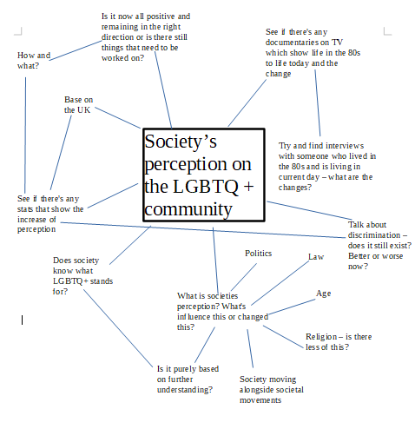

Draft

Society’s perception on the LGBTQ + community

Less than 50 years ago, sexuality consisted solely on heterosexuality. 21 years later, activists begun to use the initialism 'LGBT' to describe the increase in the variety of sexuality. 28 years later, the 'LGBT' initialism has now grown to 'LGBTQ+'.
Alongside the growth of sexuality, society too, has grown in societal acceptance.

In recent years, a remarkable shift in attitudes towards the LGBTQ+ community has embraced a new, more inclusive view of family life. With same sex intercourse once being a criminal act and same sex marriage now becoming legal, it's not just the law that's changed: we have too.
Attitudes have a complex attitude with the law. In some cases the law catches up with attitudes and in others, attitudes catch up with the law. Normally, it's rare for a law to be ahead of public attitudes, however, the perception of the LGBTQ+ community is an example of how attitudes to the change in the law were going to be development over time.

During the last three decades, the British Social Attitudes survey has been designed to ask the public what they think of homosexuality. In the first survey in 1983, 60% of participants stated that sexual relations between two same sex adults was completely wrong. Now, figures have dramatically decreased to just over 20 %, representing 1 in 5.

Social change over the last 20 years and has been driven considerably by three emerging strands. The first, is the relationship between the law and social attitudes. The second is how the issue is framed and talked about and the third is visibility – the issue itself being seen and stories being heard.
Being more exposed to the LGBTQ+ community over the years has allowed the public to accept this as 'natural' and shows how the mere fact of being exposed to a certain situation makes it seem less repugnant.

Age is a huge factor on the perception of the LGBTQ+ community. The young are born into a society where sexuality has no limits or restrictions and therefore acceptance of sexuality becomes natural and of second nature. The older generations still remain in the mind frame of the law 50 years ago and are still slowly shifting their perceptions of acceptance.

Despite the seemingly progressive attitudes towards sexuality, more than one in five LGBTQ+ individuals have been verbally or physically attacked in the last 12months due to their sexual orientation or gender identity.
Much of the attacks have taken place in public with one in six LGBTQ+ people, 17%, having being victims of hate crime in the last 12 months when visiting a restaurant, bar or night club. With one in seven experiencing discrimination when in a shop or a department store.
The abuse also translate into the online world, with homophobic, biphobic or transphobic abuse being targeted towards one in 10 LGBTQ+ internet users in the last month – a figure hat increases to one in four for trans people.
Although the UK has taken huge strides in achieving equality for the LGBTQ+ community in Britain, it's evident that much more still remains to be done in order for individuals to feel safe when in public. Despite societal perception growing in acceptance, tackling discrimination is now the focal point for change.
Emailed for edits
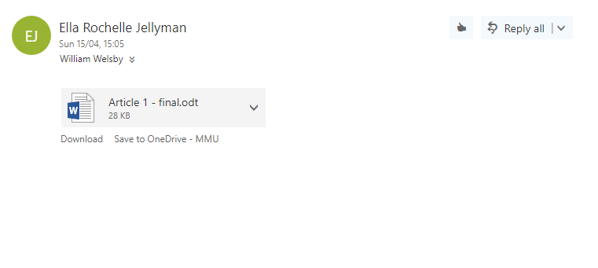
Final

Society’s perception on the LGBTQ + community

Less than 50 years ago, sexuality consisted solely on heterosexuality with very little understood of this 'norm'. 21 years later, activists began to use the initialism 'LGBT' to describe the increase in the variety of sexuality. 28 years later, the 'LGBT' initialism has now grown to 'LGBTQ+'.
The growth of the initialism is due to the reflection of the diversity of gender and sexually diverse communities being identified.
Alongside the growth of sexuality, society too, has grown in societal acceptance.

In recent years, a remarkable shift in attitudes towards the LGBTQ+ community has meant that people who identify as part of the community has meant that mainstream society now arguably embrace a new, more inclusive view of family life. With same sex relationships once being a criminal act and the legalisation of gay marriage in recent years, it's not just the law that's changed: we have too.
Attitudes have a complex attitude with the law. In some cases, the law catches up with attitudes and in others, attitudes catch up with the law. Normally, it's rare for a law to be ahead of public attitudes, however, the perception of the LGBTQ+ community is an example of how attitudes to the change in the law were going to be development over time.

During the last three decades, the British Social Attitudes survey has been designed to ask the public what they think of homosexuality. In the first survey in 1983, 60% of participants stated that sexual relations between two same sex adults was completely wrong. Now, figures have dramatically decreased to just over 20%, representing 1 in 5.
Social change over the last 20 years has been driven considerably by three emerging strands. The first, is the relationship between the law and social attitudes. The second is how the issue is framed and talked about and the third is visibility – the issue itself being seen and stories being heard.
Being more exposed to the LGBTQ+ community over the years has allowed the public to accept this as 'natural' and shows how the mere fact of being exposed to a certain situation makes it seem less repugnant. For example, storytelling has been the accelerate to the pace of change. In a 2013 Pew Survey of LGBTQ+ Americans, 70% stated that their belief of knowing someone within the community has help in terms of making them more aware and accepting of the community.

Age is a huge factor on the perception of the LGBTQ+ community. The young are born into a society where sexuality has no limits or restrictions and therefore acceptance of sexuality becomes natural and of second nature. The older generations still remain in the mind frame of the law 50 years ago and are still slowly shifting their perceptions of acceptance.

Michael Attwell, a television producer, made the first ever gay TV series in the world for ITV back in the late 70s. 'Gay Lives' was a current affairs programme that was aired only in London on a late Sunday night.In a int
erview with Micheal Attwell and the BBC, he states that 'a few months agoa gentleman came up to me and said are you Micheal Attwell? Are you the one that presented 'Gay Lives' and he said to me, I just want to thank you because you changed my life'.
Micheal then states that when the programme came out 'we had a lot of people who were very hostile, I was inundated with letters addressed to me with awful homophobic comments. However, that was just the initial response and that died down very quickly. It was just the first couple of episodes and then everyone’s opinion suddenly got better as people started to see it as a television programme and got more comfortable with the fact it was to do with two men who were in a relationship'.
This further supports the emerging strand of the importance of the community being visibly shown and stories being heard and physically seen for society to gain an understanding for acceptance.

Despite the seemingly progressive attitudes towards sexuality, more than one in five LGBTQ+ individuals have been verbally or physically attacked in the last 12months due to their sexual orientation or gender identity.
Many of these attacks have taken place in public with one in six LGBTQ+ people, 17%, having being victims of hate crime in the last 12 months when visiting a restaurant, bar or night club. With one in seven experiencing discrimination when in a shop or a department store.
The abuse also translates into the online world, with homophobic, biphobic or transphobic abuse being targeted towards one in 10 LGBTQ+ internet users in the last month – a figure that increases to one in four for trans people.
Although the UK has taken huge strides in achieving equality for the LGBTQ+ community in Britain, it's evident that much more still remains to be done in order for individuals to feel safe when in public. Despite societal perception growing in acceptance, tackling discrimination is now the focal point for change.
Discrimination is currently being tackled in workplaces by new rules being enforced to provide support, equality and eliminate discrimination. Furthermore, a report by GLAAD, found that increased knowledge about LGBTQ+ leads to lower levels of discomfort towards the community and in turn can reduce anti-LGBTQ+ discrimination. This demonstrates the power of educating society about the community.

References

Anon, (2018) [Online] [Accessed on 18 April 2018] https://www.usnews.com/news/articles/2013/06/14/survey-lgbt-adults-see-acceptance-but-also-discrimination.
Drake, B. and Drake, B. (2018) How LGBT adults see society and how the public sees them. Pew Research Center. [Online] [Accessed on 18 April 2018] http://www.pewresearch.org/fact-tank/2013/06/25/how-lgbt-adults-see-society-and-how-the-public-sees-them/.
Episode 2, Series 1, Prejudice and Pride: The People's History of LGBTQ Britain - BBC Four. (2018) BBC. [Online] [Accessed on 18 April 2018] http://www.bbc.co.uk/programmes/b08zn99q.
GLAAD. (2018) GLAAD. [Online] [Accessed on 18 April 2018] https://www.glaad.org/.
LGBT: Moving Towards Equality. (2018) Human Rights Watch. [Online] [Accessed on 18 April 2018] https://www.hrw.org/news/2015/01/23/lgbt-moving-towards-equality.
Stafford, Z. (2018) LGBT people are more accepted than ever – but we need self-acceptance too | Zach Stafford. the Guardian. [Online] [Accessed on 18 April 2018] https://www.theguardian.com/commentisfree/2016/mar/16/lgbt-people-are-more-accepted-than-ever-but-we-need-self-acceptance-too.
What Does LGBTQ+ Mean? | OK2BME. (2018) OK2BME. [Online] [Accessed on 18 April 2018] https://ok2bme.ca/resources/kids-teens/what-does-lgbtq-mean/.

