Interview with Kieran Gowan Clark

*N.B: As Kieran Gowan Clarke is a friend of mine, the main bulk of the conversation regarding the interview was largely done through word of mouth.*

Interview Questions:

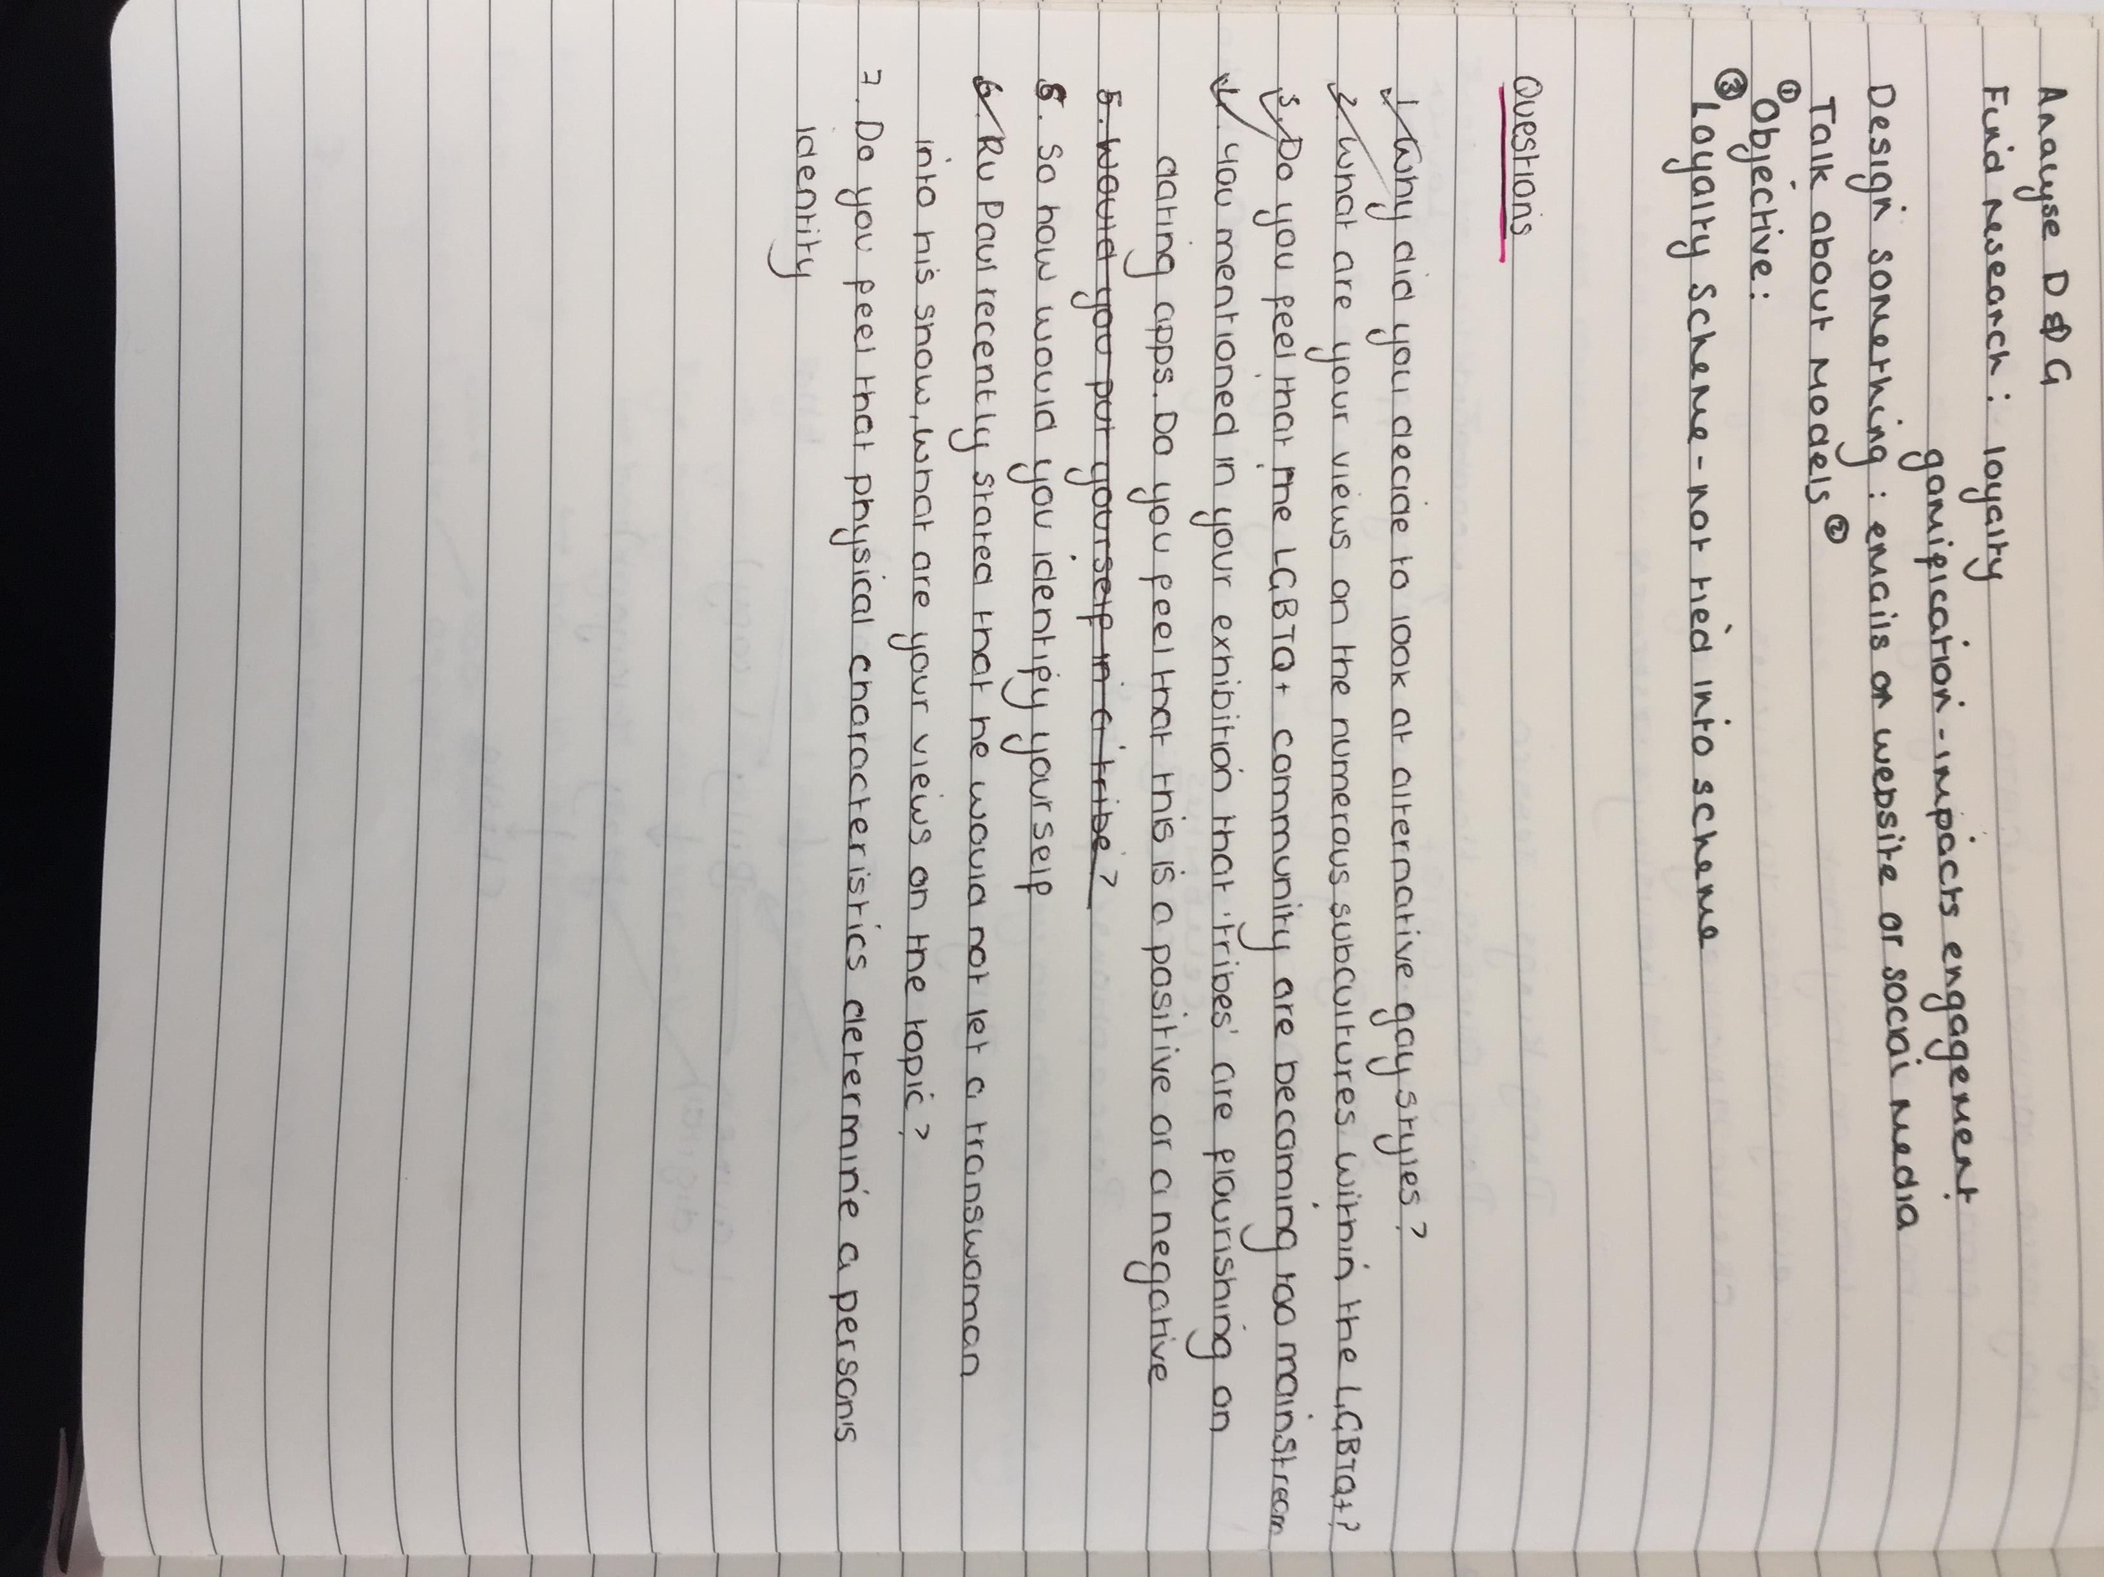

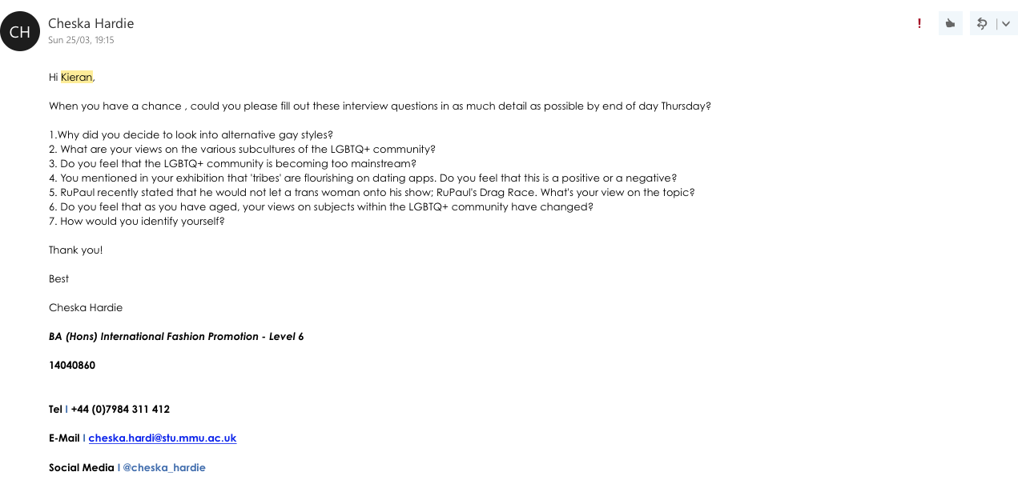

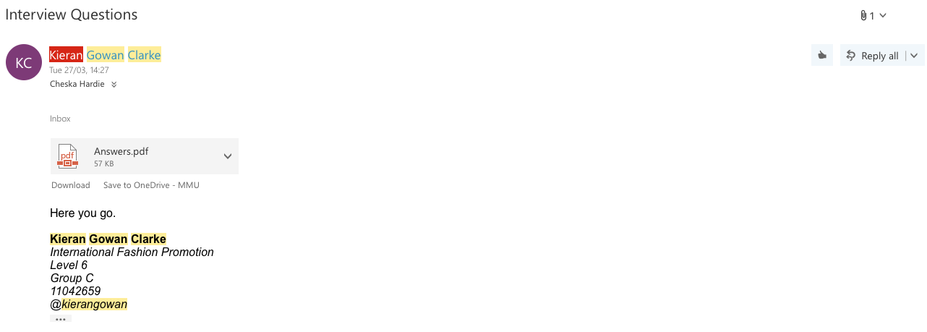

Draft:

1.Why did you decide to look into alternative gay styles?

*I decided to look into alternative gay styles due tot he recent uprising*

*of gay tribes upon gay dating apps. Gay times refer to the select*

*category that Grindr says everyone should fit into. Not everyone fits*

*these tribes though, so why should we categorise ourselves within a*

*community that has already been so alienated for such a long time? Upon*

*Grindr there is no option for those that may class themselves as*

*alternative. Alternative meaning anyone that does not fit the selected*

*tribes. My reasoning for looking into alternative styles is as I myself*

*have experienced a lot of people telling me that I am alternative and “Do*

*no fit into the community”. For someone that I don’t even know tell me*

*that I do not fit into my own community lead me onto looking as to why I*

*may not fit in.*

2. What are your views on the various subcultures of the LGBTQ+

community?

*I feel that many people outside of the community do not understand*

*all of the different letters that have been added to the usual*

*‘LGBT’ but I feel that this is very important as it is including*

*anyone that may not necessarily fit that criteria. For example,*

*involving people who may be Pansexual or Asexual is very important*

*as it allows for them to have somewhere safe to go and somewhere*

*to maybe meet other people who are like themselves.*

3. Do you feel that the LGBTQ+ community is becoming too

mainstream?

*I wouldn’t say so much mainstream, just more accepted. The only*

*thing that is coming mainstream is sayings that gay people might*

*have been saying for years, for example, the term ‘hot mess’*

*refers to someone who is beyond help. Recently this term has been*

*adopted by celebrities such as Kim Kardashian etc and then made*

*its way into the vocabulary of straight girls. This phrase*

*originates from the voguing scene of the 1970’s in New York.*

4. You mentioned in your exhibition that 'tribes' are flourishing

on dating apps. Do you feel that this is a positive or a negative?

*I feel that this is very negative on the community as we are*

*segregating people more than necessary which is leading to a very*

*bitchy atmosphere when it comes to going to the gay bars, a space*

*where you’re meant to feel like you can be yourself.*

5. RuPaul recently stated that he would not let a trans woman ontohis show; RuPaul's Drag Race. What's your view on the topic?

*I feel that this statement from RuPaul was out of order*

*completely. For him to state that someone who is trans can not*

*compete on the show is absolutely ridiculous. ONE OF THE MAIN*

*PEOPLE BEHIND THE STONEWALL MOVEMENT WAS A TRANS PERSON! (Marsha*

*P.Davis) If it was not for a trans person being the pinnacle of*

*the stonewall movement, the gay rights act would not have passed*

*in the late 60’s!*

6. Do you feel that as you have aged, your views on subjects

within the LGBTQ+ community have changed?

*When I was much younger, 16, and I had just come out, I was very*

*naive when it came to the whole community. For example, like most*

*young gays (that I know anyway), I thought I was the bee’s knees.*

*Everyone wanted Kieran, everyone look at me, laugh with me. But as*

*I’ve grown up, I have noticed the community shouldn’t be all about*

*yourself, it should be about involving everyone that is like you*

*and that everyone should get along (not always the case, but you*

*know). It is hard to actually pin point at what time I realised*

*that the community wasn’t actually as close knit as what it should*

*actually be. I think in recent years, since moving to Manchester*

*where the gay scene is so big, I have realised that maybe the*

*community could do with a bit of a shake up.*

7. How would you identify yourself?

*I myself identify as male, but I always like to experimenting with*

*different ways of dressing. I would not so know to wearing*

*clothing that is a little more feminine, I would not say no to*

*wearing something that is hyper masculine. I’m open to*

*interpretation. I’m just very free.*

Notes From the Editor:

(no electronic notes, but during a quick meeting, the Editor (Billy) showed me the changes he suggest I made).

Correspondace:

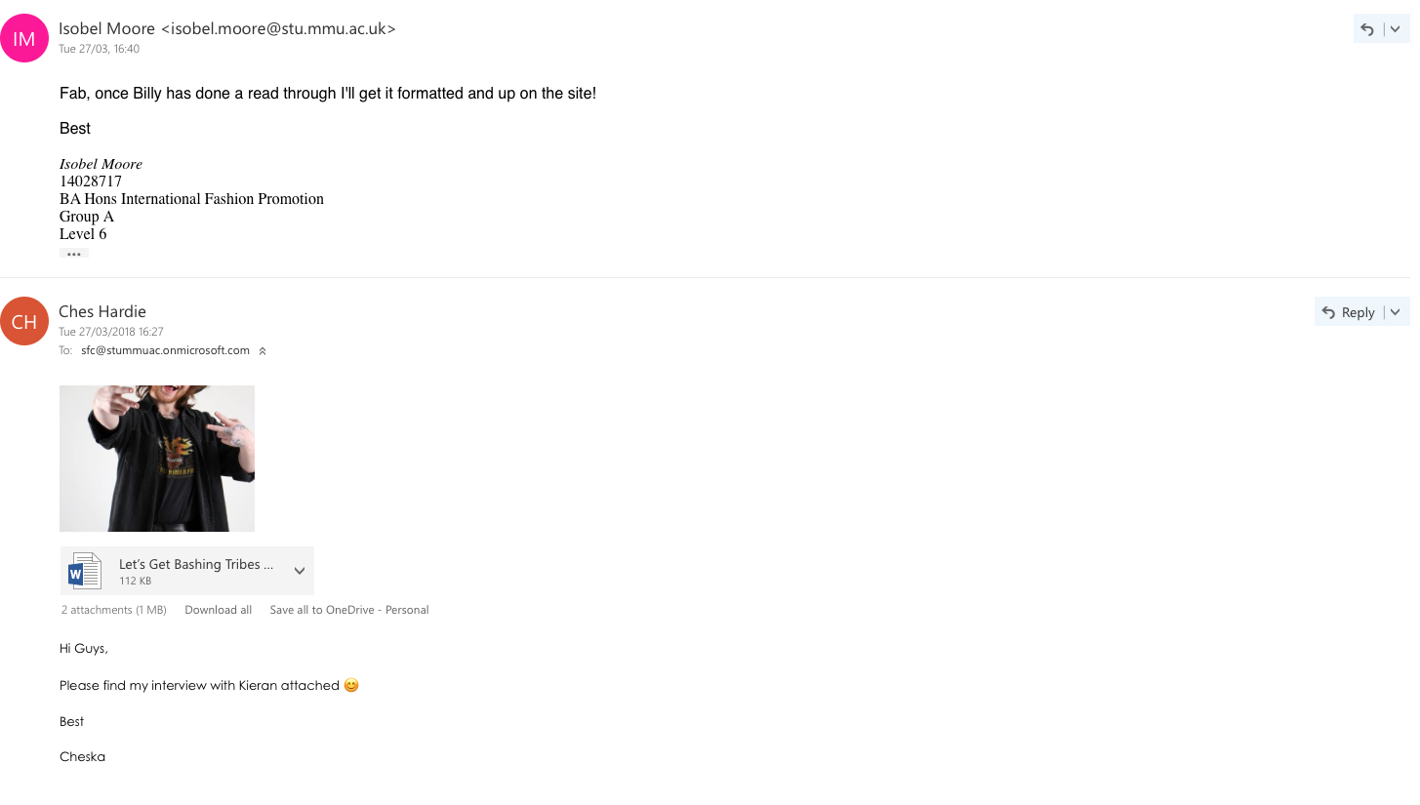

Final Interview:

Let’s Get Bashing Tribes with Questions

by Cheska Hardie

27/03/2018

Riding high from his ‘Alienation: Alternative Gay Styles’ exhibition, Kieran Gowan Clarke sits down to tell us his views on his exhibition, gay tribes and dating apps.

**1.Why did you decide to look into alternative gay styles?**

I decided to look into alternative gay styles due to the recent uprising

of gay tribes upon gay dating apps. Gay times refer to the select

category that Grindr says everyone should fit into. Not everyone fits

these tribes though, so why should we categorize ourselves within a

community that has already been so alienated for such a long time? Upon

Grindr there is no option for those that may class themselves as

alternative. Alternative meaning anyone that does not fit the selected

tribes. My reasoning for looking into alternative styles is as I myself

have experienced a lot of people telling me that I am alternative and “Do

no fit into the community”. For someone that I don’t even know tell me

that I do not fit into my own community lead me onto looking as to why I

may not fit in.

**2. What are your views on the various subcultures of the LGBTQ+**

**community?**

I feel that many people outside of the community do not understand

all of the different letters that have been added to the usual

‘LGBT’ but I feel that this is very important as it is including

anyone that may not necessarily fit that criteria. For example,

involving people who may be Pansexual or Asexual is very important

as it allows for them to have somewhere safe to go and somewhere

to maybe meet other people who are like themselves.

**3. Do you feel that the LGBTQ+ community is becoming too**

**mainstream?**

I wouldn’t say so much mainstream, just more accepted. The only

thing that is coming mainstream is sayings that gay people might

have been saying for years, for example, the term ‘hot mess’

refers to someone who is beyond help. Recently this term has been

adopted by celebrities such as Kim Kardashian etc. and then made

its way into the vocabulary of straight girls. This phrase

originates from the voguing scene of the 1970’s in New York.

**4. You mentioned in your exhibition that 'tribes' are flourishing**

**on dating apps. Do you feel that this is a positive or a negative?**

I feel that this is very negative on the community as we are

segregating people more than necessary which is leading to a very

bitchy atmosphere when it comes to going to the gay bars, a space

where you’re meant to feel like you can be yourself.

**5. RuPaul recently stated that he would not let a trans woman onto**

**his show; RuPaul's Drag Race. What's your view on the topic?**

I feel that this statement from RuPaul was out of order

completely. For him to state that someone who is trans can not

compete on the show is absolutely ridiculous. ONE OF THE MAIN

PEOPLE BEHIND THE STONEWALL MOVEMENT WAS A TRANS PERSON! (Marsha

P.Davis) If it was not for a trans person being the pinnacle of

the stonewall movement, the gay rights act would not have passed

in the late 60’s!

**6. Do you feel that as you have aged, your views on subjects**

**within the LGBTQ+ community have changed?**

When I was much younger, 16, and I had just come out, I was very

naive when it came to the whole community. For example, like most

young gays (that I know anyway), I thought I was the bee’s knees.

Everyone wanted Kieran, everyone look at me, laugh with me. But as

I’ve grown up, I have noticed the community shouldn’t be all about

yourself, it should be about involving everyone that is like you

and that everyone should get along (not always the case, but you

know). It is hard to actually pin point at what time I realized

that the community wasn’t actually as close knit as what it should

actually be. I think in recent years, since moving to Manchester

where the gay scene is so big, I have realized that maybe the

community could do with a bit of a shake-up.

**7. How would you identify yourself?**

I myself identify as male, but I always like to experimenting with

different ways of dressing. I would not so know to wearing

clothing that is a little more feminine, I would not say no to

wearing something that is hyper masculine. I’m open to

interpretation. I’m just very free.

*Instagram: @* [*kierangowan*](https://www.instagram.com/kierangowan/)