Tribe Article

Research:

As this article is a first persons take on gay tribes within the LGBTQ+ community, rather than making notes, it was easier to read articles and then wait to write the article, as it ensured that the article was unbiased and completely from my point of view and perspective. Below is an outline of the tribes I came across and below them are all the references that I read and used to formulate my opinion. I also used the interview of Kieran Gowan Clarke as another source of inspiration, as he talks very passionately about gay tribes (see article on page…).

Tribes
Geek
Body Type: Thin, no hair
Description: “a Gay man with deep and enthusiastic knowledge of one or more hobbies, sports, activities, professional fields, or intellectual pursuits.”

Twinks
Body Type: Thin, smooth, often blond, usually with longish bangs and often with highlights.
Description: This young breed of gays is never over 30 and tends to be on the queeny side and hews closely to the conventional stereotypes of gay man.
Jocks
Body Type: Athletic, muscular, possibly gone-to-seed
Description: This guy prides himself on the fact that no one thinks he is gay until he tells them. His love of sports is just about the only unaffected aspect of his masculinity.
Gym Rats
Body Type: Muscular, waxed, preened, most usually with tribal tattoos
Description: This subset rose to prominence in the '90s around the drug-fueled, all-night dance parties that were in different cities around the country.

Bear
Body Type: a husky, large man with a lot of body hair,
Description:

Daddy
Body Type: a husky, large man with a lot of body hair,
Description: a man who is usually middle-aged who has a more dominant personality.
Otter
Body Type: typically thinner, hairier Gay man
Description: called the lovechild of a bear and twink.

Rugged
Body Type: a husky, large man with a lot of body hair,
Description:

Clean Cut
Body Type:
Description:

Bear
Body Type: a husky, large man with a lot of body hair,
Description:

Daddy
Body Type: a husky, large man with a lot of body hair,
Description: a man who is usually middle-aged who has a more dominant personality.
Otter
Body Type: typically thinner, hairier Gay man
Description: called the lovechild of a bear and twink.

Wolf
Body Type: lean, muscular, semi hairy
Description: “

Puppy
Body Type: slender, young with a bit of muscle
Description: “Energetic, cute, and naïve”

Bull
Body Type: super built, a bit of hair and refers to any age
Description: addicted to working out but not associated with sports

Daddy
Body Type: a husky, large man with a lot of body hair,
Description: a man who is usually middle-aged who has a more dominant personality.
Otter
Body Type: typically thinner, hairier Gay man
Description: called the lovechild of a bear and twink.

Wolf
Body Type: lean, muscular, semi hairy
Description: “

Puppy
Body Type: slender, young with a bit of muscle
Description: “Energetic, cute, and naïve”

Bull
Body Type: super built, a bit of hair and refers to any age
Description: addicted to working out but not associated with sports

One of the biggest pushers of ‘tribes; within the gay community is the dating app Grindr. It uses the tribes to help men categorize themselves, so that they match with those who are their preference without having to go through those who aren’t.

Quote on Tribes from Kieran Gowan Clarke Interview:

“I feel that this [Grindr pushing tribes] is very negative on the community as we are
segregating people more than necessary which is leading to a very
bitchy atmosphere when it comes to going to the gay bars, a space
where you’re meant to feel like you can be yourself.”

https://thetab.com/uk/newcastle/2017/12/12/gay-tribes-on-grindr-why-its-time-to-stop-categorising-each-other-29938

http://www.rebelcircus.com/blog/gay-male-tribes-demystified/

http://www.wussymag.com/all/2016/8/2/identity-crisis-on-grindr

https://pairedlife.com/dating/Gay-Men-Are-you-a-Jock-Otter-Bear-or-Wolf

https://www.fastcompany.com/1683308/an-illustrated-guide-to-recognizing-your-gay-stereotypes

https://www.huffingtonpost.com/dieter-holger/grindr-is-digitizing-the-_b_7250054.html

https://www.theguardian.com/fashion/2017/apr/25/30-years-of-gay-style-from-disco-chic-to-hipster-bears

https://www.standard.co.uk/lifestyle/north-south-east-and-west-the-gay-tribes-of-london-6373979.html

http://gawker.com/5472263/a-handy-guide-to-all-gay-men

https://www.planetromeo.com/en/blog/which-gay-animal-tribe-do-you-belong-to/

https://www.advocate.com/health/love-and-sex/2014/02/25/grindr-tribes-helpful-or-hindrance

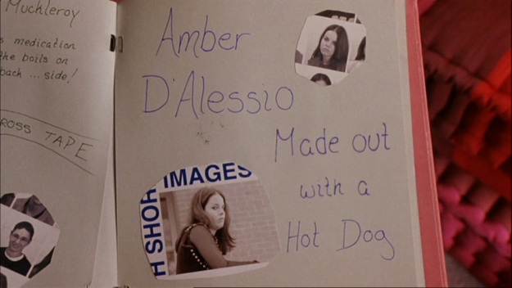
Moodboard (Layout):
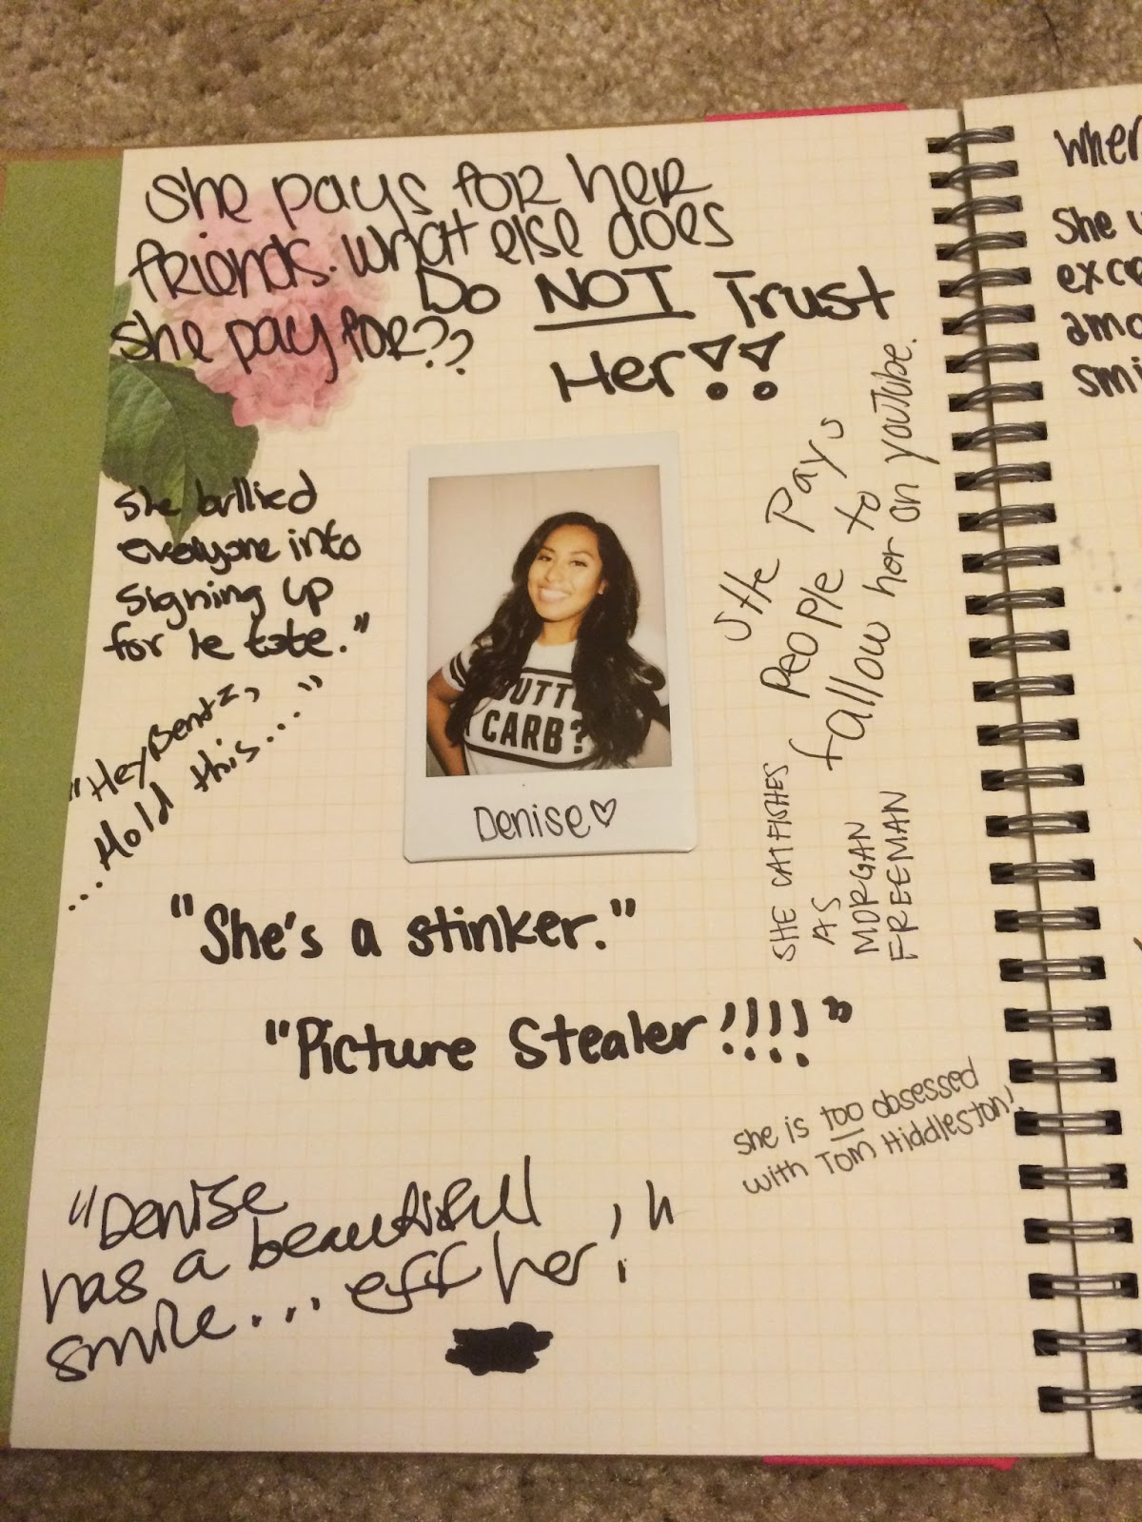
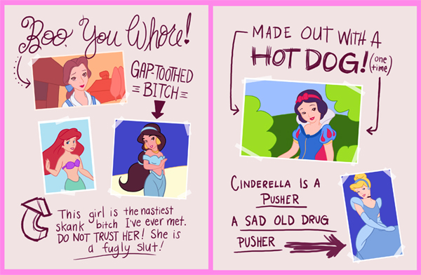
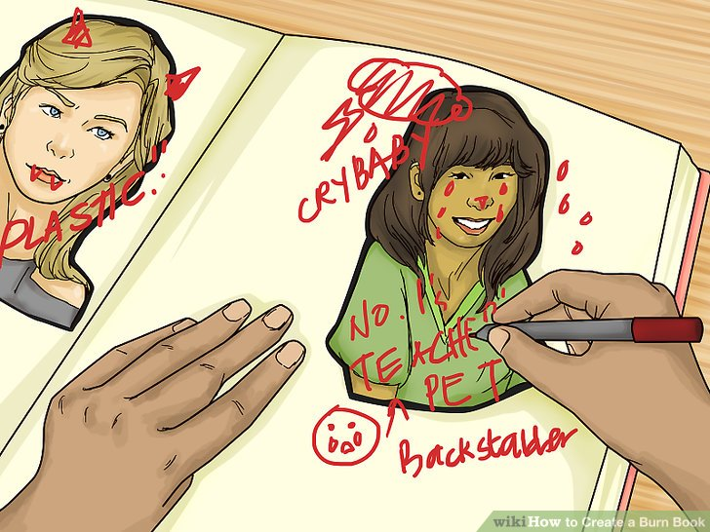
Mood board Layout

I initially decided that I would take a ‘burn book’ approach to my article. The idea was to make the article appear as part of the burn book, but instead of hurtful comments, it would be facts about each tribe. Initially I though that this would be a visual only piece of work, however, it was later revealed to me by my group that there had to be a written element as well,

For my layout, I researched a number of different ways the burn book could be duplicated, both digitally and by hand. After some consideration, I decided that I would do it digitally, as it was the way everyone was doing their articles. I decided to stick to a traditional burn book layout, with an illustration of each tribe within a polaroid and writing around it.

Illustration Process:

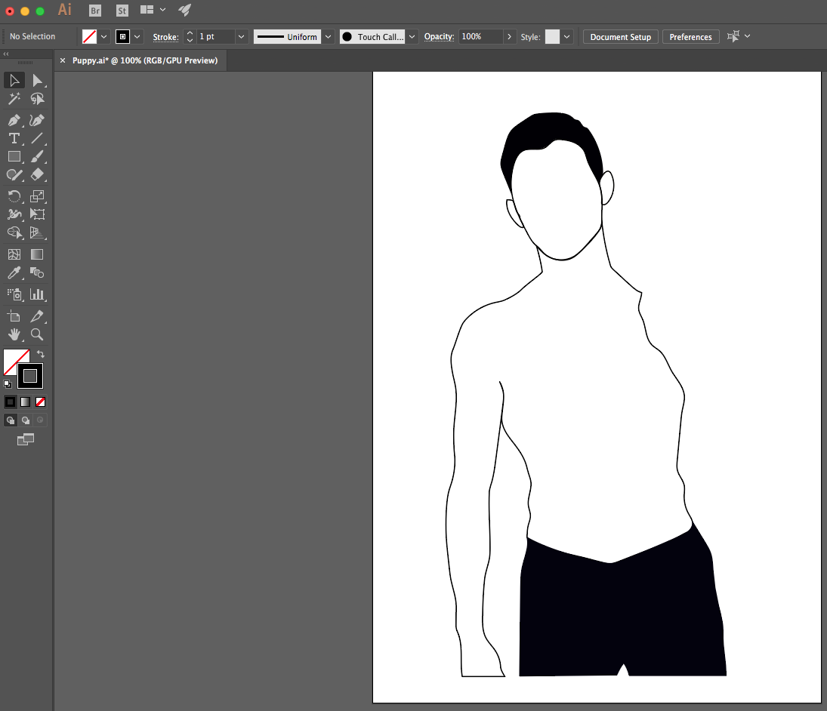
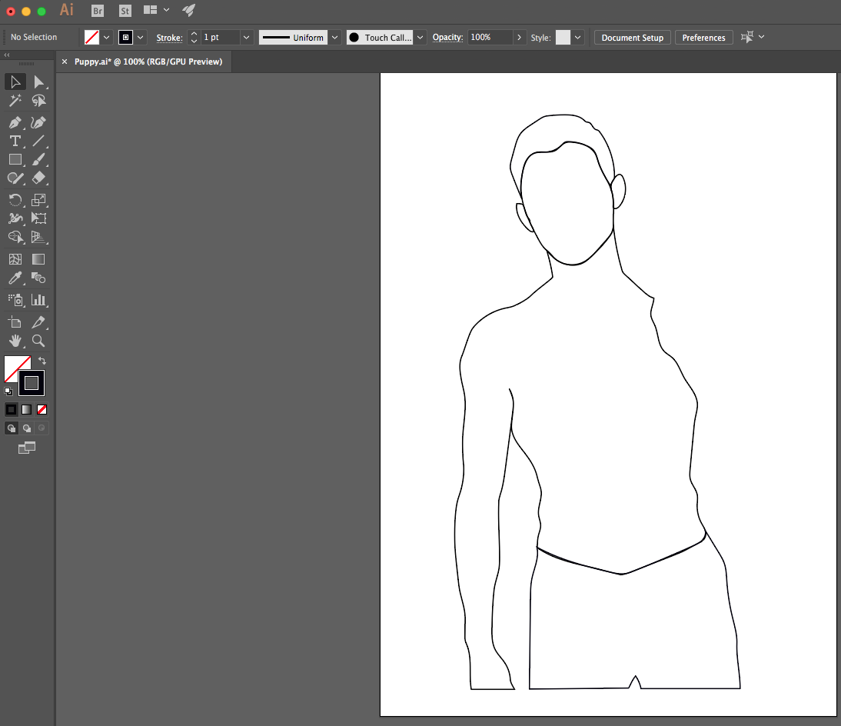

2.
1.

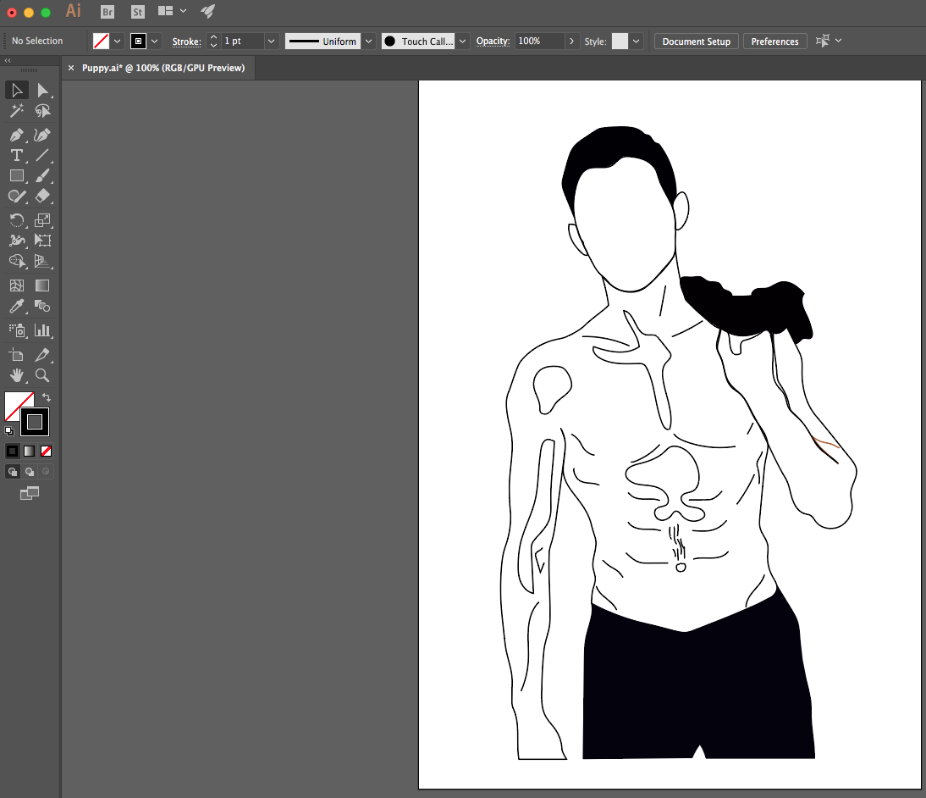
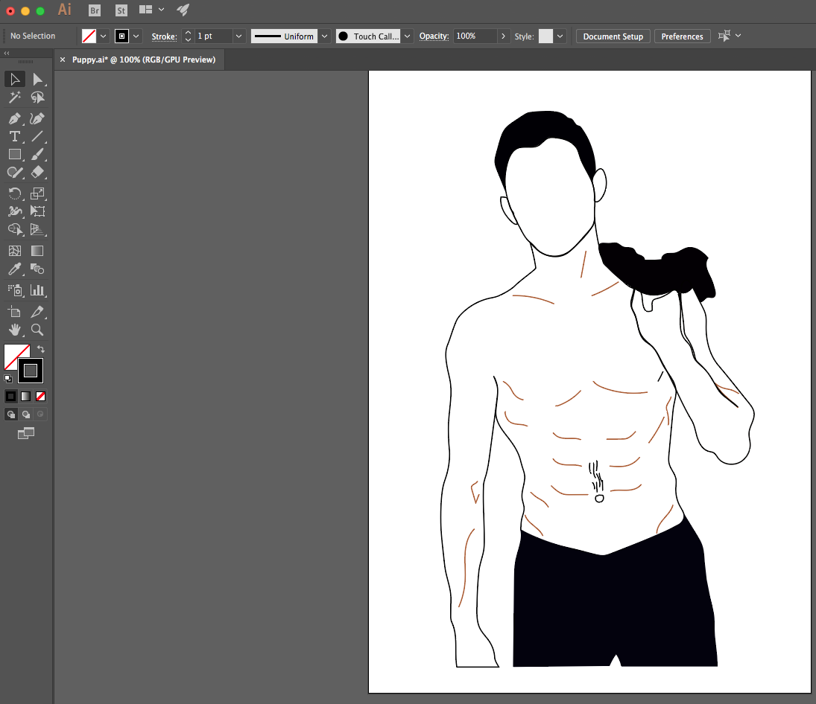

4.
3.

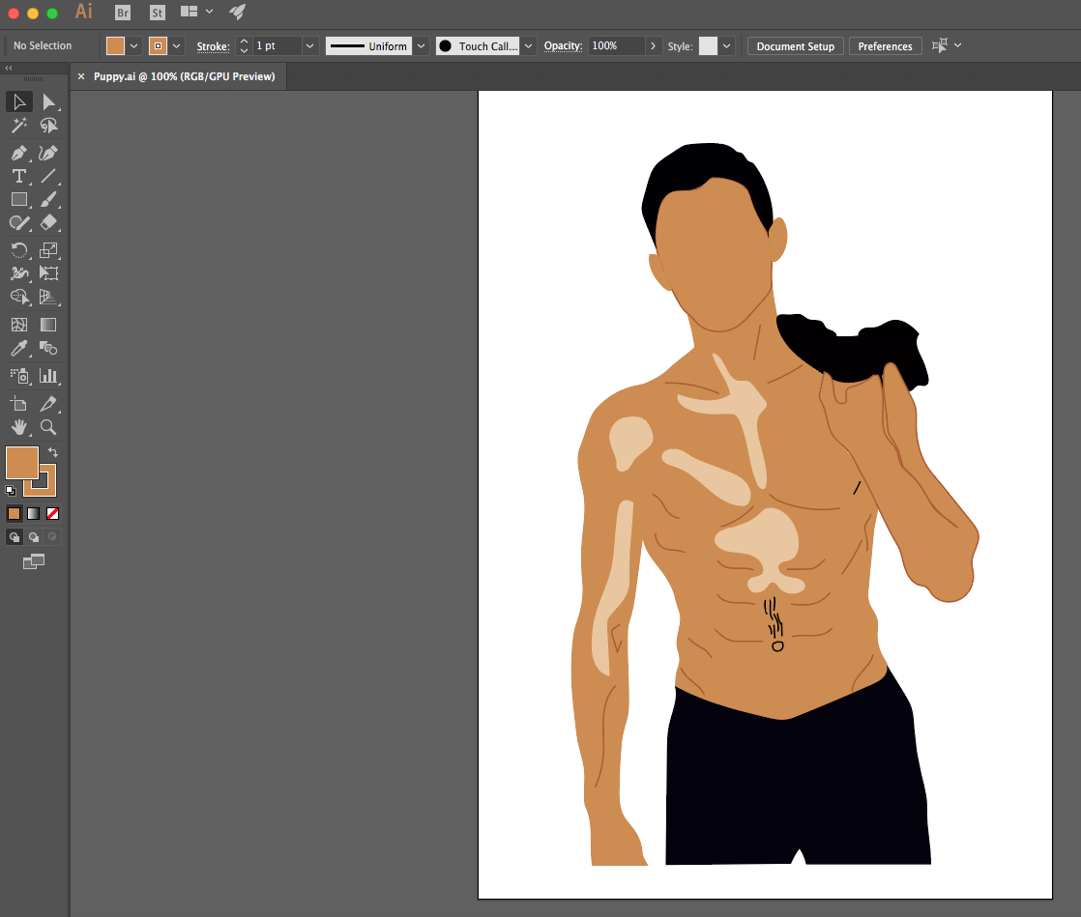
Initial Layout idea:
Illustration experimentation

I wanted to ensure that I was able to interject a creative aspect to my article. I decided to do that through illustrations, because I felt it resonated more with the but book idea, as I did not want to copy the burn book layout piece by piece, word for word. I want to create something that was similar and unique to the magazine and platform.

5.
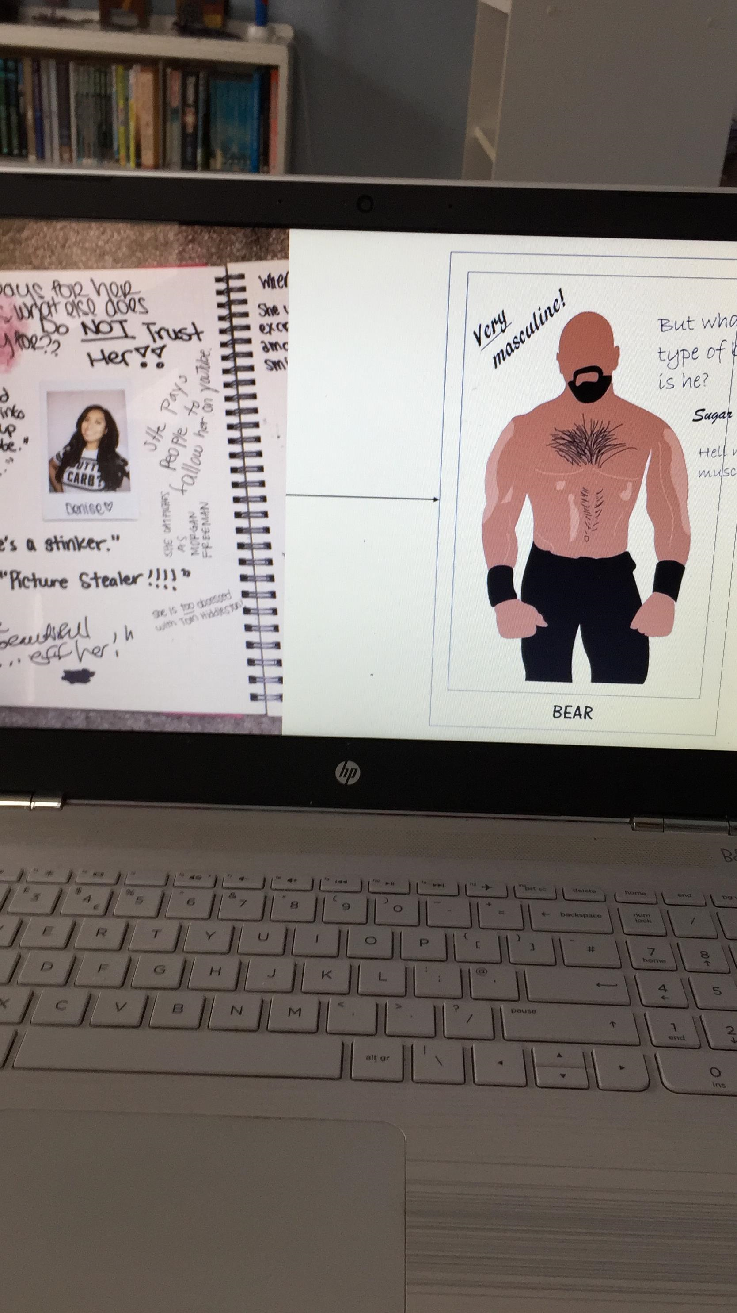
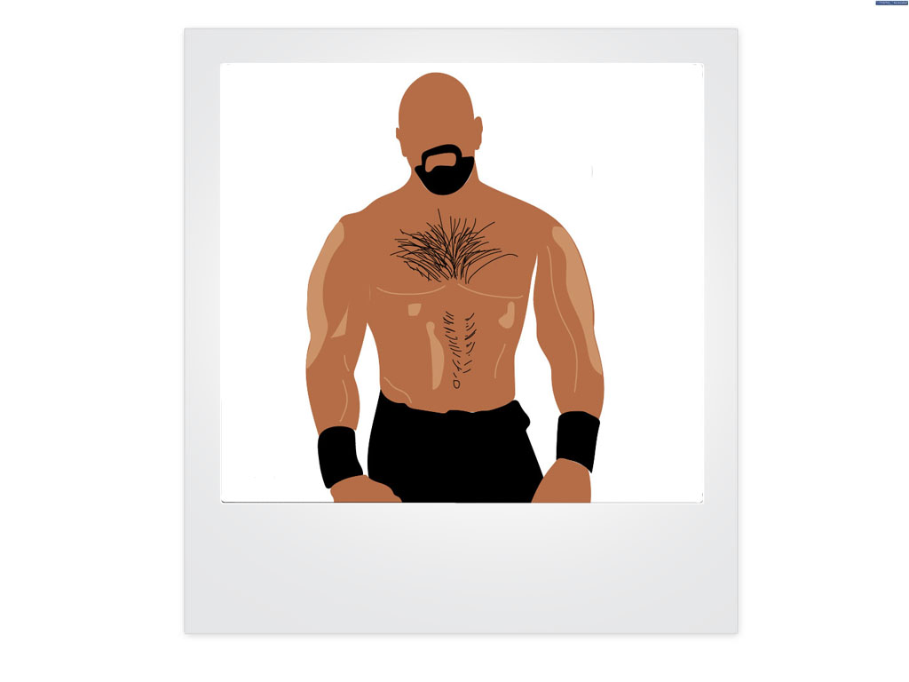

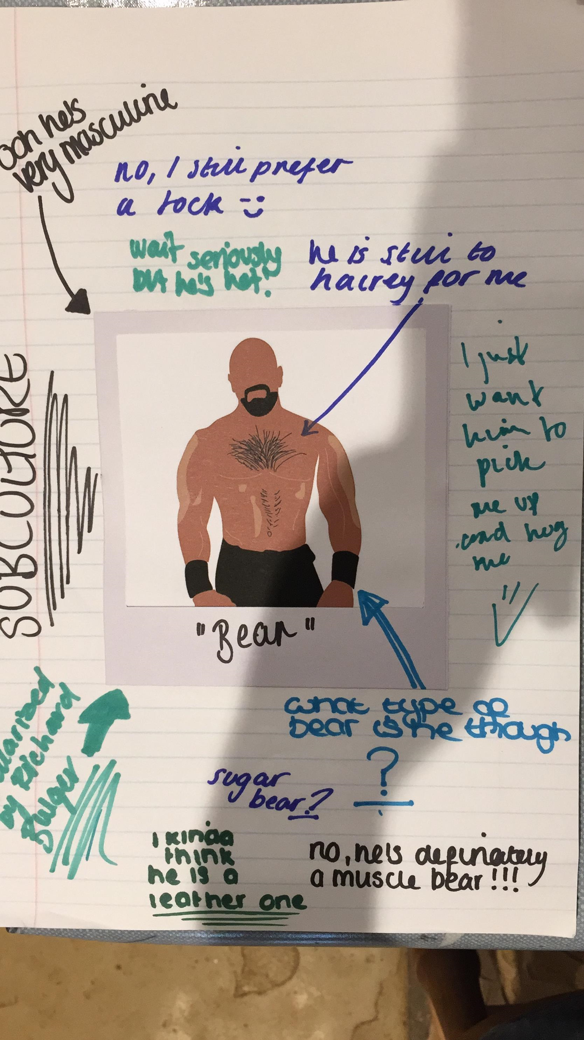

In regards to the layout of the illustrations / article, I experimented with the possibility of doing it digitally or by hand. I definitely wanted to put the illustrations into a polaroid picture, because I felt that that was more in-tune with the whole burn book idea.

As shown in the conversation below, my group and I decided that it would look more authentic and have a more ‘collage’ like feel to it (image: bottom right). However, as shown in the subsequent conversations, it was decided that as Hannah and Izzy were both in charge of layout, that the layout of my article should be left up to them. While disappointed, I understood that it would probably all look cleaner and more in sync with the rest of the articles.

Conversation with Group about Layout:
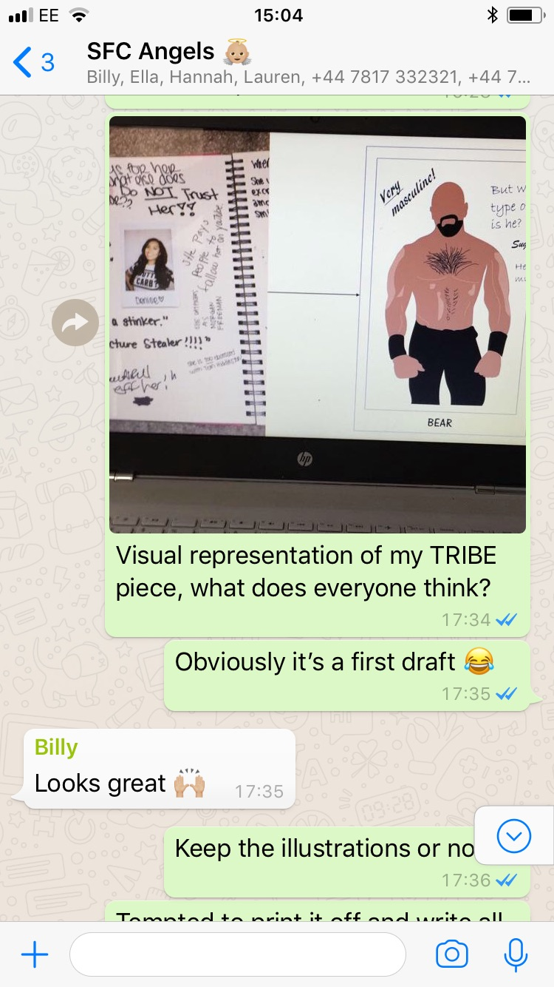
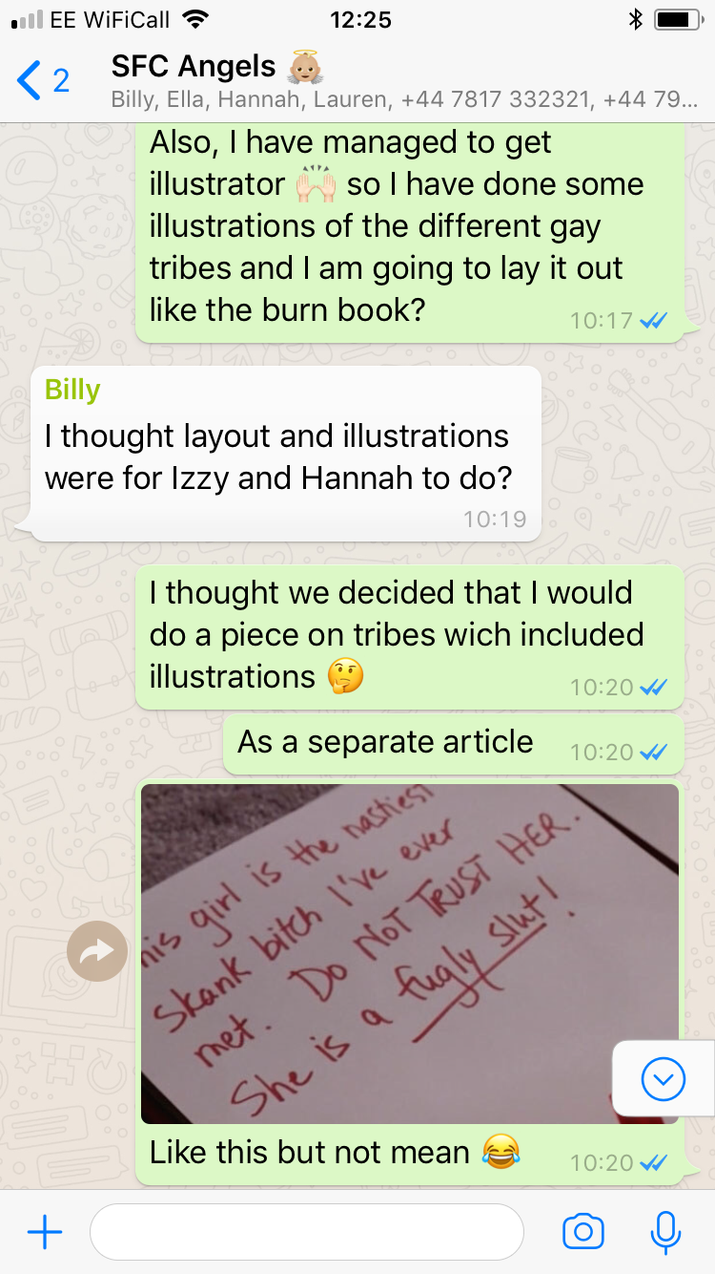

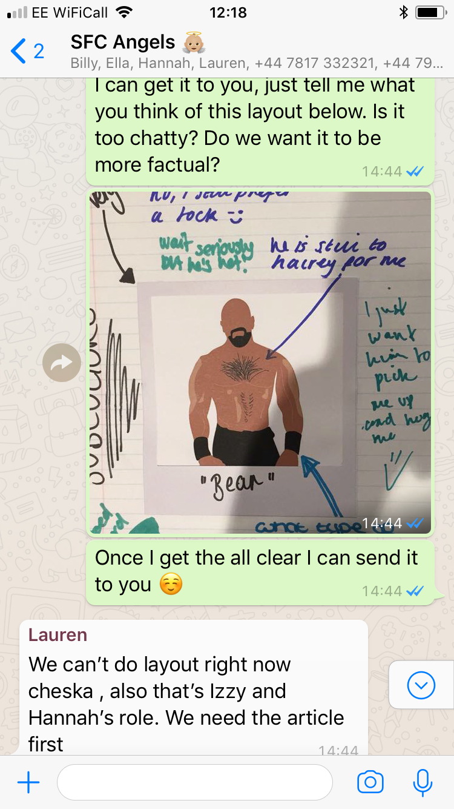
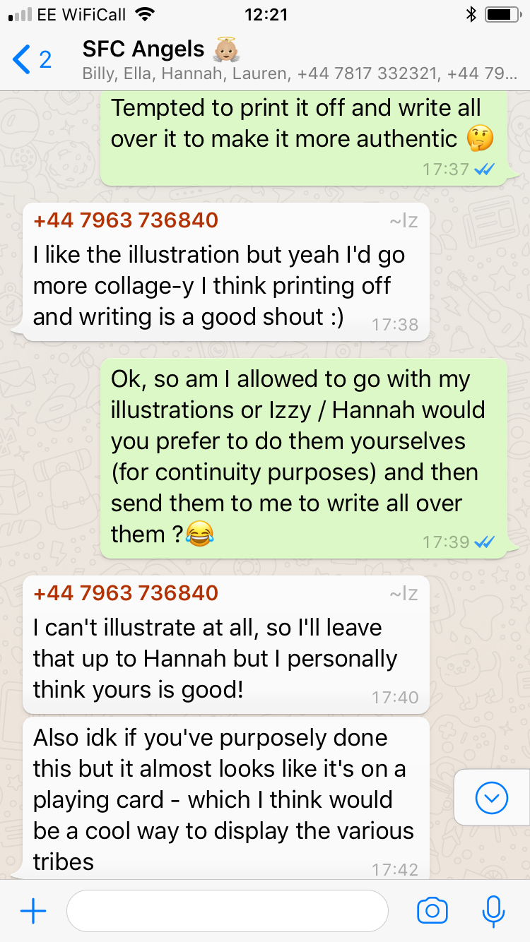

First Draft:

Looking at the Gay community: Bears, Twinks and Queens (500 WORDS)

By Cheska Hardie

11/04/2018

Tribes have been around since the dawn of time and have had many different names; cliques, gangs and community. They offered people a place where they could find acceptance for who they are. The gay community is no different and in recent decades, have seen tribes flourish within this community, made more mainstream by the introduction of the gay dating app Grindr.

However, as with any tribe or community, there are naïve and uneducated people (myself included) who don’t quite understand the different tribes within the LGBTQ+ community. These people are mainly heterosexuals, who sometimes assume rather than ask. Now, as a heterosexual female (and a very naïve one at that), I was unaware that there were numerous tribes within the gay community, which resulted in a lot of laughter from my homosexual peers when they started to talk about a cute ‘bear’ or ‘jock’ and I would look on with confusion. So, I decided to look deeper into the world surrounding these tribes.

What I found was a whole a lot of different tribes, I mean they have one for nearly every single characteristic a human male can possess (no joke). Now in my eyes, I have always firmly believed that people can identify as whatever and whoever the want and I believe the same when it comes to the tribes within the gay community. For a group of people to have faced such discrimination, it is understandable that the moment they found comfort in a group, that they would stick to it.

But its not always black and white, and while I felt that tribes were a positive, some within the community see them more as a negative. Brett Pall who is gay and writes for the Huffington post, wrote that he felt that tribes were separating the community, rather than bringing them together. Kieran Gowan Clark, an artists and student, revealed in an interview that he felt that he felt that tribes were turning the community into a bitchy atmosphere, rather than an accepting one.

But this article is not to debate the benefits or negatives of the different tribes within the gay community. This article aims to educate those who are unaware or just stupidly bigoted when it comes to the LGBTQ+ community. I remember a homosexual friend of mine remarking that it was better for me to ask then to assume. So, although you probably have not asked for this article, you’re getting it. Below is a lowdown on the different ‘tribes’ within the community for those who still get confused when someone mentions having a thing for ‘otters’ (and looks at you weirdly when you mention Benedict Cumberbatch).

Editor’s Note:
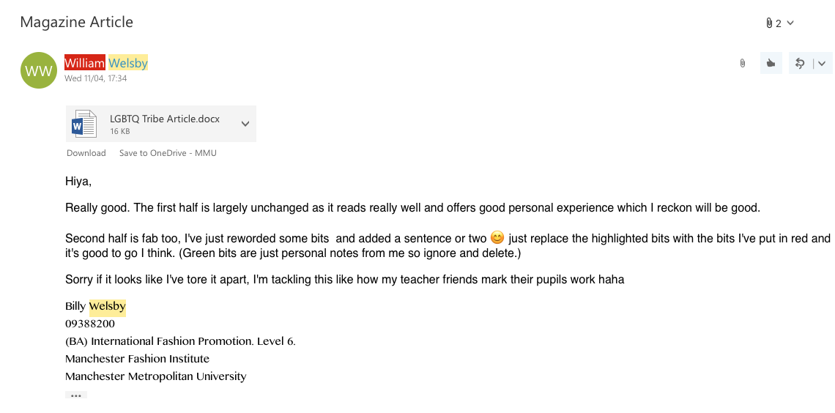

(for the edits, please see Billy Welsby Creative Process)
Final Article:

Looking at the Gay community: Bears, Twinks and Queens

By Cheska Hardie

11/04/2018

Tribes within all cultures and societies have been around since the dawn of time and have had many different names; cliques, gangs and community. They offered people a place where they could find acceptance for who they are. The gay community is no different and in recent decades, have seen tribes flourish within this community, made more mainstream by the introduction of the gay dating app Grindr.

However, as with any tribe or community, there are naïve and uneducated people (myself included) who don’t quite understand the different tribes within the LGBTQ+ community. These people are mainly heterosexuals, who sometime assume rather than ask. Now, as a heterosexual female (and a very naïve one at that), I was unaware that there were numerous tribes within the gay community, which resulted in a lot of laughter from my homosexual peers when they started to talk about a cute ‘bear’ or ‘jock’ and I would look on with confusion. So, I decided to look deeper into the world surrounding these tribes.

What I found was a whole a lot of different tribes, I mean they have one for nearly every single characteristic a human male can possess (no joke). Now in my eyes, I have always firmly believed that people can identify as whatever and whoever they want to, and I believe the same when it comes to the tribes within the gay community. For a group of people to have faced such discrimination, it is understandable that the moment they found comfort in a group, that they would stick to it.

But it’s not always black and white, and while I felt that tribes were a positive, some within the community see them more as a negative. Brett Pall, a writer for the Huffington Post who identifies as gay, wrote that he felt that tribes were separating the community, rather than bringing them together. Kieran Gowan Clark, an artist and student, revealed in an interview for X,Y,Z magazine (see page X), that in his personal experience, he saw the occurrence of tribes as creating somewhat ‘bitchy atmosphere and dividing from within, rather than emulating a feeling of acceptance.

With this in mind, the article aims to educate those who are unaware or have been previously mis-educated when it comes to the LGBTQ+ community. I remember a gay friend of mine remarking that it was better for me to ask then to assume. So, although you probably have not asked for this article, I’ve written it anyway. Below is a brief lowdown on the different ‘tribes’ within the community for those who still get confused when their LGBTQ+ friends and family members mention they have a thing for ‘otters’ (and look at you weirdly when you mention Benedict Cumberbatch).

Final Illustrations:

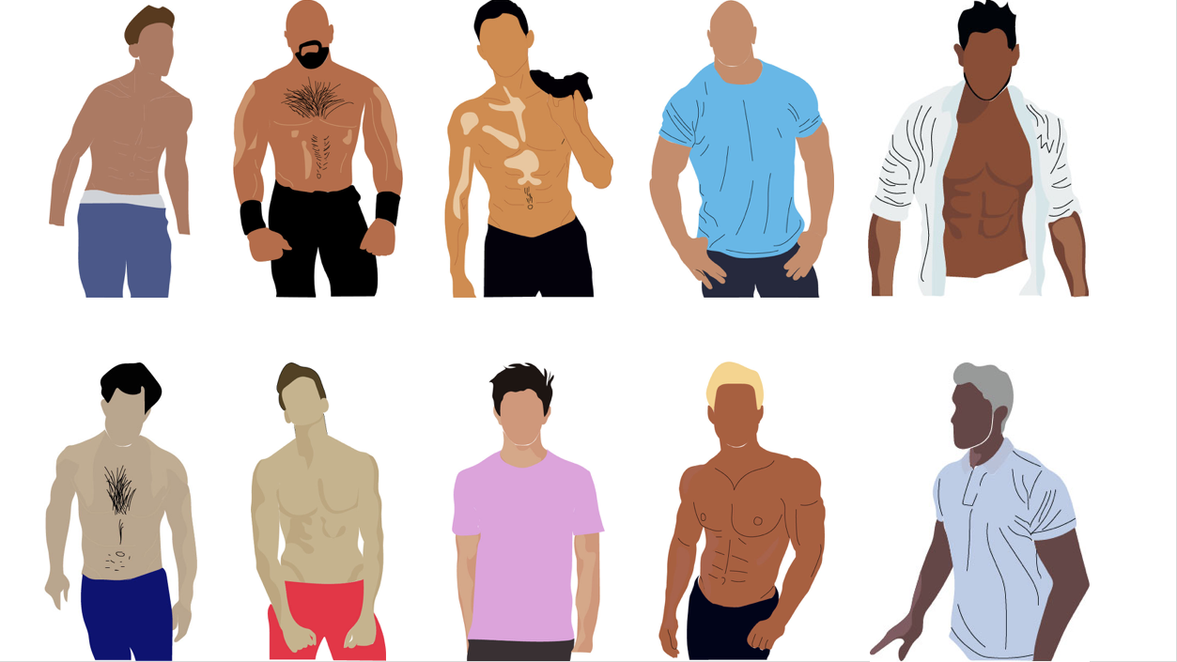

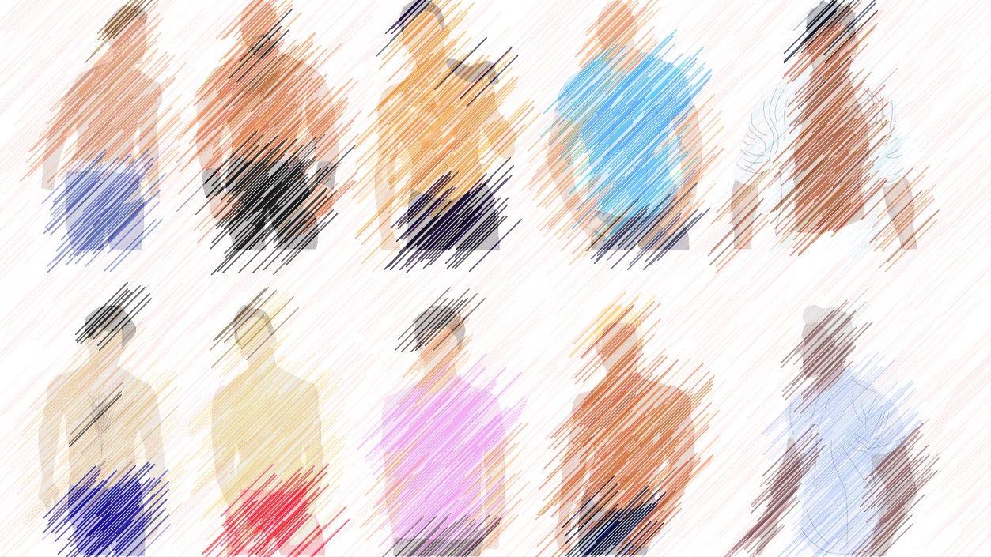
BEAR
DADDY
GYM RAT
GEEK
JOCK
OTTER
WOLF
BULL
TWINK
PUPPY

Notes from Website Editor regarding Layout:
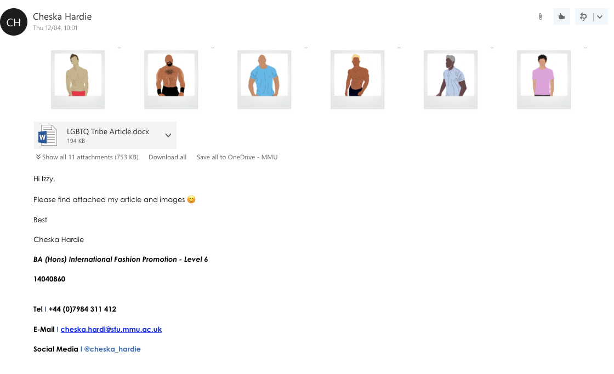

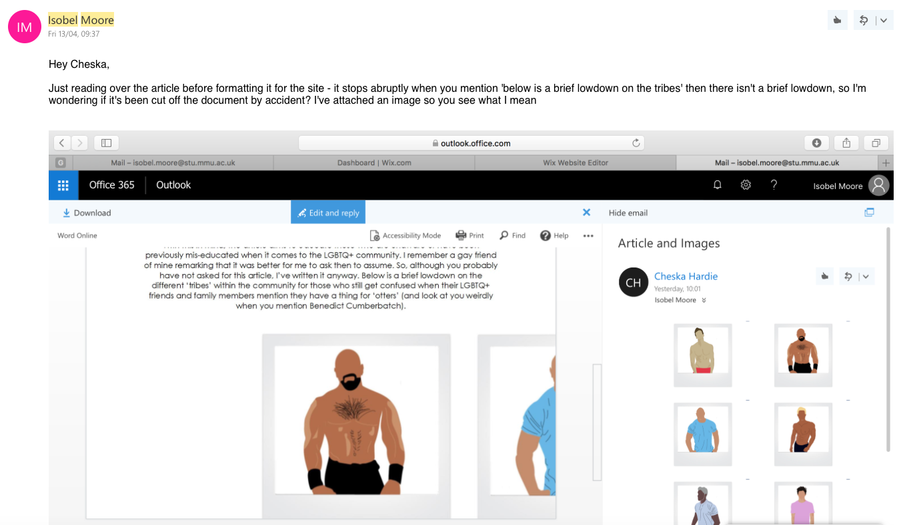

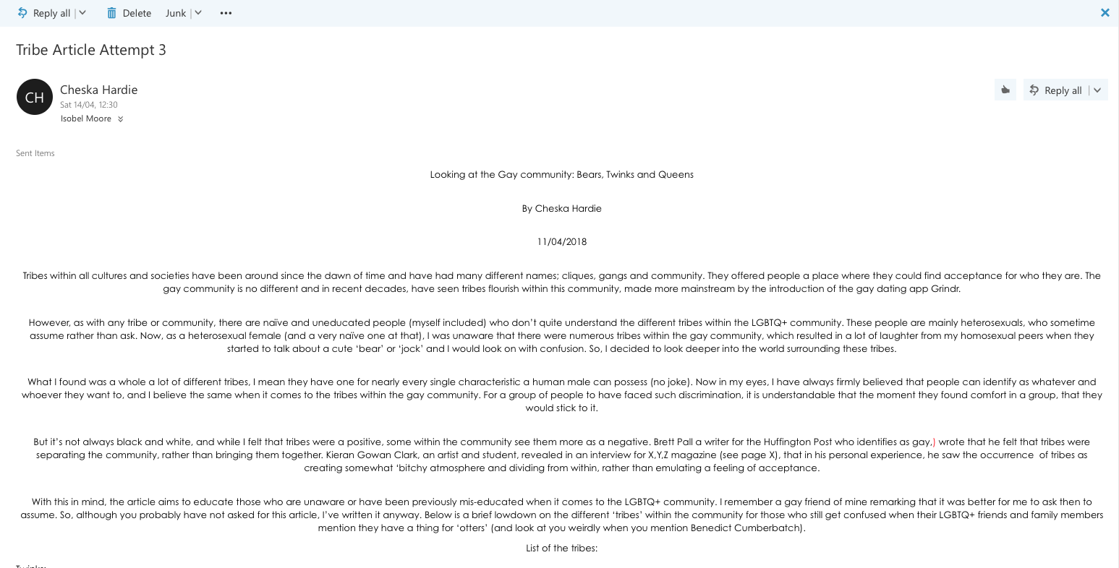

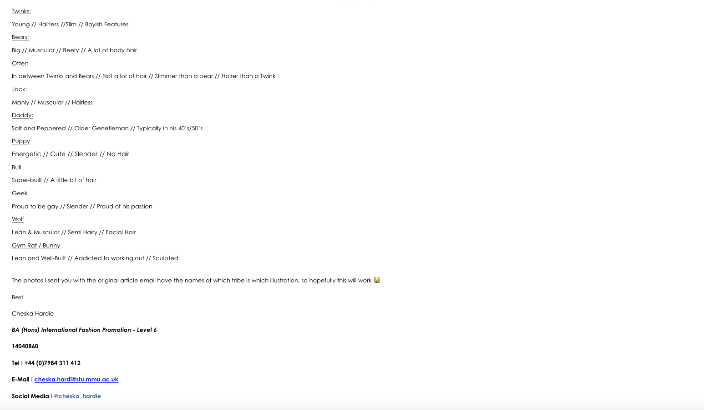

(for the article layout, please see Isabel Moore & Hannah Parr Creative Process)

