**REPRESENTITIVES OF LGBTQ+ IN MUSIC OF RECENT YEARS**

In recent years it definitely feels as though more performers than ever are embracing their true identity and successfully enjoying their careers as out-and-proud queer people. From pop artists such as Sam Smith and Sia, to Indie artists such as Declan Mckenna or Beth Ditto. There is a broad array of musicians across all genres who can be praised for unapologetically being themselves.

Below is a selection of artists hand-picked by X,Y,Z writer Isobel Moore, highlighting the variety and what she thinks makes them great advocates.

**Declan Mckenna**

Although Declan Mckenna hasn't specifically identified himself as part of the LGBTQ+ community, he is still a fantastic advocate. At just age 19 he is not only one to watch, but a credit to the LGBTQ+ community and song writers. The death of Leelah Alcorn in 2014, a transgender teen from Ohio, is said to have bought on a flurry of song writing that he hoped would encourage people to care. Self-releasing his second single titled “Paracetamol”, which is five and a half minutes long, and openly discusses how transgender teenagers are misrepresented in the media. In an interview, McKenna explained that**“ the idea of using the lyric paracetamol was a way of comparing the belief that someone can be cured from who they are, via therapy, to an everyday painkiller."**

This song shows an extreme maturity for someone so young, it highlights that McKenna isn’t just your ordinary ‘one hit wonder teenage dream’ but rather, as said by Matt Wilkinson of NME, a ‘solid and accomplished songwriter who can deliver "bruised and vulnerable" vocals.

Speaking about this particular song, McKenna said:

**Paracetamol is not written specifically about Leelah’s case, but about sections of the media’s representation of LGBT communities in general. On the odd occasion they are represented, the media tends to handle it so horribly that the cumulative effect is that their readers – quite understandably – just don’t quite get it either. It’s pretty important to note here that I’m not trying to suggest that I know everything about this topic, because I don’t, but I do care and I wanted to act, and I think more people need to start actively caring. People need to start getting it.”**

**L is for LESBIAN**

**Beth Ditto**

The American singer-songwriter has often been reported for describing herself as a “fat, feminist lesbian from Arkansas.” Well known for her outspoken support on LGBTQ+ and feminist causes, as well as being an advocate for large women being body positive.

**“For me the greatest revenge of all is having a happy adulthood, waking up in my gorgeous turquoise bedroom in the morning beside a person who really inspires me. That's the best revenge a girl-loving girl from the Bible belt could possibly have. And, importantly, it's healthy.”**

**G is for GAY**

**Sam Smith**

Publicly coming out as gay in May 2014, Sam Smith has gone on to be one of the most recent well-known gay pop artists of this century. During the 57th Annual Grammy Awards “Stay with Me” won the ‘Record of the Year’ award, with Smith thanking the man the record was about **“I want to thank the man who this record is about, who I fell in love with last year. Thank you so much for breaking my heart because you got me four Grammys!”** In 2017, he stated his latest album, *‘The Thrill of It All’* showed the gay guy he has become since starting out his career singing about his heartbreak.

Smith has also previously spoken in interviews about how he feels just as much a woman as he is a man:

“I don’t know what the title would be, but I feel just as much a woman as I am man,” said in an interview with *The Sunday Times.* Is this coming out as being genderqueer? We wouldn’t want to speculate however Smith went on to share not only his love of high heels, by telling the newspaper, “I love a heel. I’ve got loads of heels at home.” But also recalling on his past teenage years, that he dressed as his idols; Boy George and Marilyn Monroe.

“People don’t know this, but when I was 17, I remember becoming obsessed with Boy George and Marilyn [Monroe]…There was a moment in my life where I didn’t own a piece of male clothing, really. I would wear full make-up every day in school, eyelashes, leggings with Dr Martens and huge fur coats, for 2.5 years.”

**Frank Ocean**

The American singer, songwriter, rapper, producer and photographer got adopted by many as an LGBTQ+ icon after the release of ‘Channel Orange.’ It was said to have ‘marked a watershed in the music industry.’ Beautifully blending a number of genres, as well as vivid poetic accounts of unchecked materialism and addiction, but the showstoppers of this album were songs chronicling Oceans own heartache; most notably his one sided affection for another man.

Posting an open letter to his Tumblr page prior to the records release, Ocean recalled falling for a male friend at age 19. “it was my first love, it changed my life.” Going on to highlight that he attempted coming to grips with this revelation through his outlet of song writing. Concluding the letter by writing “I feel like a free man.”

It didn’t take long for *Channel Orange* to quickly become a talking point, Ocean established a legion of LGBTQ+ fans, many of which had not heard of him prior to him sharing his story. Speaking so bravely and openly as a an acclaimed R&B and hip-hop artist, most definitely makes Frank Ocean a notable LGBTQ+ advocate.

**B is for BISEXUAL**

**SIA**

The Australian singer-songwriter, record producer and music video director has openly discussed her bisexuality. Previously stating in interviews that she falls in love with the person, not the gender. In 2010 Sia was happily in a relationship with JD Samson, a female DJ she met on MySpace. They were reportedly settled and discussed having children, however in 2011 the longtime couple confirmed their split. By 2014 Sia was engaged to a male documentary maker; Erik Anders Lang. While this only lasted for 2 years, with Sia filing for divorce in 2016. Sia’s love life is a prime example that being bisexual is *real*, legitimate and it is far from the temporary fad that some would have you believe.

Sia also sang the hauntingly beautiful song used during the finale of *Six Feet Under*, a programme that is a representative of the LGBTQ+ community.

**Halsey**

The American singer and songwriter is known for being openly bi-sexual. Realising bi-sexual love songs, such as Strangers which was sung with fellow bisexual star Lauren Jauregui of Fifth Harmony fame. Her record label reportedly suggested Katy Perry for the other half of the song, which Halsey refused. Allegedly telling executives: “I’m not putting an artist on this song unless they’re f***ing gay” – and indeed she got her way.

In 2017 Halsey outed people who have black and white vision, by saying:

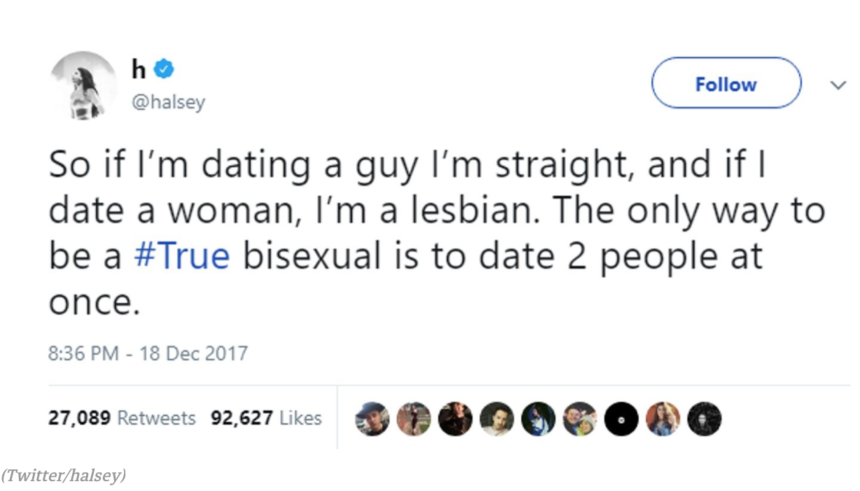

You can ***feel*** the irony. Some fans have even hailed her as the ‘Queen of bisexuality.’

Beyond the music industry, Halsey is also massively involved in social activism, including suicide prevention awareness and sexual assault advocacy.

**T is for TRANSGENDER**

Unfortunately it remains the sad case that the trans community is still hugely under-represented in the music industry, however the likes of Laura Jane Grace of Against Me! and Skylar Kergil are out their representing.

**Laura Jane Grace**

Born Thomas James Gabel, from a young age Grace experienced feelings of **gender dysphoria**, and recalled them as her “earliest memories.”

Constantly bullied at school, Grace was experimenting with alcohol and drugs at just age 13. She went on to struggle with addiction for years, and other coping mechanisms included skipping school in order to go home and cross-dress. Later described by Grace as a "binge-and-purge cycle, where engaging in any behaviour giving in to dysphoria was immediately met afterwards with intense feelings of shame and self-hate."

Grace was married to visual artist Heather Hannoura between 2007 to 2014. Having dealt with gender dysphoria since a young age, Grace publicly came out as a transgender woman in 2012. Announcing plans to begin transitioning. Grace was inspired to come out after a chance meeting with a transgender Against Me! fan. (the name of her band)

In 2016 Laura Jane Grace reportedly burned her birth certificate on stage in protest of transgender discrimination in North Carolina.

**Skylar Kergil**

This queer, transgender artist has been documenting his transition from female-to-male on YouTube since early 2009. Because of Skylars passion for trans rights and education, he speaks, performs, educates, mentors, and travels sharing his stories as well as opening spaces for others to share theirs. “Life is a journey - I don't know where I am going, but I'm loving every step. Currently, I am walking around Boston.”

Outside of transgender activism, he is a singer-songwriter described by the FTMDen as having a style that is “acoustic, though some would argue ‘passionate’ better describes it.”