Creative Process

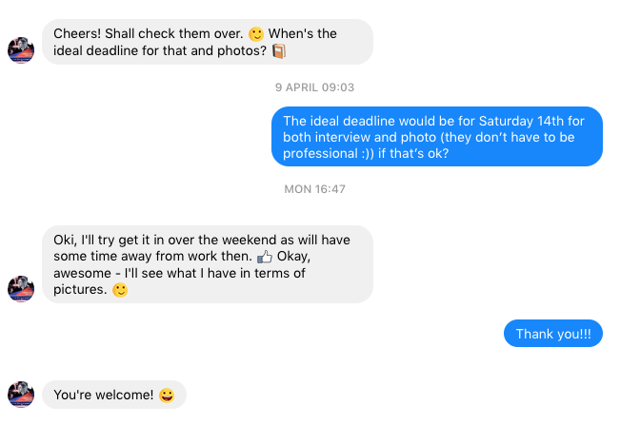

Interview with Maier G Pryne

Facebook Conversation:

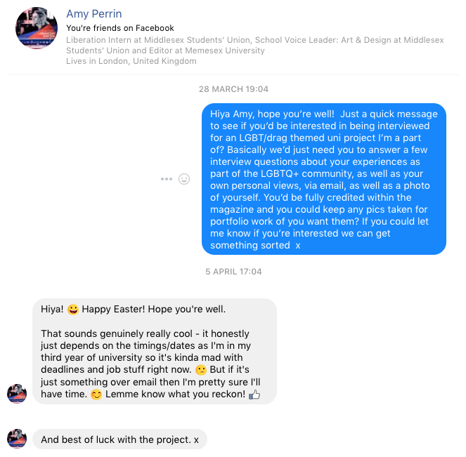

Interview Questions:

1. What are the top 5 lesbian stereotypes that could not be further from reality?
2. Do you feel that as you have gotten older, your experiences regarding lesbian stereotypes have changed?
3. Do you feel that there is not a lot of focus on lesbians in the media?
4. RuPaul’s Drag Race has shed light onto the drag industry, but it is mainly focused on queens. Do you feel that Drag Kings have yet to have their voices heard?
5. On your Facebook page, you say you are an activist. What are some of your most recent and why were they important to you?
6. In light of the Cambridge Analytica / Facebook controversy, a lot of the LGBTQ+ community are considering deleting their accounts as they feel that Facebook does not respect them. What is your view on this?
7. There is a lot of knowledge about the numerous tribes within the Gay community (otter, bear etc.). Are there any tribes within the Lesbian community and if so, why do you think they are not more well known?

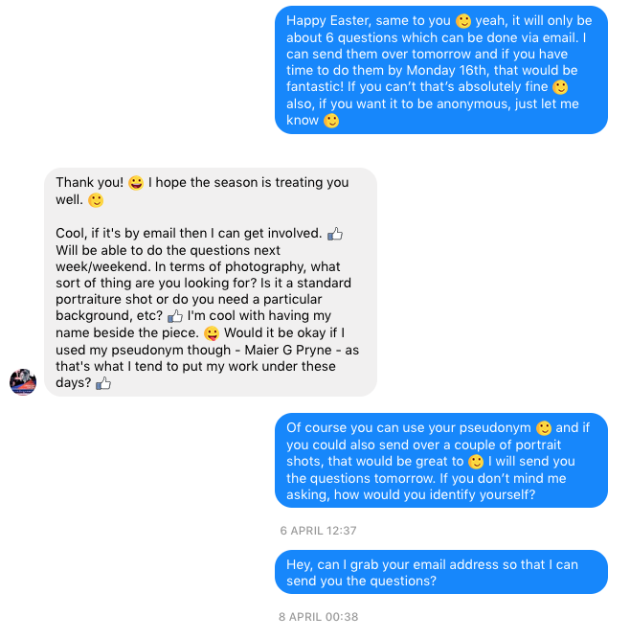

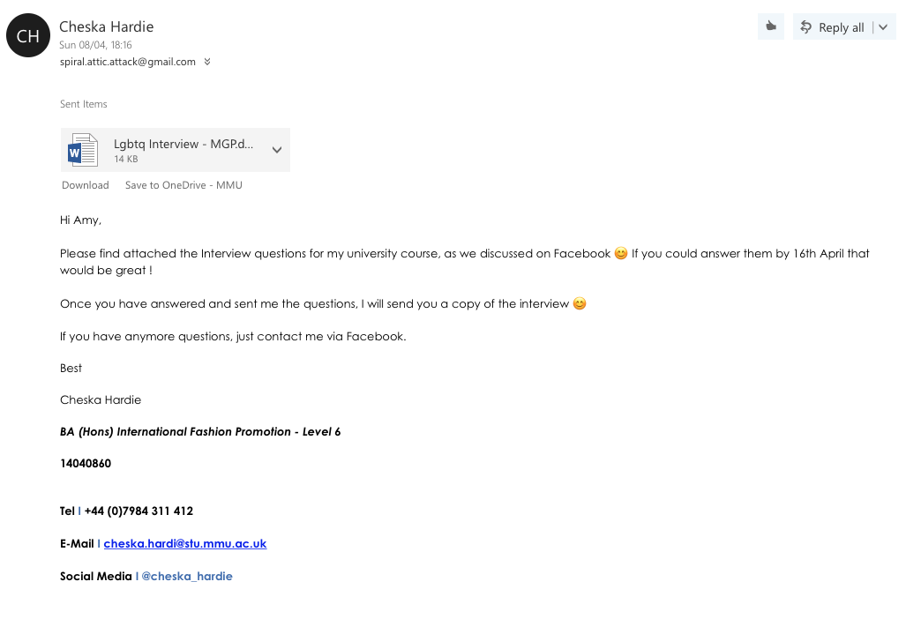E-Mail Conversation:

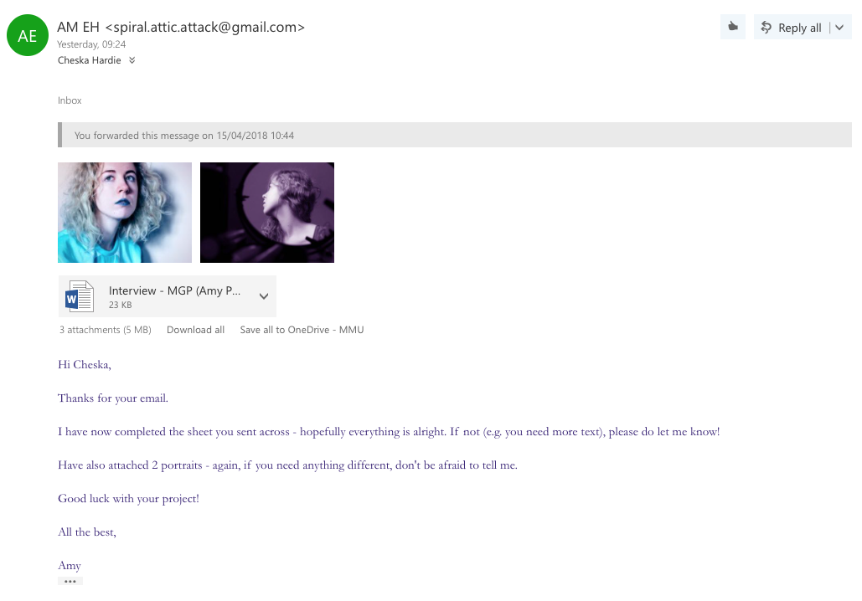

Draft:

Interview Questions: 08/04/2018

**Maier G Pryne (Amy Perrin)**

1. What are the top 5 lesbian stereotypes that could not be further from reality?

* **The Dirty Hipster:** This stereotype is probably the most contemporary, especially in the age of intersectional feminism. This one surrounds the idea that lesbians are women who never shave, wear makeup or dress glamorously presumably in protest against a historically patriarchal society.
* **The Man-hater:** The most unproductive stereotype and one that unfortunately contributes to gender division within the LGBT+ community itself.
* **The Sex-obsessed Predator:** This idea seems to have stemmed from an unfair misconception that lesbian sexuality objectifies women by default regardless of how respectful the individual is.
* **The Straight Woman Who Turns:** One of the most popular tropes used in queer media, this is a very frustrating stereotype. Though there are women who have realised later in life that they are LGBT+, frequently in film and TV the character in question will cheat on their male partner in order to trial their queries or fantasies, something which usually leaves the female counterpart in disarray as the protagonist flits back and forth. Another issue surrounding this stereotype is the erasure of bisexuality and pansexuality, as often the lead character’s sexuality is treated as binary.
* **The AWOL Couple:** Another common occurrence in lesbian-based media is unclear or unhappy endings. This doesn’t always come along in the form of a breakup but very often an open conclusion whereby a solid outcome is never provided for the characters we have been rooting for.

1. Do you feel that as you have gotten older, your experiences regarding lesbian stereotypes have changed?

In my personal experience, stereotypes have never affected the way I present myself to the world. In fact, to many I apparently come across as straight rather than a bisexual who much prefers dating girls. Despite this, I don’t feel the pressure to deliberately enforce a stereotype in order to get female attention – if I prefer to dress ‘gay’, it’s entirely down to my mood on the day! There was a time during college whereby I was being discriminated against for my sexuality, however any stereotypes unearthed focused more on the female gender as a whole. With the LGBT+ community growing stronger and earning more rights, it seems that archetypes are being vivisected more and more, something which hopefully is helping to open people’s eyes to the different types of people who identify as LGBTQIA+.

1. Do you feel that there is not a lot of focus on lesbians in the media?

Overall there seems to be a concentration on male protagonists, which doesn’t help with the awareness aspect of women – let alone women who like women. However, more queer fictional figures are creeping into pop culture – I was overjoyed to see that a campaign trying to persuade Disney to make Frozen’s ice queen the first LGBT+ royal, #GiveElsaAGirlfriend, is still going strong. On the other hand, there is some cropping and cutting going on. For example, DC’s Wonder Woman has the power to act as a priest during the marrying of a same-sex couple, a normal occurrence on her homeland island whereby the entire population is female; sadly this cannon fact was never mentioned in the recent film, even during a scene in which Diana discusses the concept of marriage with a male love interest. Another negative aspect is the use of lesbians for the benefit of the male gaze, which tends to only portray the sensual side of same-sex relationships rather than emotional.

1. RuPaul’s Drag Race has shed light onto the drag industry, but it is mainly focused on queens. Do you feel that Drag Kings have yet to have their voices heard?

Unfortunately I’m not up-to-date with the last few seasons yet but so far there hasn’t been a massive amount of Drag King presence. This may be because it is a lesser-known sector of Drag culture but RuPaul’s excellent show would be a fantastic way to encourage new talent thus we have to hope for more exposure in future!

1. On your Facebook page, you say you are an activist. What are some of your most recent and why were they important to you?

Part of my creative practice is about exploring different methods in order to combine art and activism. I started out my career as an acrylic painter who did charity volunteering on the side but it wasn’t until university that I was given the chance to fuse both passions together. Because I come from Surrey, it was hard to break the small-town mentality as a teenager so when I moved to England’s capital I jumped on every campaign-based opportunity available! I know that not everyone is politically driven, which is not a problem, but personally the feeling of putting in work towards the greater good makes me smile. Currently I am organising an event with Middlesex Students’ Union, called The Liberation Station, which focuses on celebrating the achievements of minority groups on-campus at MDX. Since London is such a multicultural hotpot, it’s crucial that everyone feels represented.

1. In light of the Cambridge Analytica / Facebook controversy, a lot of the LGBTQ+ community are considering deleting their accounts as they feel that Facebook does not respect them. What is your view on this?

It’s definitely understandable why people would contemplate deleting their accounts if they no longer sense that their personal data is safe. In the age of the internet it’s difficult to know how much to give away, especially since a platform such as Facebook does provide various privacy settings – of which should always be abided by. Fingers crossed the wave of many threatening to leave such a renowned site will be a wakeup call to other social media companies who’s products have loopholes.

1. There is a lot of knowledge about the numerous tribes within the Gay community (otter, bear etc.). Are there any tribes within the Lesbian community and if so, why do you think they are not more well known?

There are known types of LGBT+ woman – femme, butch, stud, androgynous (etc) – but this appears more akin to the individual’s style as opposed to an invitation to a certain group. To be honest, I’m no expert when it comes to this sort of knowledge – genuinely, I can tell you more about Native American tribes than queer tribes – but this may be due to never feeling specific enough to fit into one; I basically do my own thing and perhaps a lot of other LGBT+ women are similar. Despite that, I reckon the female LGBT+ community is accepting of all kinds of people, which is one of the reasons I do feel one of the community’s favourite words: pride.

Editor’s Notes:

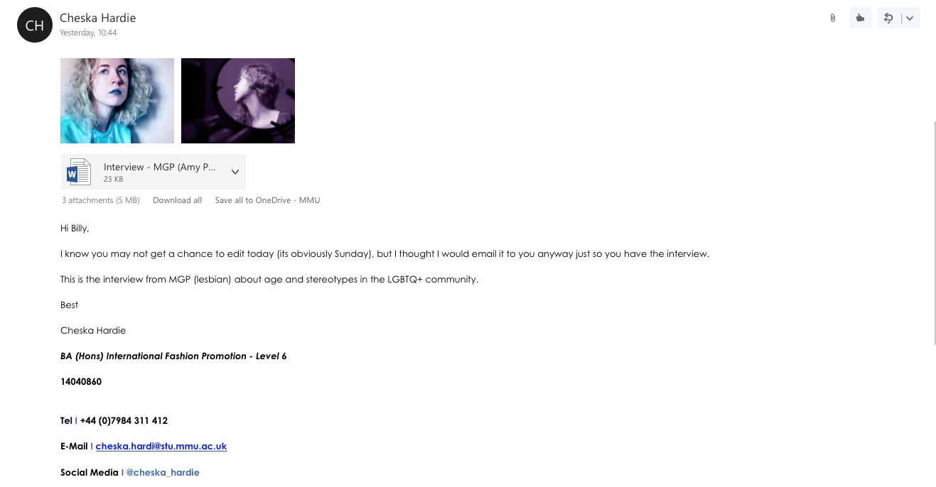

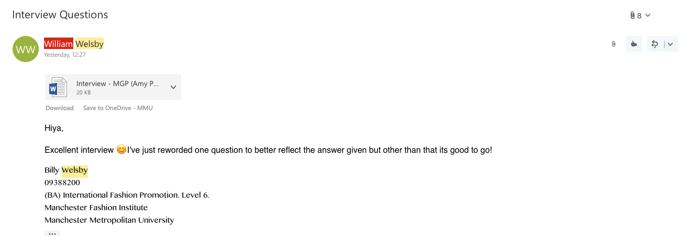

*(for the edits, please see Billy Welsby Creative Process)*

Final Interview:

Lesbians: Going Beyond The Quibbles

By Cheska Hardie

08/04/2018

Identifying as a lesbian, cis-gender women, Maier G Pyrne is an artist, writer, campaigner and photographer. Having grown up in the countryside, it was her move to London that cemented her confidence to discuss personal observations on a variety of contemporary topics. These conversations slowly infiltrated Pyrne’s main discourse and as a result, her artistic experiments and projects have a decidedly more political tone to them.

X,Y,Z. magazine journalist Cheska Hardie sits down with Ms. Pyrne to talk stereotypes, activism and the Cambridge Analytica scandal.

1. **What are the top 5 lesbian stereotypes that could not be further from reality?**

**The Dirty Hipster:** This stereotype is probably the most contemporary, especially in the age of intersectional feminism. This one surrounds the idea that lesbians are women who never shave, wear makeup or dress glamorously presumably in protest against a historically patriarchal society.

**The Man-hater:** The most unproductive stereotype and one that unfortunately contributes to gender division within the LGBT+ community itself.

**The Sex-obsessed Predator:** This idea seems to have stemmed from an unfair misconception that lesbian sexuality objectifies women by default regardless of how respectful the individual is.

**The Straight Woman Who Turns:** One of the most popular tropes used in queer media, this is a very frustrating stereotype. Though there are women who have realised later in life that they are LGBT+, frequently in film and TV the character in question will cheat on their male partner in order to trial their queries or fantasies, something which usually leaves the female counterpart in disarray as the protagonist flits back and forth. Another issue surrounding this stereotype is the erasure of bisexuality and pansexuality, as often the lead character’s sexuality is treated as binary.

**The AWOL Couple:** Another common occurrence in lesbian-based media is unclear or unhappy endings. This doesn’t always come along in the form of a breakup but very often an open conclusion whereby a solid outcome is never provided for the characters we have been rooting for.

1. **Do you feel that as you have gotten older, your experiences regarding lesbian stereotypes have changed?**

In my personal experience, stereotypes have never affected the way I present myself to the world. In fact, to many I apparently come across as straight rather than a bisexual who much prefers dating girls. Despite this, I don’t feel the pressure to deliberately enforce a stereotype in order to get female attention – if I prefer to dress ‘gay’, it’s entirely down to my mood on the day! There was a time during college whereby I was being discriminated against for my sexuality, however any stereotypes unearthed focused more on the female gender as a whole. With the LGBT+ community growing stronger and earning more rights, it seems that archetypes are being vivisected more and more, something which hopefully is helping to open people’s eyes to the different types of people who identify as LGBTQIA+.

1. **Do you feel that there is not a lot of focus on lesbians in the media?**

Overall there seems to be a concentration on male protagonists, which doesn’t help with the awareness aspect of women – let alone women who like women. However, more queer fictional figures are creeping into pop culture – I was overjoyed to see that a campaign trying to persuade Disney to make Frozen’s ice queen the first LGBT+ royal, #GiveElsaAGirlfriend, is still going strong. On the other hand, there is some cropping and cutting going on. For example, DC’s Wonder Woman has the power to act as a priest during the marrying of a same-sex couple, a normal occurrence on her homeland island whereby the entire population is female; sadly, this cannon fact was never mentioned in the recent film, even during a scene in which Diana discusses the concept of marriage with a male love interest. Another negative aspect is the use of lesbians for the benefit of the male gaze, which tends to only portray the sensual side of same-sex relationships rather than emotional.

1. **RuPaul’s Drag Race has shed light onto the drag industry, but it is mainly focused on queens. Do you feel that Drag Kings have yet to have their voices heard?**

Unfortunately, I’m not up-to-date with the last few seasons yet but so far there hasn’t been a massive amount of Drag King presence. This may be because it is a lesser-known sector of Drag culture but RuPaul’s excellent show would be a fantastic way to encourage new talent thus we have to hope for more exposure in future!

*For more info on the visibility of Drag Kings, see our current article on page…*

1. **On your Facebook page, you say you are an activist. Could you give us some insight into some of your most recent political activism and why the issues you protest are important to you?**

Part of my creative practice is about exploring different methods in order to combine art and activism. I started out my career as an acrylic painter who did charity volunteering on the side but it wasn’t until university that I was given the chance to fuse both passions together. Because I come from Surrey, it was hard to break the small-town mentality as a teenager so when I moved to England’s capital I jumped on every campaign-based opportunity available! I know that not everyone is politically driven, which is not a problem, but personally the feeling of putting in work towards the greater good makes me smile. Currently I am organizing an event with Middlesex Students’ Union, called The Liberation Station, which focuses on celebrating the achievements of minority groups on-campus at MDX. Since London is such a multicultural hotpot, it’s crucial that everyone feels represented.

1. **In light of the Cambridge Analytica / Facebook controversy, a lot of the LGBTQ+ community are considering deleting their accounts as they feel that Facebook does not respect them. What is your view on this?**

It’s definitely understandable why people would contemplate deleting their accounts if they no longer sense that their personal data is safe. In the age of the internet it’s difficult to know how much to give away, especially since a platform such as Facebook does provide various privacy settings – of which should always be abided by. Fingers crossed the wave of many threatening to leave such a renowned site will be a wakeup call to other social media companies whose products have loopholes.

1. **There is a lot of knowledge about the numerous tribes within the Gay community (otter, bear etc.). Are there any tribes within the Lesbian community and if so, why do you think they are not more well-known?**

There are known types of LGBT+ woman – femme, butch, stud, androgynous (etc.) – but this appears more akin to the individual’s style as opposed to an invitation to a certain group. To be honest, I’m no expert when it comes to this sort of knowledge – genuinely, I can tell you more about Native American tribes than queer tribes – but this may be due to never feeling specific enough to fit into one; I basically do my own thing and perhaps a lot of other LGBT+ women are similar. Despite that, I reckon the female LGBT+ community is accepting of all kinds of people, which is one of the reasons I do feel one of the community’s favourite words: pride.

*For more information on Maeir G Pyrne and her work, follow her on social media:*

*Twitter: @MaeirGPyrne*

*Facebook: @maeirgpyrneofficial*