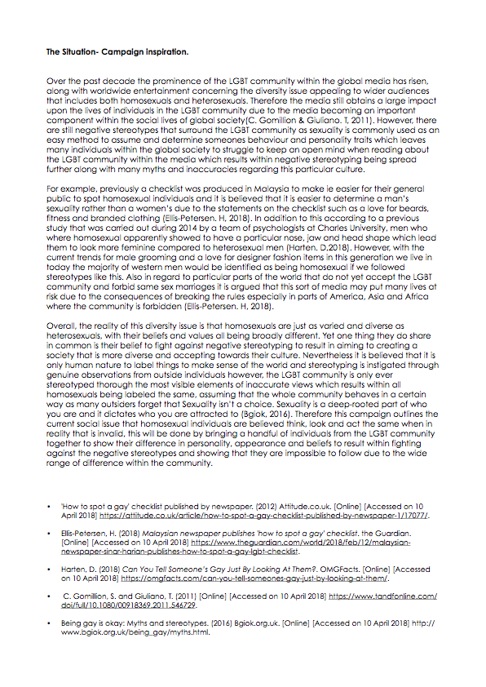

BEFORE BEING EDITED BY BILLY

AFTER BEING EDITED BY BILLY

**Ageism within the LGBT community.**

When looking back at LGBTQ+ visibility one of the most shocking things that can be seen is that homosexuality was listed and recognised as a pathological disorder and studied as a mental disorder. This miseducation is often used as a reason as to why LGBTQ+ men and women were not accepted to the extent they are in todays society meaning what we see as human nature today was a criminal offence for decades.

However, since the legalisation in 1967  the LGBTQ+ community has experienced rapid societal changes all over the world with many countries now accepting gay marriage and celebrate the LGBTQ+ community. This new freedom has seen research carried out into the dynamics of homosexual relationships. In a study carried out in the UK, USA, Sweden, France and Netherlands it was found that gay relationships were more likely to have an age gap of 10+ years in co parison to heterosexual relationships and that gay people were more willing to date someone with an age gap in order to further break barriers.

However, due to social stigmas that are still recognised within todays generation, the majority of the older generation of the LGBT community had or still conceal their sexual orientation or gender identity throughout their life which causes great struggle for an older LGBTQ+ individual to reveal their sexuality in consequence from still remembering the hatred, discrimination and the abuse that occurred for being gay in the previous era. In addition to this, many believe that homosexuals are seen as more attractive when young even though the older generation of gays fought for the rights we have today. For example many mainstream subcultures often conflate beauty and self worth with youth and appearance which leaves many individuals feeling unattractive and insecure as they age. With research showing that LGBT communities are yet to make room for the older generation of homosexuals, proving that ageism is an unspoken issue within the community.

*Does this mean the LGBT community lacks a positive and fuller representation of the older generation?*

The truth is that LGBT elders obtain a smaller support network and are at greater risk of social isolation which may affect their lives in many more ways compared to the younger generation. With ageism being a problem within the LGBTQ+ community that isn’t discussed enough for example, many older members of the community are becoming concerned about being placed into a care home that isn’t LGBTQ+ friendly with evidence stating that members of the community have had to go “back into their closet” to be eligible to receive appropriate support and to be admitted to this service. This of course seems ridiculous considering the amount of abuse they have faced over the years to gain the freedom for others which they cannot enjoy themselves, yet many younger members of the LGBTQ+ community remain unaware of the struggle the older generation face within their day to day lives.

Therefore to contribute to this article and explore this matter further we at X,Y,Z asked a handful of homosexual millennial’s set questions to gather their opinions regarding ageism within the LGBTQ+ community, below is a video so summarise our findings.