Social Media Calendar

17th April: 3 Days before Launch



COPY FROM BILLY- WE’RE TALKING STEROTYPES, SAFEPLACES AND BREAKING DOWN BARRIERS. READ OUR EXCLUSIVE INTERVIEW WITH INTERNATIONAL FASHION PROMOTION STUDENT AND LGBTQ+ EXHIBITION CURATOR, KIERAN GOWAN CLARKE. JOIN IN THE CONVERSATION ON 20TH APRIL…

18th April: 2 Days before Launch

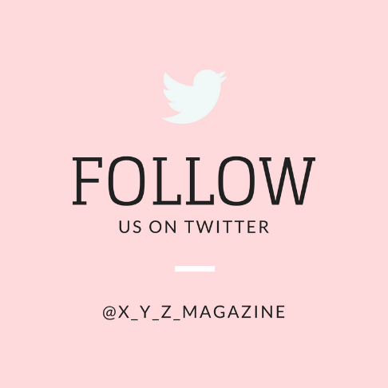

19th April: 1 Day before Launch

COPY FROM BILLY- YOU ALREADY FOLLOW US ON INSTAGRAM SO WHY NOT ON TWITTER? WE’RE NOW LIVE ACROSS ALL SOCIAL MEDIA PLATFORMS (EXCEPT SNAPCHAT BECAUSE WE DON’T SUPPORT THAT MESS) SO GOVE US A FOLLOW AND HELP US CONTINUE THE CONVERSATION (PEACE FINGERS EMOJI)

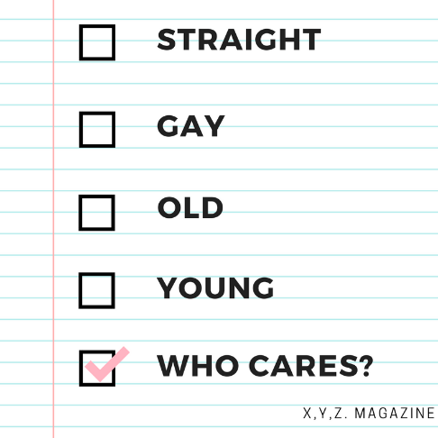

COPY FROM BILLY- WE LOVE BEING ABLE TO TICK STUFF OF OFF A LIST! XYZ LAUNCHES TOMORROW! JOIN US OVER AT XYZ.COM FOR OUR FIRST ARTICLES, INTERVIEWS AND CAMPAIGN VIDEO… ITS GOING TO BE UNMISSABLE!

20th April: Launch Date

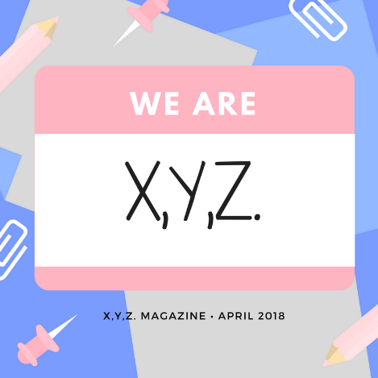

COPY FROM BILLY- WE’RE HERE, WE’RE QUEER (WELL SOME OF US ARE) AND WEVE GOT SOMETHING TO SAY! XYZ.COM IS NOW LIVE AND WE WANT TO HEAR YOUR THOUGHTS, OPINIONS AND GENERAL FEEDBACK. WHAT DO YOU LIKE? WHAT DO YOU WANT TO SEE? DO YOU HAVE SOMETHING TO SAY? ALL ARE WELCOME AT XYZ AND WE MEAN **ALL.** SO FOLLOW THE LINK IN THE BIO AND FOLLOW US ON TWITTER TO JOIN IN THE CONVERSATION!