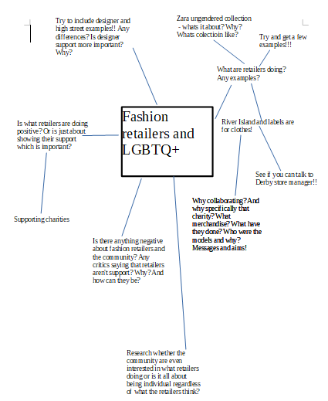
Draft

Fashion retailers and LGBTQ+

Retailers are progressively making improvements to engage, represent and support diverse communities.

River Island, a high street fashion brand, celebrated it's 30th year anniversary with a new campaign which featured the international anti-bullying charity; 'Ditch the Labels'.
The diverse range of models included; Stav Strashko, who was born male declaring that she is ''100 per cent women' and couple Charlie and Bella
The campaign sought out to raise awareness of irrelevant labels given to individuals regarding race, sexual orientation and religion and to celebrate individuality. The campaign encourages people to be who they want to be and encourage others to be accepting without identifying with labels.
To reiterate the purpose and message behind the campaign, the brand produced gender-free merchandise that would be sold in all stores for consumers to purchase where £3 of each garment purchased would go to the charity. Merchandise sold included the hashtag '#labelsareforclothes' and slogans such as 'cool vibes only, genuine aesthetic' and 'best kept glam, handles own business' each featuring care labels.
Derby store manager, Jordon Chalmers, states; 'I think it's amazing that River Island are standing by equality and encouraging it's customers to express themselves and be who they want to be. River Island is a huge retailer so it's really important that they're following and supporting social movement. All the merchandise we had in store has sold out and it's so positive to see that the Derby customer is supporting the charity'.

In 2017 ASOS, an online fashion store announced its collaboration with GLAAD. GLAAD (Gay and Lesbian Alliance Against Defamation) is a company which shapes the media narrative by tackling issues to provoke dialogue that leads to cultural change and accelerates acceptance for the LGBTQ+ community. The collection included eight gender neutral pieces embellished with the ampersand (&) character = the symbol of unity and acceptance.

Furthermore, two years ago, Zara, a trend-lead fashion retailer, released an 'un-gendered' range made up of gender-free basics including t-shirts, sweatshirts, denim and tracksuit bottoms. The inspiration behind the range is to break down the idea that there's solely two genders and to embrace equality and individuality.
Despite the positive message behind the range, critics have stated that in fact, the word 'un-gendered' is an additional word for 'uni-sex' and therefore the range has little to do with gender identity. Brands like American Apparel have been selling unisex clothing for years which had little impact on the social movement of gender identity.

Although the reasoning’s behind gender-neutral collections are taking a step in right direction for the representation of equality, the designed collections still remain misogynistic.
Majority of the collections available feature baggy t-shirts, loose fitted hoodies and jeans all in neutral colours. What brands are missing out on is the celebration of femininity. Females currently, and have done for a while, adopt masculine styles. However, males boundaries aren't being pushed and are repeatedly kept safe with hoodies and t-shirts which have the association of men.

Despite retailers being progressive, brands need to further understand that gender-neutral clothing is not solely t-shirt and hoodies and in fact includes both male and female associated garments for it to be seen as gender-neutral rather than just unisex.

Emailed for editing

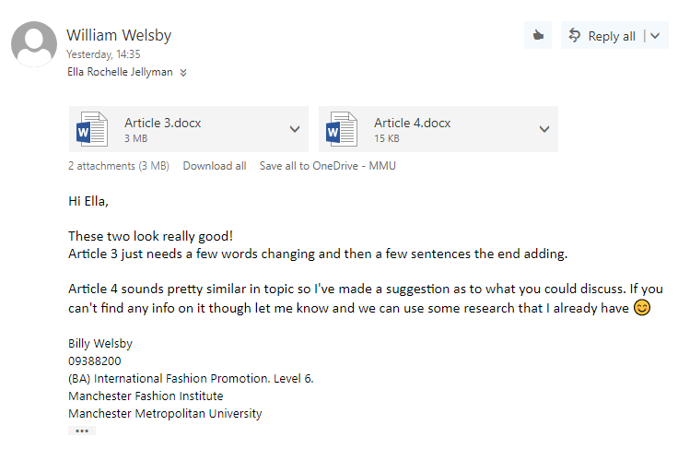
Final

Fashion retailers and LGBTQ+

Retailers are progressively making improvements to engage, represent and support diverse communities.

River Island, a high street fashion brand, celebrated it's 30th year anniversary with a new campaign which featured the international anti-bullying charity; 'Ditch the Labels'.
The diverse range of models included; Stav Strashko, who was assigned male at birth, declaring that she is ''100 per cent women' and lesbian couple Charlie and Bella who are in a committed relationship.
The campaign sought out to raise awareness of irrelevant labels given to individuals regarding race, sexual orientation and religion and to celebrate individuality. The campaign encourages people to be who they want to be and encourage others to be accepting without identifying with labels.
To reiterate the purpose and message behind the campaign, the brand produced gender-free merchandise that would be sold in all stores for consumers to purchase where £3 of each garment purchased would go to the charity. Merchandise sold included the hashtag '#labelsareforclothes' and slogans such as 'cool vibes only, genuine aesthetic' and 'best kept glam, handles own business' each featuring care labels.
Derby store manager, Jordon Chalmers, states; 'I think it's amazing that River Island are standing by equality and encouraging it's customers to express themselves and be who they want to be. River Island is a huge retailer so it's really important that they're following and supporting social movement. All the merchandise we had in store has sold out and it's so positive to see that the Derby customer is supporting the charity'.

Similarly, in 2017 ASOS, announced its collaboration with GLAAD. GLAAD (Gay and Lesbian Alliance Against Defamation) is an organisation which shapes the media narrative by tackling issues to provoke dialogue that leads to cultural change and accelerates acceptance for the LGBTQ+ community. The collection included eight gender neutral pieces embellished with the ampersand (&) character = the symbol of unity and acceptance.

Furthermore, two years ago, Zara, a trend-lead fashion retailer, released an 'un-gendered' range made up of gender-free basics including t-shirts, sweatshirts, denim and tracksuit bottoms. The inspiration behind the range is to break down the idea that there's solely two genders and to embrace equality and individuality.
Despite the positive message behind the range, critics have stated that in fact, the word 'un-gendered' is an additional word for 'uni-sex' and therefore the range has little to do with gender identity. Brands like American Apparel have been selling unisex clothing for years which had little impact on the social movement of gender identity.

Although the reasoning’s behind gender-neutral collections are taking a step in right direction for the representation of equality, the designed collections still remain misogynistic.
The majority of the collections available feature baggy t-shirts, loose fitted hoodies and jeans all in neutral colours. What brands are missing out on is the celebration of femininity. Females currently, and have done for a while, adopt masculine styles. However, males boundaries aren't being pushed and are repeatedly kept safe with hoodies and t-shirts which have the association of men.

Despite retailers showing that they want to be progressive, brands need to further understand that gender-neutral clothing is not solely t-shirt and hoodies and in fact includes both male and female associated garments for it to be seen as gender-neutral rather than just unisex.
This can be achieved by brands further understanding both typical female and male associated garments and colours. Brands need to steer away from neutral coloured collections and included bright colours and patterns that are typically seen as 'female' or 'male' to truly produce a gender neutral collection.

References

"ASOS x glaad" retail collab launches for the Together Movement. (2018) GLAAD. [Online] [Accessed on 18 April 2018] https://www.glaad.org/blog/glaad-launches-retail-line-asos-support-togethermovement.
Generation Gender Neutral. (2018) Vogue.co.uk. [Online] [Accessed on 18 April 2018] http://www.vogue.co.uk/article/suzy-menkes-generation-gender-neutral.
GLAAD. (2018) GLAAD. [Online] [Accessed on 18 April 2018] https://www.glaad.org/.
Just how progressive is Zara’s new ‘ungendered’ range?. (2018) Dazed. [Online] [Accessed on 18 April 2018] http://www.dazeddigital.com/fashion/article/30256/1/just-how-progressive-is-zara-s-new-ungendered-range.
Labels for Clothes | River Island. (2018) River Island. [Online] [Accessed on 18 April 2018] https://www.riverisland.com/c/labels-for-clothes.
Moran, G., Kat Spybey and Sholl, A. (2018) Genderless fashion: a fad or the future?. Drapers. [Online] [Accessed on 18 April 2018] https://www.drapersonline.com/product-and-trade-shows/genderless-fashion-a-fad-or-the-future/7006302.article.
Piece, G. (2018) Comment: It's time for retailers to show their LGBT-inclusive credentials with pride - Retail Gazette. Retail Gazette. [Online] [Accessed on 18 April 2018] https://www.retailgazette.co.uk/blog/2016/07/comment-its-time-for-retailers-to-show-their-lgbt-inclusive-credentials-with-pride/.
Stevens, B. (2018) Retail Gazette Loves: River Island “Labels are for Clothes” campaign. Retail Gazette. [Online] [Accessed on 18 April 2018] https://www.retailgazette.co.uk/blog/2018/02/retail-gazette-loves-river-island-labels-clothes-campaign/.
UK retailers not LGBT friendly. (2018) Fashionunited.uk. [Online] [Accessed on 18 April 2018] https://fashionunited.uk/news/retail/uk-retailers-not-lgbt-friendly/2016071921121.
Young, S. (2018) River Island's new anti-bullying campaign celebrates diversity. The Independent. [Online] [Accessed on 18 April 2018] https://www.independent.co.uk/life-style/fashion/river-island-anti-bullying-campaign-30th-birthday-labels-are-for-clothes-stav-strashko-a8200336.html.

Derby store manager, Jordon Chalmers, states; 'I think it's amazing that River Island are standing by equality and encouraging it's customers to express themselves and be who they want to be. River Island is a huge retailer so it's really important that they're following and supporting social movement. All the merchandise we had in store has sold out and it's so positive to see that the Derby customer is supporting the charity'.



