Marketing Plan

Research:

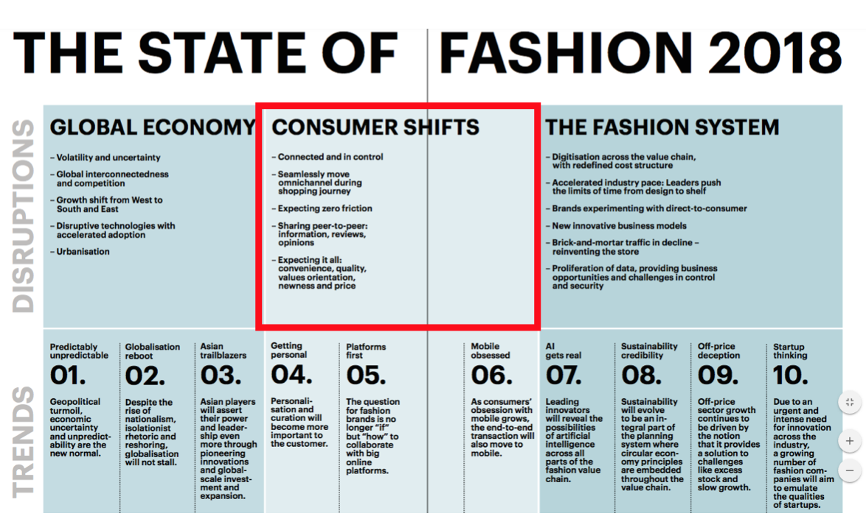
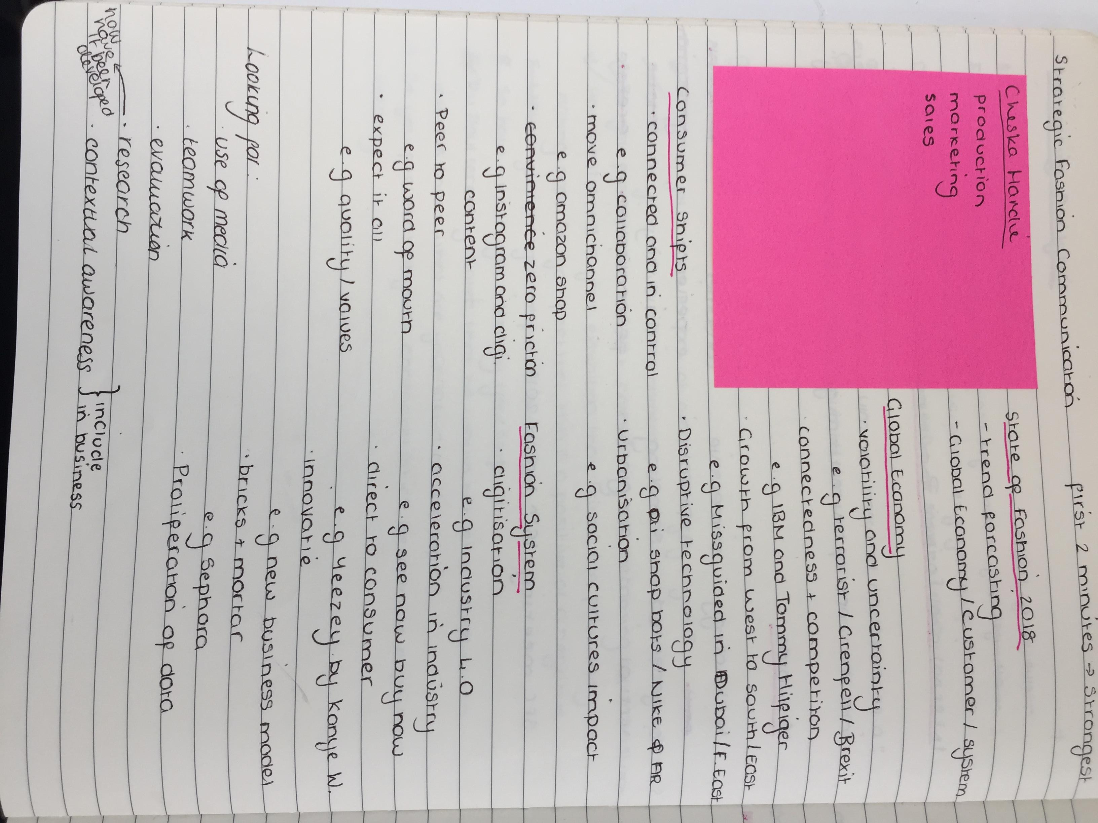
https://www.mckinsey.de/files/state_of_fashion_2018_final_online.pdf

I decided to first look at the current customer trends of 2018, as the most important part of the marketing plan is obviously how the brand can communicate and engage with the customer

Notes from SFC Marketing Lecture

Business of Fashion: Generation Next (NOTES)
https://cdn.businessoffashion.com/reports/The_State_of_Fashion_2018_v2.pdf

STATISTICS

Gen Z & Technology – 67% own a laptop, 96% own a smart phone & 63% have a tablet.

Gen Z & Social Media – 63% of time is spent on Facebook, 66% on YouTube, 36% on Instagram & 17% on Twitter.

Gen Z & Diversity – 49% (most ethnically diverse cohort)

- Generation Next, unlike previous generations who were more likely to value traditional displays of social status through materialism, would rather have experiences, authenticity and value community.
- 769 Gen-Z/Millennials consumers in the US, aged 13-34, gave some interesting insights:
  - 74% would rather spend money on a great experience rather than luxury goods.
  - On a hotness scale of 0-4, only Chanel, Gucci, Dior and Saint Laurent scored 3.0. Burberry, Coach and Ferragamo were at the bottom of the heap.
  - 85% of respondents – “an investment I will pass down to the next generation”
  - 81% of respondents – “luxury brands are all about craftsmanship”
  - 18% of respondents – “luxury brands are a waste of money”
  - 15% of respondents – “ luxury brands are less relevant to their generation”
- Clearly some challenges for luxury and fashion brands aiming to connect with Generation Next.
- Variety of Generation Next celebrities have built long term partnerships with major global fashion brands, with the aim to connect with the numerous communities of young people.
  - Selena Gomez – 25 years old (Millennial) has connected with hundreds with authenticity and vulnerability that was previously unheard of.
  - Lily-Rose Depp – 18 years old (Generation-Z), daughter of Johnny Depp and Vanessa Paradis. The face of Chanel (looking at brands and their ambassadors)
  - Adwoa Aboah – 25 years old (Millennial) launched Gurls Talk – a community devoted to young women facing numerous mental health issues- and has drawn a following of likeminded people (speaks to Generation-Z’s pluralist / ethical side)
  - Kris Wu – 27 years old (?) is one of the world’s biggest influencer, having singing, acting and modelling under his belt. Amassed huge followers in China, along with his global endorsements.
Tapping Generation Next – by Lauren Sherman & Robb Young
- Every generation has a specific fad that defines them:
  - Nineties – slap bracelets.
  - Noughties – Pokémon.
  - Generation-Z – Sand Slime ( a DIY fad that cost next to nothing).
- According to a non-partisan think tank in Washington D.C:
  - 1980 – 1996 : Millennials
  - 1997 – 2010 : Generation Z
- Millennials and Generation-Z combined represent a powerful force for consumer culture.
- Millennials + Post-Millennials + Generation-Z = Generation Next
  - Expected to account for 45% of the global market for personal luxury goods by 2025 (Bain & Company).
- Due to Generation Next having grown up during numerous recessions, a sense of financial instability in still at the forefront of their minds.
- Some believe that a priority shift , not just macro-environment trends, is part of the reason why young people can’t afford to buy a home.
- Generation Next are also digital natives, which means that they are more likely to look up make-up tutorial of YouTube stars.
- Generation-Z prefers advertising that is funny, has good music and a narrative, meaning that they’re a group that are “highly discriminating” and “more averse” to advertising – Kantar Milward Brown (market research firm).
- Generation-Z also prefer to spend money on experiences, rather than possessions.
- This does not bode well for the fashion-industry, which profits from the conspicuous consumption of expensive goods in a world where displaying social status is becoming more about the accumulation of (Instagrammable) experiences and less about the accumulation of objects.
- According to data taken in July 2017, a survey of 769 mainly female consumers aged 13-34, conducted by Galore (LA Marketing Agency) in partnership with The Business of Fashion.
  - 74% - would rather spend their income on experiences rather than luxury goods.
  - 54% - consider owning a luxury brand a marker of success.
  - 65% - see purchasing a luxury item as an investment that can be passed down to the next generation.
  - Chanel // Saint Laurent // Dior // Gucci – earned top ratings in regards to brands that resonate most with Generation-Z.
  - Balenciaga // Balmain // Prada // Hermes – registered average ratings.
  - Ferragamo // Coach – underperformed.
  - Of all the brands surveyed, Hermes actually scored higher with Millennials, while Dior scored higher with Generation-Z.
- REMEMBER – look at the Generation-Z // Millennials in China, a country that offers major opportunities for luxury brands.
  - The Millennial and Gen-Z concepts in China might not translate to those of the West.
  - Gen-Z and Millennials are the equivalent to China’s post-80s / 90s generation.
  - Furthermore, due to the rapid socio-economic progress bought about by reform policies over the last 30 years, along with china’s ‘One Child’ policy, has given rise to the ‘Little Emperor Syndrome’ – only children are the beneficiaries of money and attention from their parents and elders.
  - China’s youth have experiences, mind-sets and patterns of behaviour that are very different to those of the West, particularly finance.
    - Not typically saddled with student loans.
    - Few have high rent / mortgage – due to being subsidised by family or already own homes.
  - ‘80s – more willing to pay to pay premium for original and unique brands, as they see it as essential to their identity.
  - ‘90s – lesser level of brand loyalty and not so committed to buying luxury for status quo.
- The Front Row – In the digital age, the front row of a fashion show is about image.

Where there is youth, there is fashion; The Post-War 50s had its noir-clad Left bank existentialists / Teddy Boys and Girls, The Sixties had its mini-skirts and Mods, the Protest-era 70s had glam sequins and punky leather, The 80s had fluro leggings and club kids and the 90s had logomania and grunge.

The blender effect came at the beginning of the 21st century, when everything was combined with a digital vigour. Ted Polhemus described it as the “Supermarket of Style”, wherein every world and era is on a shelf, ‘like a tin of soup on a supermarket shelf’.

There is no look for Generation Next, as it has been born into a generation, which is fragmented, with no dominant aesthetics. It’s post-truth and post-ugly. – Lulu Kennedy, Fashion East.

In Selfridges’ [third floor] is where the youth-favoured labels are place [contemporary Fashion]. Bella Hadid’s ‘Millenial edit’ is a corner of the store with a large emphasis on swift-selling, streetwear-inflected brands, such as Ventements / Off-White / Palm Angels / Unravel and Heron Preston.

“When you buy Gosha Rubchinskiy and Off-White, it is a way of connecting with a community of other like-minded people who like the same music, hang out in the same places and watch the same films” – Stavros Karelis, Machine A

“Sexuality, gender or even geography doesn’t apply – they could be anywhere in the world. When I was younger, we were wearing things to belong to a very small community, but now they’re much bigger.” - Stavros Karelis, Machine A

There is certainly a sense of community at the core of most streetwear brand, such as Gosha Rubchinskiy but there is also the rise of social-media irony of some pieces of merchandise, not unlike internet memes, for some brands , sold by brands such as Vetements.

“Designers know that if people are consuming their clothes primarily on a small screen, then you want something that’s going to grab the eye on a small screen and get people to respond to that,” – Dr Valerie Steele, F.I.T

“It’s things like big logos, bright colours and patterns; it’s things that you’re seeing from the front, there’s a certain flattening effect to what you’re putting out there because you know it’s important to see it on that little handheld screen.” – Dr Valerie Steele, F.I.T
(Continue later – the aesthetic blender)

On the opposite side of the floor [Selfridges third floor] are designers such as Art School // Area NYC // Dilara Findikoglu and Matty Bovan. These labels share high-spirited, fantasticality and colourfully gender neutral in sentiment, heavey on narrative and escapist in spirit. All of these attributes appeal to Generation-Z’s pluralist nature.

In between the ‘Millennial Edit’ and ‘Generation-Z Pluralist’ are a handful of labels that embue individuality, speciality and sometime seperatists. Having been delt the worst hand, economically, means that these brand appeal to the activist side of Generation-Z.

“This is the most politically engaged younger generation of designers we’ve seen for decades, with a conscience and quite a lot of anger and despair at the world around them, as well as frustration at a corporate system which has ceased to offer this generation the opportunities which were dangled in form of them when they went for expensive education. For the first time since the 80s, young designers care more about their meaning and message that is shown in their clothing” – Sarah Mower, BFC Ambassador for Emerging Talent

Framework:

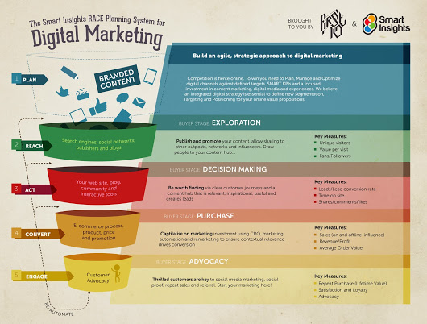

Created by Dave Chaffey, the framework helps digital marketers to manage and plan activities and content for a digital marketing plan. It also gives a framework to help small businesses’ take advantage of the opportunities that have been made available from the rise of digital marketing. https://www.smartinsights.com/digital-marketing-strategy/race-a-practical-framework-to-improve-your-digital-marketing/

Initial research:

Meeting w/ The Team 23rd February:
- Research consumers and different marketing plans.
- Look at Generation Z as a consumer.
- Look at the magazine market in the UK as well as Teens.

Target Consumer

Broadly defined as being born after 1996, Generation Z is the latest demographic to make an appearance (Weller, 2017). Unlike their predecessors, Gen Z are less likely to be found partying the night away and more likely to be striving towards joining the workforce as soon as possible (Kane, 2017). This demographic has frequently been compared to teens from years pat, such the Baby Boomer and Generation X era (Mander, 2017).

A globally aware and informed generation, it is important for businesses to understand that social causes play a large part in Generation Z’s life (MullenLowe, 2015) and this has a knock on effect to their spending habits and loyalty (Gough, 2017). Having grown up being constantly reminded that the world is not perfect has led Generation Z to adopt a more realistic approach to life (insert reference), leading to the need to have financial stability and making them more aware what they spend their money on (insert reference).

UK Magazine market

Despite an increase in magazine launches and publications since 2016 (Hennessy, 2017), it is predicted that the UK magazine market will fall by 5% (pwc.com, n/d). However, certain sectors will far better than other, such as special-interest titles while women’s weekly titles will suffer (Carey, 2017).

Furthermore, despite the digitization of the magazine market, the penetration of digital prints still remains low (2%) , despite a rise in interest from Generation Z (Bearne, 2015). However, in the six months leading up to June 2017, digital magazine circulation grew to 19% suggesting that digital magazines are the way forward (Trachtenberg, 2017).

Mini Case Study: GLAMOUR Magazine

Following the November 2017 publication, GLAMOUR revealed that print magazines would only be released for S/S and A/W (Goldbart, 2017), as part of their new digital strategy.

https://www.campaignlive.co.uk/article/2017-year-resurgence-magazines/1420697

https://www.pwc.com/gx/en/entertainment-media/pdf/newspapers-and-magazines-outlook-article.pdf

https://www.journalism.co.uk/news-commentary/the-magazine-market-isn-t-dead-it-s-different/s6/a698229/

https://www.campaignlive.co.uk/article/forget-millennials-brands-need-win-generation-z/1348169

https://www.wsj.com/articles/for-time-inc-s-magazines-fewer-copies-is-the-way-forward-1507667214

https://www.printweek.com/print-week/news/1162478/glamour-magazine-to-focus-online

Teen Magazine Market

The Teen Magazine Market is very sparse, with Teen Vogue and Seventeen being the only magazines that are in circulations (Ilyashov, 2016). Despite a plethora of teen magazines in the late 90’s / early 00’s, they have slowly disappeared, thanks to the recession (Wills, 2014).
The questions is, do teens want or even need print magazines or are they ok with digital magazines (McIntosh, 2017). Research suggests that Generation Z prefer digital magazines, with 37% of readership being allocated to digital magazines (Lurilli, 2017). Therefore, it is suggested that diversification within a magazine is one way of increasing circulation etc. (Harvey, 2017), as it resonates with Generation Z, who have the biggest purchasing power (insert reference).

One of the biggest trends at the moment is the diversification of publications and whether a market will be available for gendered magazines in the future (Rossi, 2017). Numerous magazine editors agree that diversity of opinions will benefit any magazine publication (Kay, 2017).

https://www.refinery29.com/2016/08/119065/teen-magazines-nostalgia-seventeen-ym?bucketed=true&bucketing_referrer=https%3A%2F%2Fwww.google.com%2F

https://www.independent.co.uk/news/media/press/teenage-flicks-the-end-of-an-era-for-girls-teen-magazines-9481538.html

http://wainscotmedia.com/blog/young-people-still-read-print-magazines

http://www.bbc.co.uk/news/entertainment-arts-40897967

http://www.pubexec.com/article/adv-circ-dwindling-diversification-continued-imperative-mag-industry/

https://www.theguardian.com/media-network/2017/jan/30/reinvention-publishing-media-firms-diversify-survive

https://www.theguardian.com/fashion/2017/jul/08/does-fashion-industry-need-vogue-in-instagram-age

Generation Z Magazine Market

Connected, digitally intelligent and skeptical, Generation Z is the latest demographic to make waves in the magazine industry (Golob, 2017). However, this has led to them having a short attention span, something that hinders the print magazine market (Mickiewicz, Buchanan & Stott, 2016). The ‘8-second’ attention span means that Gen Z consumers are less likely to purchase a print magazine, as most articles take longer than 8 seconds to read (Egan, 2016). Furthermore, they are are also very thrifty and as such are less likely to spend money on a print magazine when they can access one online for free (Segran, 2017).

However, despite the small attention span, research suggests that in terms of processing information, Generation Z are the fastest and as such means that they are capable of handling and remembering more information than previous demographics (Patel, 2017).

https://www.forbes.com/sites/deeppatel/2017/11/27/5-d%E2%80%8Bifferences-%E2%80%8Bbetween-%E2%80%8Bmarketing-%E2%80%8Bto%E2%80%8B-m%E2%80%8Billennials-v%E2%80%8Bs%E2%80%8B-%E2%80%8Bgen-z/#1780de142c9f

http://www.transformmagazine.net/articles/2017/brand-disloyalty-and-career-fluidity-gen-z-in-focus/

https://www.lsnglobal.com/tribes/article/19116/gen-viz-1

https://www.nytimes.com/2016/01/22/opinion/the-eight-second-attention-span.html

https://www.fastcompany.com/3062475/your-guide-to-generation-z-the-frugal-brand-wary-determined-anti-millen
Personalized Communication Plan

After extensive research, it has been revealed that the three things that most appeal to Generation Z are personalized content, visual content and collaborative communication. Therefore, the magazine will adopt a Personalized Visual Communication plan in order to capitalize on this research (Grider, 2017)

The aim of this marketing plan is to enable the magazine to have a 1:1 relationship with its readers, to ensure that they feel included and part of the magazine. This can be done with personalized emails, as well as allowing readers to contribute to the magazine themselves (insert reference).

https://capturehighered.com/news/designing-generation-z-captivate-todays-tech-savvy-teens/
Social Media

Social Media is the most popular form of communication and garnering information for the Generation Z demographic (Sehl, 2018). Therefore, it would be a mistake not to utilize such an imperative marketing tool (insert reference). However, the problem arises in terms of the length of the communication, as Generation Z have an 8-second attention span (Hope, 2016). Therefore, it is important that any one piece of information generated has an 8 second timer on it. In terms of videos, this is very simple, especially as YouTube have 5-second adverts at the beginning of certain videos. The hard part comes with text and other forms of traditional media.

However, why can’t communication be limited to 8-seconds? If 8-seconds I all that Generation Z have, then it would be silly to dismiss this. Therefore, in order to ensure all the needs are met, the entire advertising / marketing technique will revolve around the information being digested in 8 seconds or less.

https://blog.hootsuite.com/generation-z-statistics-social-marketers/

http://www.thedrum.com/opinion/2016/05/17/generation-generation-generation-z

Content Marketing Plan Questions
What is it that the magazine is trying to do?
What point is the magazine trying to get across?
What are the requirement for the content to be produced?
How can this be implemented?
-SEO
-Paid search marketing
-Social media marketing
-Email marketing
-Conversion rate optimization

Customer Journey Overview

Entry points
-Via Social Media & e-mail consumers can click on a link that takes them to the website.
-The website will include a subscription to the physical magazine.

Forge a path to lifetime value
-Keep consumer’s up to date via personalized emails and social media, allow them to contribute to the magazine, as well as share their opinions online.
-Allow them to download the app and subscribe.

Identify where customers might drop off (and how to bring them back)
-Retarget
-Retention
-Idea: Start with the content that might bring a potential customer back. Then, consider what information you have to target someone? Retargeted paid social display content, email, and even direct mail can be used to test what drives someone back to convert.

Incorporate key benchmarks and metrics
-Ensure that despite various parties, the goal is the same.
Ensure the map allows parties to be connected.

Online Personalization
Personalization is a way for a magazine encourage potential customers to subscribe to the magazine 9insert reference). This can be done through a variety of methods, such as personalized messages, social media posts and emails (insert reference). Personalization will also enable the magazine to cultivate a relationship with the reader, which will lea to loyalty and retention (insert reference).

FORMATIVE ASSESMENT CONCLUSION: LOOK AT DIVERSITY

Brief Meeting w/ Jennifer 2nd March:

- How to market a magazine:
  - Strategy: social // visuals // customer journey // inforgraphics
  - Looking at Diversity: look at primary research and ethical concerns BE CAREFUL)

Diversity Research

Fashion Diversity

How diversity is being used to market fashion.
At NYFW March 2017, models of colour accounted for 27.9%, an increase from the last season, with a further 30.4% being used in Fall 2017 printed ads.
Brands: Coach – 67% models of colour, Dior – 67% models of colour, D&G – 63% models of colour and Saint Laurent- three out of four models as colour.
Has the Fashion Industry Reached a Transgender Turning Point? Gregory, 2015 https://www.vogue.com/article/andreja-pejic-transgender-model
Andreja Pejic has walked for numerous luxury brands and has been modelling since she was a small child. In 2014 Pejic underwent gender-confirmation surgery to become a woman.

“society doesn’t tell you that you can be trans”- A. P
success embodies a mainstreaming (culturally and politically) of transgender identity.
“she has done what no other model has ever been able to: toe the line between male and females successfully for a long time” Gene Kogan (coordinator at DNA Model Management).

Is The Fashion World Finally Getting Diversity?
http://www.elleuk.com/fashion/longform/a37245/fashions-ever-evolving-new-diversity/

Hijab-clad Halima, 73 year old Benedetta Barzini and size 14 model Ashley Graham made headlines when they walked the runways at AW17 catwalks.

For years, due to the stereotypical skinny, mainly-white models, the fashion industry has had a backlash of criticisms, so the AW17 shows allowed the fashion industry to present a refreshing counterpoint to this view. This is the same with the magazine industry, especially with fashion magazines, as they are seen as emulating this above stereotype.

The term diversity has been damaged by marketers that have turned it into a cooperate buzzword, but with the recent events, the meaning is evolving significantly, with it now encompassing more than just race.

Halima – walked for Max Mara, because the creative director felt that by including real women in their catwalk then it would help consumers identify with the brand better. As Max Mara position, themselves as a fashion brand that creates real clothes for real women, this decision emulated this ethos.

DvN / Simone Rocha and Dolce & Gabbana – casted models such as 70-year-old Jan de Villeneuve, 73-year-old Benedetta Barzini and 67-year-old Barbara Math.

Michael Kors / Parabal Gurung & Rosman – embraced more realistic body types in their runways, with models such as Ashley Graham, Marquita Pring and Candice Huffine, to name a few.

Jennifer Davidson, editor-in-chief of The Fashion Spot, says:
'The biggest change I've seen is the definition of diversity.'

This has however led to serious shading towards brands that do not appear to diversify which has an impact, as well as adding fire to the flames of a culture in which people can speak out boldly and be heard. James Scully (a casting director) shamed Lanvin at PFW for requesting non-black models for their catwalk, as well as Balenciaga’s directors for locking in dark stairwells. Suddenly, Lanvin featured black models and Balenciaga fired its casting directors.

“IT'S NOT HARD TO AVOID ACCUSATIONS OF CULTURAL APPROPRIATION (A TRENDING TOPIC IN THE FASHION WORLD THIS YEAR) WHEN YOU HAVE A DIVERSE GROUP OF PEOPLE, REPRESENTING DIFFERENT POINTS OF VIEW, IN DECISION-MAKING POSITIONS.”

Statistics: AW17 show season

- 30 / 7,035 models used were plus sized
- of the 241 shows, only 21 included women over 50
- but the number of models of colour has increased from 22.4% in SS16 to 27.9% in AW17

Vogue Magazine’s Complicated Relationship with Diversity

http://www.independent.co.uk/life-style/fashion/vogue-magazine-s-complicated-relationship-with-diversity-a7872386.html

Edward Enninful is finally taking up the helm at British Vogue after months of anticipation. The new editor-in-chief has a proven track-record of bringing diversity to the fore that many hope will be the start of an overhaul of the global Vogue brand.
The initial news of Enninful’s appointment came with a flurry of approval from the fashion industry, media and readers alike.

The current editor-in-chief of Vogue Australia, Edwina McCann, opined that appointing Enninful is a bold move that will be very well received by the industry, and “hopefully” by readers too.

Enninful has a talent for blending high fashion with thought-provoking social issues, earning an OBE and the Isabella Blow award – given to an inspiring member of the fashion industry – for his efforts.

Feminism

Feminism is a conversation that has been communicated for over 100 years and is getting louder with each new demographic. The 4th Wave refers to the resurgence of the feminist movement in 2012. It is focusing on justice for women in regards to, but not limited to, sexual harassment and violence. The difference that this wave has is that the predominant form of communication about it and around it is social media. Examples of campaigns include: #MeToo, #YesAllWomen, ‘Free the Nipple’, ‘No More Page 3’ and ‘One Billion Rising’.In terms of magazines, it used to be that fashion and feminism were perceived as being antagonistic, as feminists viewed fashion magazines as publications that critiqued women's appearance (insert reference), with headlines revolving around losing weight, as well as using skinny models (insert reference). However, these perceptions are slowly being understood by magazines who are responding by introducing diversity to their publications e.g Ashley Graham (plus size model) on the front cover of Vogue.

https://www.lsnglobal.com/micro-trends/article/21769/safe-spaces https://www.lsnglobal.com/design-directions/article/21679/femininity-rebranded
https://www-wgsn-com.ezproxy.mmu.ac.uk/content/board_viewer/#/55784/page/1

Gender Neutral

Gender neutrality describes the idea that job roles, and other social institutions should not be assigned depending on a persons gender (Echkert & McConnell-Ginet, n/d). It also effects gender, with the view that people should be allowed to choose what gender they want to live as, rather than get assigned one (Loughrey, 2017).

In 2017, gender no longer dictates the way people dress and stereotypical views on clothing (such as men should wear trousers and women should wear skirts) are something of the past (Petter, 2017). No longer seen as a trend that started in the 80s, gender neutrality is now seen seen as the norm, with consumers taking a ‘wear what makes you happy’ approach, which is mirrored by fashion brands (such as Rick Owens) in their current collections (Marinelli, 2017).
In terms of demographics, Generation Z is seen as having a more fluid sense of sexual identity and gender, as well as turning gender-specific roles on there head. An 2016 NCS survey revealed that only 63% defined themselves as 100% straight, with only 78% of men identifying and 80% of women.

Furthermore, having grown up surrounded by political, social and economic unrest has led Gen Z consumers to become more tolerant and understanding (insert reference) resulting in the collapse of traditional identifiers and opening the doors to blended identities and equality no matter what race or gender a person is (insert reference).

http://www.independent.co.uk/life-style/fashion/gender-neutral-clothing-fashion-future-male-female-women-wildfang-hm-a8017446.html
http://www.whowhatwear.co.uk/gender-neutral-fashion
https://web.stanford.edu/~eckert/PDF/Chap1.pdf

Diversity 2.0
One of the biggest growing trends for any new brand is paying closer attention to the emotional needs of the consumer. There is now a drive to place greater importance of the emotional intelligence in the fashion industry, with empathy now being a key skill needed for brands to succeed.

AI is redefining the roles within businesses, pushing them to re-evaluate the skill set their employees hold, in particular, the diversity policies. It will be important to not focus on equal representation of race and gender, but rather, should look to hire a broad range of employees with a range of diverse neurological conditions, such as dyslexia and autism. The reason for this is that many people with disorders have higher-than-average abilities. A lot of people with mental disorders, such as dyslexia or autism, will have special skills that far surpass those without a mental disorder, such as noticing a pattern or being able to retain a large amount of information.

https://www.vogue.com/article/nina-marker-versace-model-on-fashion-autism-awareness,
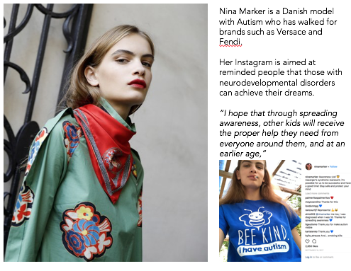
For the magazine:

While addressing people on the spectrum is a challenge, as the magazine is all about diversity, it is suggested by the marketing manager that when the marketing and layout aspect is being discussed, the habits of those on the spectrum need to be taken into consideration. Obviously, it is hard to do that and one must tread carefully and ensure that it does not become the main focus of the magazine. As this is a diversity magazine, it would be a mistake to not take this into consideration.

Meeting w/ Jennifer and my Group:

- Decided to change the theme, rather than diversity we decided to look at age (specifically in the LGBTQ+ community).
- Needed to do research on age and the magazine marketplace.

Meeting w/ Group:
- Split the marketing plan between myself and Ella. Cheska: the R & A part of the RACE framework and Ella will be doing the C & E parts.

Marketing Plan:

The aim of this marketing plan is to enable the magazine to have a 1:1 relationship with its readers, to ensure that they feel included and part of the magazine. This can be done with personalized emails, as well as allowing readers to contribute to the magazine themselves.

Plan: build an agile and strategic approach to digital marketing

Digital Magazine Marketplace

In the six months leading up to June 2017, digital magazine circulation grew to 19% (insert reference) suggesting that digital magazines are the way forward (insert reference). Despite an increase in magazine launches and publications since 2016 (insert reference), it is predicted that the UK magazine market will fall by 5% (insert reference). However, certain sectors will far better than other, such as special-interest titles while women’s weekly titles will suffer (insert reference).

Despite evidence that the digitization of the magazine industry is due to decline in first world countries, it is important to remember that the convenience of online platforms, due to ease of access, has lead consumers to be more susceptible to content that is both mobile and tablet friendly. Therefore, if a digital magazine can be optimized across mobile platforms, as well as desktop ones, this decline can be reversed. Furthermore, one of the biggest trends at the moment is the diversification of publications and whether a market will be available for gendered magazines in the future. Numerous magazine editors agree that diversity of opinions will benefit any magazine publication.
So, in order to ensure that X, Y Z magazine does not decline before it has been started, a new strategic marketing plan needs to be implemented, which focuses on visualisation and personalization, two key trends making an appearance in 2018. Examples include mobile, advertising technology, video and digital audio/podcasts.

Target Customer Persona
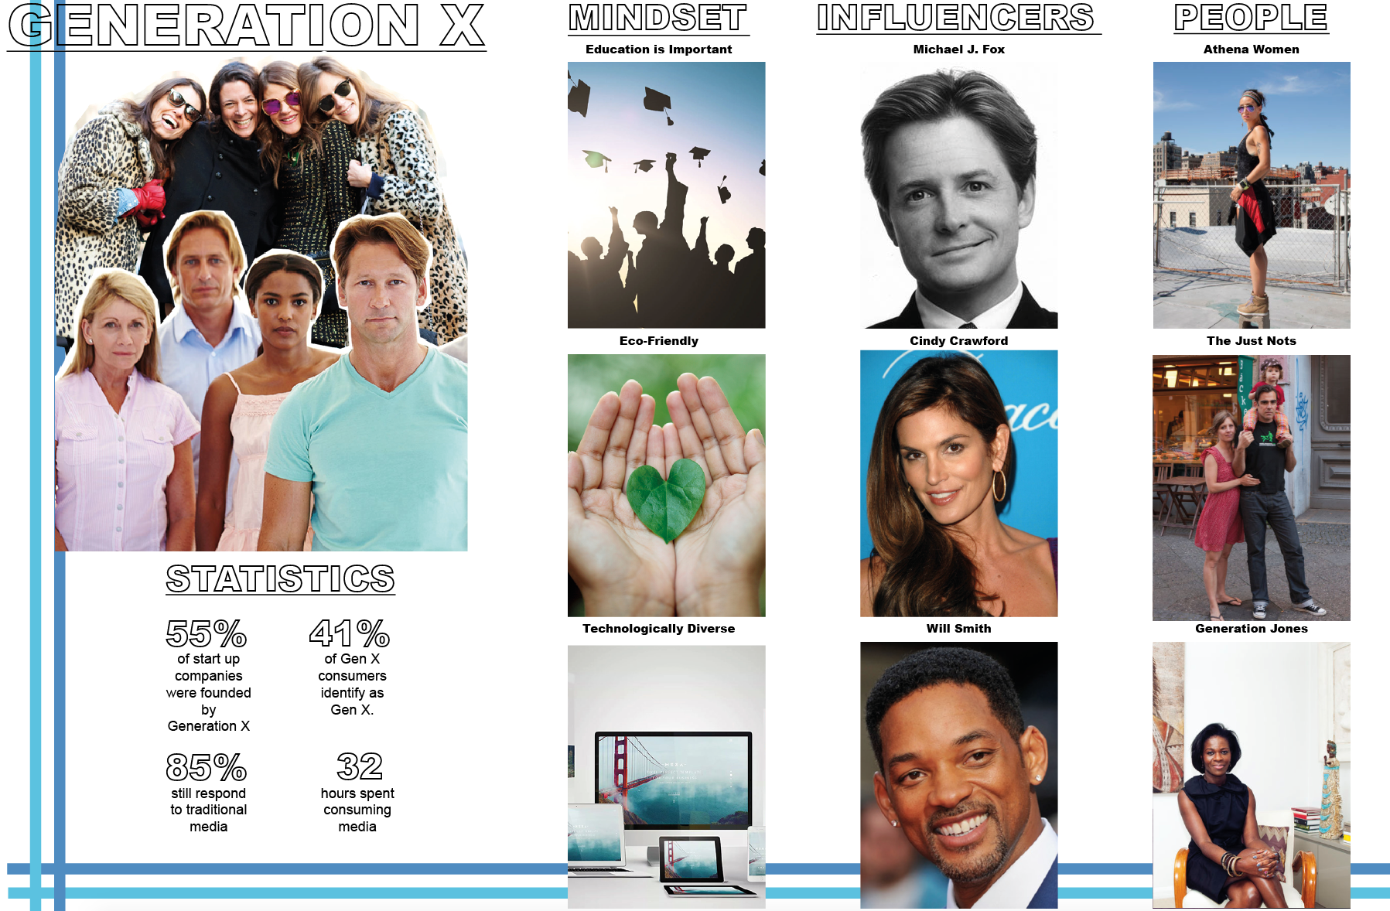
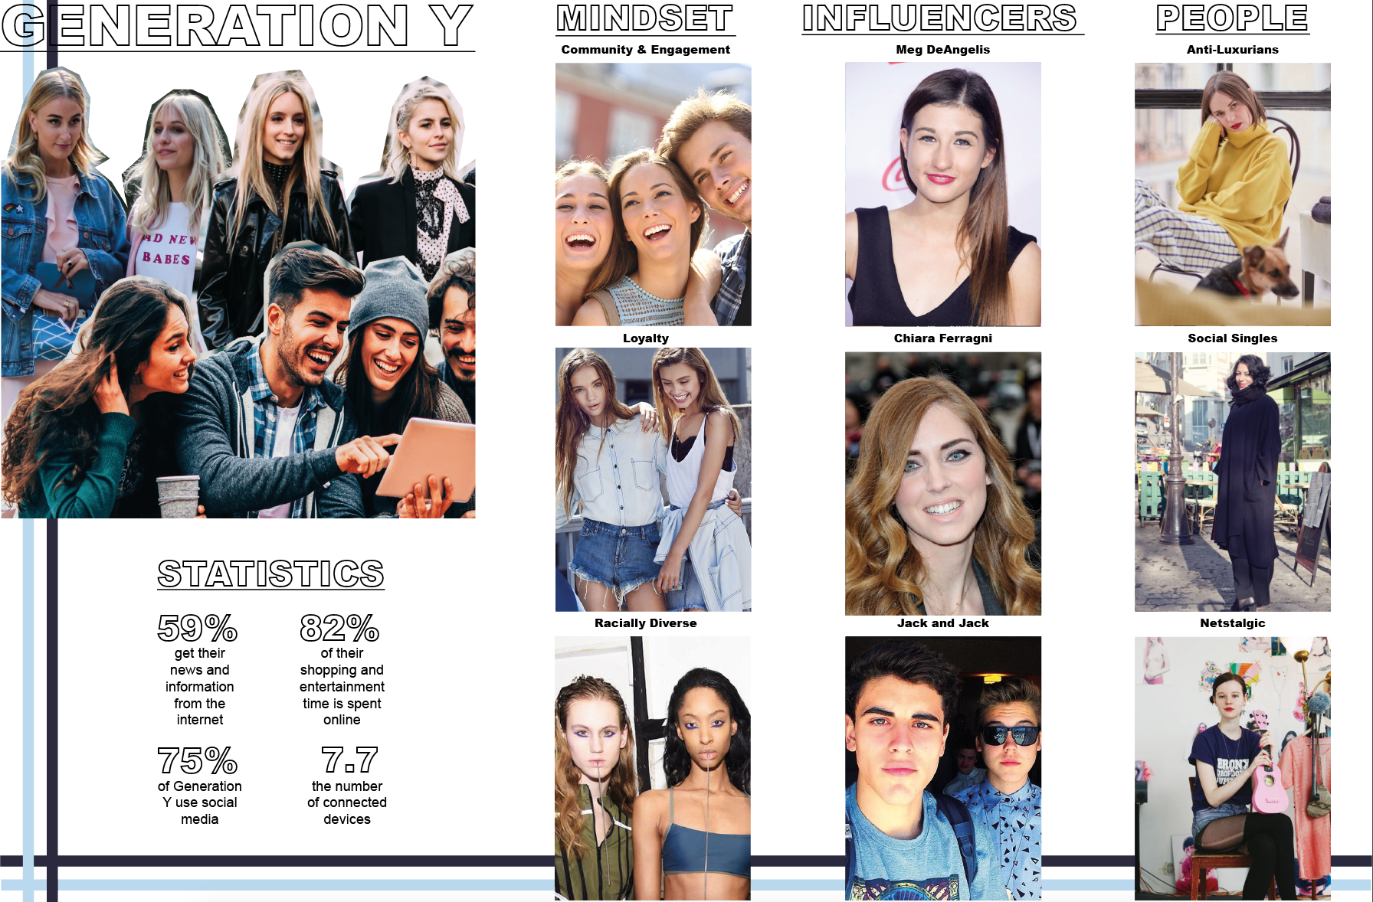
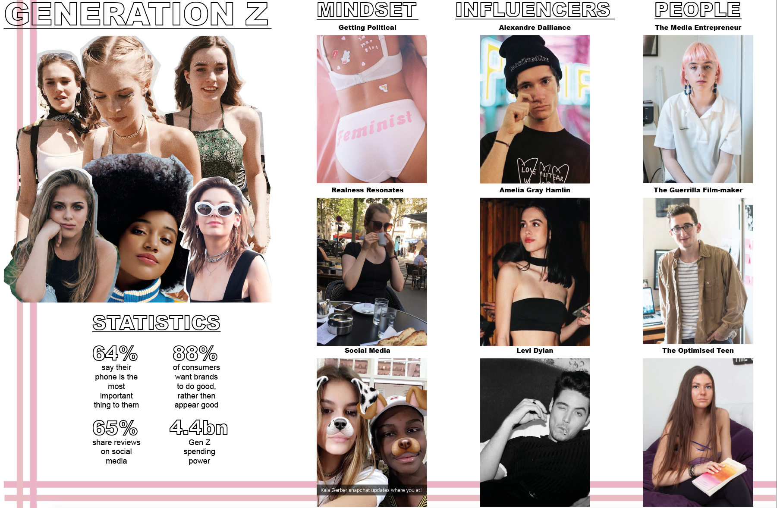

Content Marketing (WHO ARE WE)

Content marketing is the approach to creating and distributing content to attract readers and increase awareness. It clearly defines the key elements and outline who you will be talking to, what you will say and how to say it.

What is it that the magazine is trying to do?

X,Y, Z is a magazine aimed at exploring the topic of age within different communities and societies. For the Spring issue,, the focus will be on age in the LGBTQ+ community. We want this digital platform to become a safe space where people can have discussions, contribute to the platform an overall feel that they are a part of a community. – Cheska Hardie

A place to vent about the experiences, both good and bad, of being part of a minority by communicating with like-minded individuals and finding relatable content to identify with. – Billy Welsby

A safe, online community in which individuals can express themselves freely and passionately, without the fear of being judged or ridiculed for their opinions and choices. – Jessica Broadbent

The digital platform is a highly-curated and safe environment for people of all ages to express themselves in any form they want.

Online Value Proposition (WHAT CAN WE OFFER)

Marketing Mix (4P’s)

Product: a seasonal digital platform and digital magazine that readers can purchase or just read online. Mobile friendly and easy to navigate.

Price: readers can purchase a print copy of the digital magazine through the website: issuu.com. The cost of the magazine will be £5.99, as this is the average for a coffee book table magazine.

Place: Multichannel

Promotion: Social Media / Influencers / Press Release

Competitors

THEM - A LGBTQ+ digital platform and community set up by Conde Nast, them identifies as a next generation platform that allows people's voices to be heard. It chronicles stories from ordinary people and lets their voices be heard. It covers topics from pop culture to politics.

HERE - A LGBTQ+ social media community set up by Seventeen magazine, HERE identifies as a space that is dedicated to getting the voices of the LGBTQ+ community heard, as well as a place for teens to express themselves.

http://www.condenast.com/press/conde-nast-launches-them-the-first-project-from-the-companys-new-incubator/

http://www.condenast.com/brands/them/

https://www.manrepeller.com/2017/12/meet-staff-of-them-lgbtq-publication-conde-nast.html

Reach: promoting the magazine through networks and influencers

5 D’s of Digital Marketing

https://www.smartinsights.com/digital-marketing-strategy/what-is-digital-marketing/
http://onlinecoachingcenter.com/5-ds-of-digital-marketing/

Digital Devices – Mobile /Laptop
Digital Media - Advertising, email and messaging, search engines and social networks
Digital Platforms

- Instagram

- Facebook:

- Twitter

- Meetup: an online platform that allows people to meet up would be the perfect platform to launch any events on, as well has creating a community. By killing two birds with one stone, Meetup will allow the magazine to talk to numerous people who may not use traditional forms of social platforms.

Digital Technology - The technology used to create experiences from websites and mobile apps e.g. buffer (Instagram schedualing platform).

Digital Data - Data collected by the magazine to analyse consumer attitudes towards the publication e.g likes / followers

Social Media Marketing Optimization

https://www.forbes.com/sites/jaysondemers/2014/11/17/a-guide-to-optimizing-your-social-media-marketing-campaign/#1cfa6d582342

One of the main goals of the magazine’s social media marketing optimization, is to ensure that consumers are made aware of the publication through social platforms (insert reference). It is important therefore, for the magazine to ensure that their content is shareable by consumers (insert reference). One way that this can be achieved Iis by ensuring that the website / interviews / blogs etc. by including social share buttons after every post (insert reference).

Headlines – this is what will capture the attention of the reader and as such, must be attention grabbing to make an impact. This could be achieved by making the title of each post for the LGBTQ + issue is made up of the letters of LGBTQ.

For example: Let’s Go Behind The Questions (behind the scenes post)
Let’s Get Busy Talking about Queens (drag queen article)
Looking Good Billy: Turning into a Queen (makeover)
....... Lets Get Bashing Tribes with Questions (stereotypes in the LGBTQ+ community)

Calls to Action – It is important to apply CTAs on the social media platforms, as well as the website, as this will not only increase click through to the website, but also let social media followers aware of new and upcoming articles and posts.

Images: 82% of consumers revealed that an image would make them continue reading a blog. As people have an average attention span between 8 – 12 seconds, an image is a perfect way to draw the reader in. They do say that a picture costs 1,000 words.

For example:
Facebook: Inspiring pictures that readers will want to share will allow for more visibility, as well as increasing post reach.

Twitter: Twitter cards allow the incorporation of rich media with a tweet, which leads to increased views and interaction. Furthermore, photos shared on Twitter are estimated to gain 35% bump in retweets than tweets with no imges.

5 C’s of Social Media

Coordination – combination of media flow through observation
Commitment - Engaging with followers and persuing social interactions
Confidence - The platform must be interesting, to ensure social media excellence
Comprehension - Comprehension drives social media mastery and deepens perfonce capacity
Cultivation - Ensure that there is cultivation of ideas and relationships throughout

PR / Influencer Outreach

Micro-influencers: can be the best to use, to engage with consumers. They don’t require large payments for sponsorship and there is a chance to build a stronger relationship.

Celebrities: While authenticity is a key motivator for todays consumers, one must not disregard the power celebrity endorsements have on customers. Using a celebrity will allow X, Y, Z. to build brand equity, while making consumers associate the brand with superstar status.

Staff: As consumers are more wary, influencer opinions need to be authentic. What is more authentic than using people who work at the brand.

Interviewees: also known as a brand ambassador, by utilizing the social media channels of the interviewees, by getting them to upload behind the scenes photos from photoshoot, to tweeting that they have an interview at X,Y,Z. This will contribute to word of mouth marketing, which is authentic and very effective.

Act: be worth finding via clear customer journeys and a relevant content hub

Customer Journey
Social Media post – Click Through to Website – Read the stories / suggest ideas etc. – Interest is piqued - Click Through to issuu digital magazine – Purchase ‘X,Y,Z Magazine

Social Media Calendar
Instagram / Facebook / Twitter
Date | Content | Image
16 / 04 / 2018 | N/A | 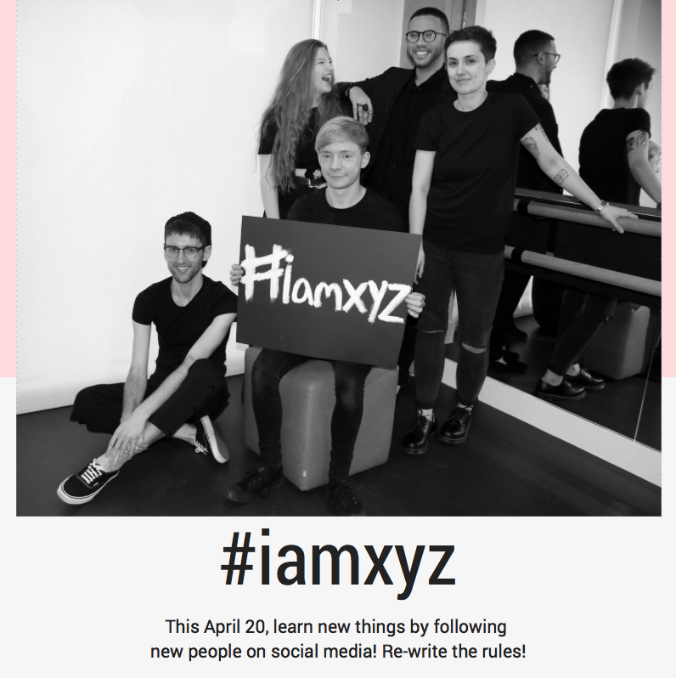
17 / 04 / 2018 | WE’RE TALKING STEROTYPES, SAFEPLACES AND BREAKING DOWN BARRIERS. READ OUR EXCLUSIVE INTERVIEW WITH INTERNATIONAL FASHION PROMOTION STUDENT AND LGBTQ+ EXHIBITION CURATOR, KIERAN GOWAN CLARKE. JOIN IN THE CONVERSATION ON 20TH APRIL… | 
18 / 04 / 2018 | YOU ALREADY FOLLOW US ON INSTAGRAM SO WHY NOT ON TWITTER? WE’RE NOW LIVE ACROSS ALL SOCIAL MEDIA PLATFORMS (EXCEPT SNAPCHAT BECAUSE WE DON’T SUPPORT THAT MESS) SO GOVE US A FOLLOW AND HELP US CONTINUE THE CONVERSATION (PEACE FINGERS EMOJI) | 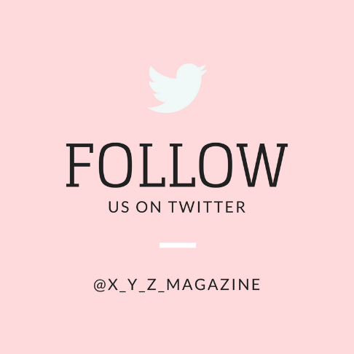
19 / 04 / 2018 | WE LOVE BEING ABLE TO TICK STUFF OF OFF A LIST! XYZ LAUNCHES TOMORROW! JOIN US OVER AT XYZ.COM FOR OUR FIRST ARTICLES, INTERVIEWS AND CAMPAIGN VIDEO… ITS GOING TO BE UNMISSABLE! | 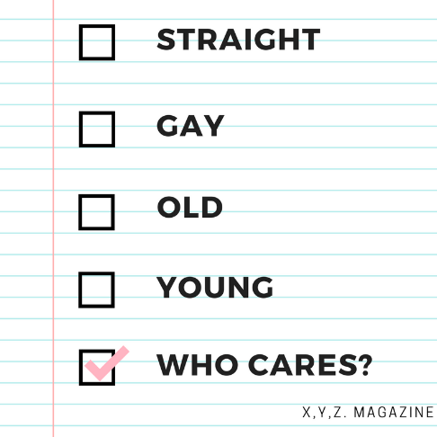
20 / 04 / 2018 | WE’RE HERE, WE’RE QUEER (WELL SOME OF US ARE) AND WEVE GOT SOMETHING TO SAY! XYZ.COM IS NOW LIVE AND WE WANT TO HEAR YOUR THOUGHTS, OPINIONS AND GENERAL FEEDBACK. WHAT DO YOU LIKE? WHAT DO YOU WANT TO SEE? DO YOU HAVE SOMETHING TO SAY? ALL ARE WELCOME AT XYZ AND WE MEAN ALL. SO FOLLOW THE LINK IN THE BIO AND FOLLOW US ON TWITTER TO JOIN IN THE CONVERSATION! | 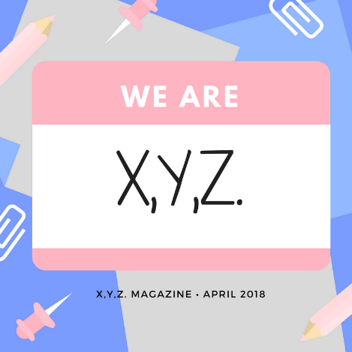

Video Marketing

https://www.forbes.com/sites/forbesagencycouncil/2017/02/03/video-marketing-the-future-of-content-marketing/#9b6a6556b535

With the digital landscaping having changed in the past decade, it has led to a change in content marketing. Today it is all about what the customer wants, when they want it and how they want it. Hence, video marketing is one type of online material that provides value and flexibility that customers want from a company. With video claiming more than 80% of web traffic by 2019, as well as 90% of customers’ purchasing decisions being influenced by videos, this is a perfect tool of communication the magazine can use to increase awareness and relevance.

Statistics:

64% of consumers are likely to purchase after watching a video about the product (Hall, 2013)
https://www.socialmediatoday.com/content/consumers-64-more-likely-purchase-product-after-watching-online-video-infographic

87% of online marketers are currently using video content in their digital marketing strategies (West, n/d)
https://blog.scrunch.com/video-content

35% of online ad spending is on video ads (Goodfellow, 2017) http://www.thedrum.com/news/2017/10/17/online-video-ad-spend-grows-46-year-overtake-banner-ads-first-time

59% of company decision makers would rather watch a video, than read an article or blog post (invisia.com, 2017)
http://www.insivia.com/27-video-stats-2017/

Furthermore, video marketing can be embedded in a variety of digital communication forms:

For example:

E-Mail: Adding videos to marketing emails can boost click through rates to as high as 300% (Bowen, 2017)

https://www.forbes.com/sites/forbesagencycouncil/2017/02/03/video-marketing-the-future-of-content-marketing/#48d17b426b53

Mobile: mobile video consumption on mobiles grows over 90% every year (roettgers, 2016)

http://variety.com/2016/digital/news/mobile-video-viewing-stats-1201934907/

Landing Pages: by embedding a video into a landing page, conversion rates could increase by 80% (Cunha, 2018)

https://www.wordstream.com/blog/ws/2016/03/30/video-for-conversion-rate-optimization

Community

Creating a community from X,Y,Z. will allow the brand to create a place where readers feel safe to voice heir thoughts and opnions. That’s the main aim of X,Y,Z. .

Rules when creating the community:

- Focus on customer’s needs
- Foster many relationships
- Think local
- Don’t Create More
- Foster Peer Celebrity
- Communicate
- Let advocates advocate
- Don’t moderate
- Simplicity
- 1-9-90 rule

https://hbr.org/2013/02/building-customer-communities

https://www.blackstonemedia.com/building-a-community-around-your-brand/ https://www.americanexpress.com/us/small-business/openforum/articles/10-tips-for-building-brand-communities-1/

Behind the Scenes

The easiest and most effective form of social content and communication, by including behind the scene content, X,Y,Z. can increase loyalty, create intimacy, cultivate greater customer engagement and get readers to start having a discussion (which is the main focus of the whole platform and magazine). It also offers customer an intimate look into the brand, which will allow them to realise how relatable X,Y,Z. is, and as such, motivate them to continue visiting and engaging with the online platform.

http://gm-design.co.uk/blog/social-brand-building-taking-consumers-behind-the-scenes/

https://spoonagency.com/academy/content-marketing-behind-the-scenes/

Personalization

In order to ensure that the personalization aspect of the Personalized Communication Plan is realized, X,Y,Z. will allow consumers to create their own magazine based off the articles and discussions on the platform, allowing them to feel that they have had a hand in the curation of the X,Y,Z. magazine.

There are four steps that must be completed:
- Identify
- Differentiate
- Interact
- Customize

https://www.ngdata.com/what-is-personalized-marketing/

https://www.e-xanthos.co.uk/blog/9-benefits-personalisation-digital-marketing/

https://www.bostoninteractive.com/blog/marketing/5-key-benefits-personalized-marketing-strategies

Collaborations

With consumers wanting a more meaningful relationship with a brand, it would be wise to start exploring the possibility of collaboration with the readers of X,Y,Z. . This will be done by getting people to email in their opinions, articles, discussions etc. and then X,Y,Z. publishing the content on the platform. This will then lead to the writers sharing their work on X,Y,Z. which in turn will allow for more reach and awareness of the platform.

http://www.thedrum.com/opinion/2015/08/05/why-your-next-marketing-collaboration-should-be-your-customers

https://www.campaignlive.co.uk/article/co-creation-why-brands-collaborate-survive/1433516

http://www.insites-consulting.com/collaborating-with-consumers-to-grow-your-business/

Competitions

With the rise of social media, it is imperative for X,Y,Z. to take advantage of what the social platforms allow a brand to do. One of these is creating a competition, which will peak a consumer’s interest, as it answers the question ‘what’s in it for me?’. The benefits of including competition are below:
- Builds Up Fan Base
- Engage with consumers who are unaware of the Platform
- Rich Source of Data
- Cultivate User Generated Marketing

https://mashable.com/2011/07/21/contest-marketing/#QHUV16GZnEqa

https://blog.kissmetrics.com/contests-user-generated-content/

Social Media

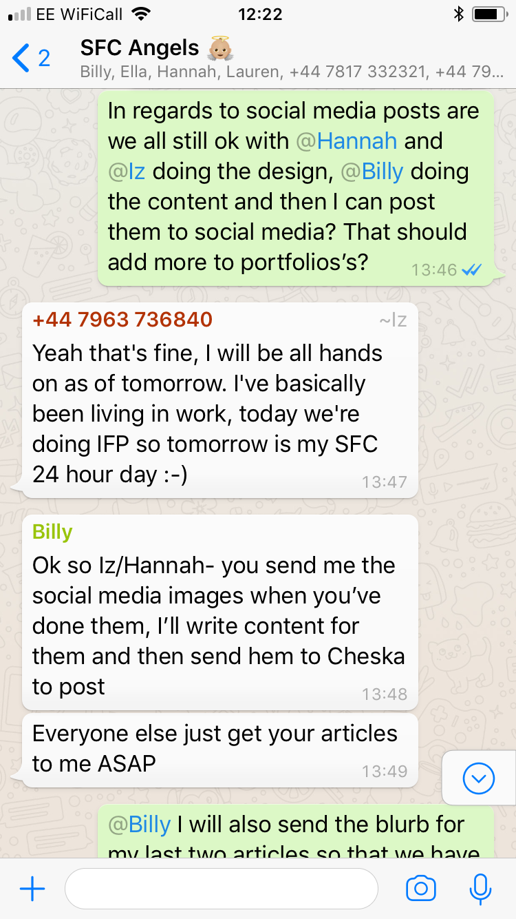
Conversation with the Team:
However, after this discussion, it was then decided later on that I should be primarily in charge of sourcing the majority of the images used for social media. While images from campaigns and the rest of the group will be used, it was decided that it would be my job to create the actual posts that would appear on the social media accounts. However, as editor, I decided Billy should write the content, as it is what he is great at and it also shows inter-team working.

Ideas:
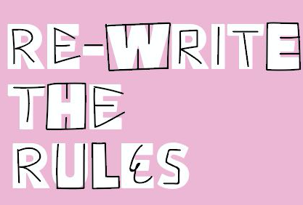
Hannah Parr did send over some illustrations for social media posts, which were used.

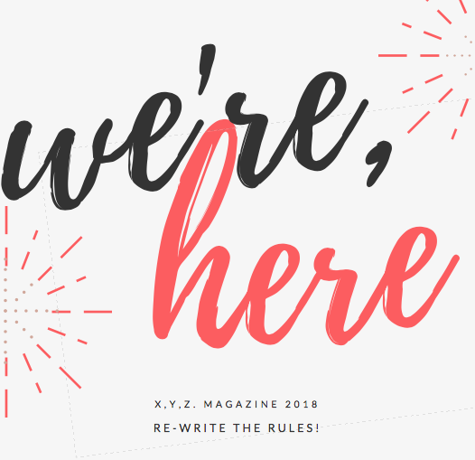
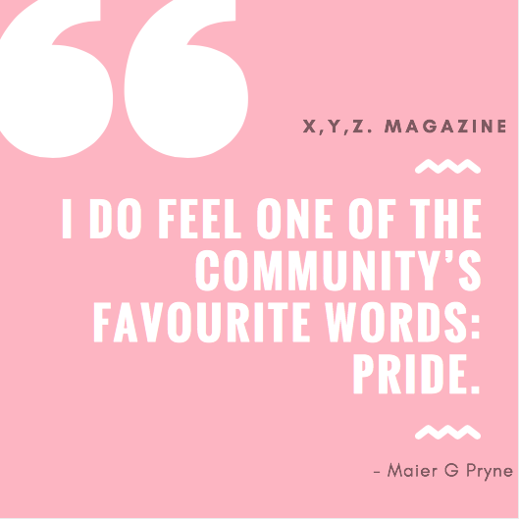
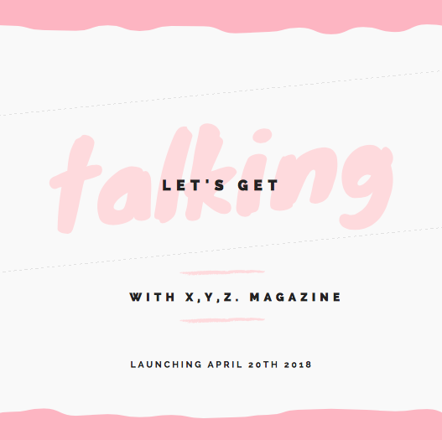
I experimented with different colors, but decided to focus on the pink theme, as I was told that that was the color of the website and the logo, so it flow better. Plus, it would allow consumers to associate with the brand if the color scheme was roughly the same.

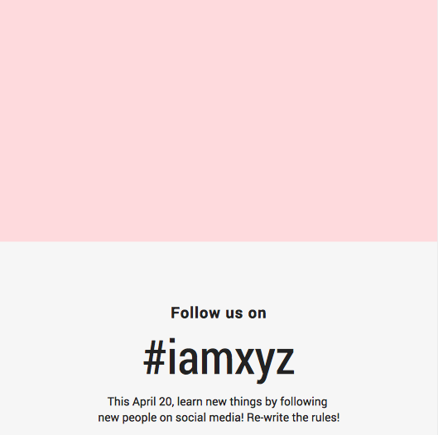
I also experimented with different forms of layout, to see which ones were most attention grabbing, as well as experimenting between quotes and full text. I also incorporated calls to action posts as well, in order to get consumers to follow all of our social media platforms.

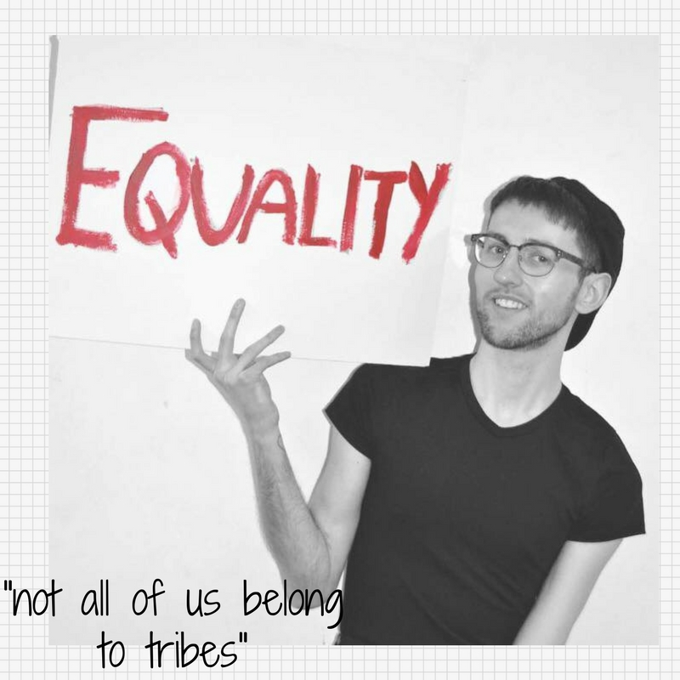
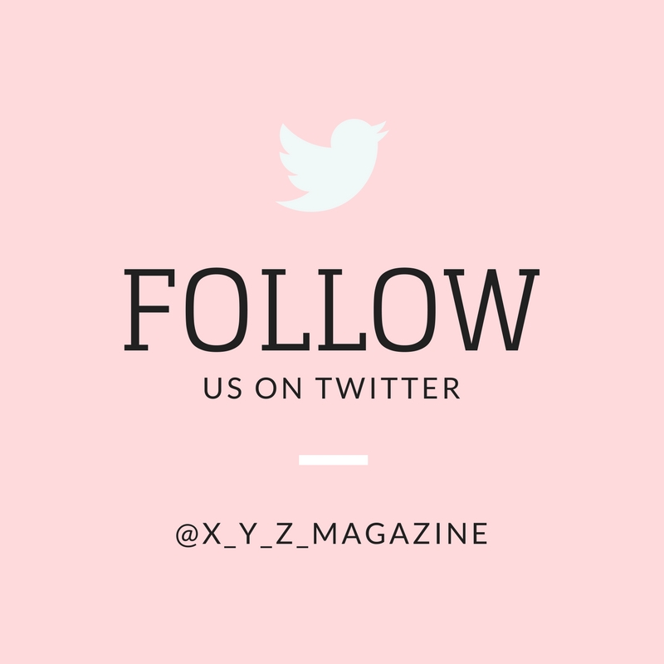
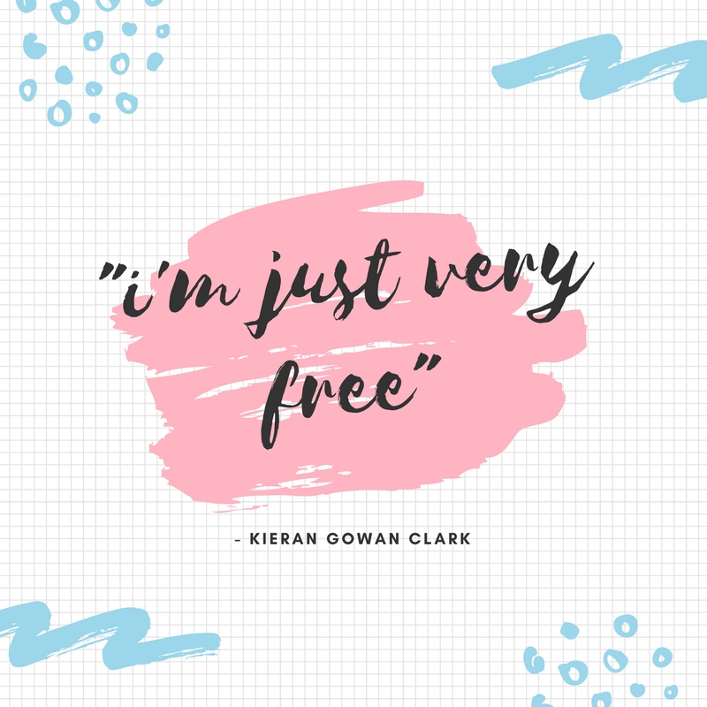
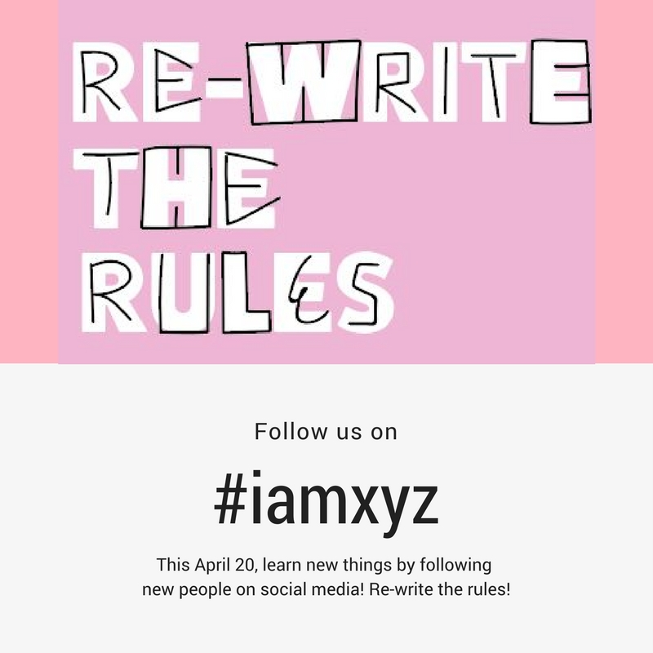
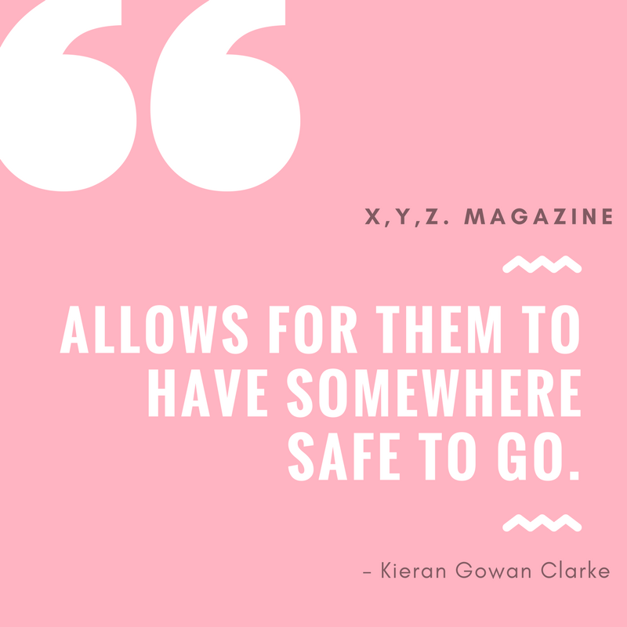
While I was creating the social media posts, I was also doing the marketing plan and based on that, I decided to incorporate
Some of the ideas, such as using images photos from the campaign as part of the social media posts, especially as the campaign revolved around the key message that X,Y,Z. wanted to convey.
Conversation with Content Editor (Billy Welsby):

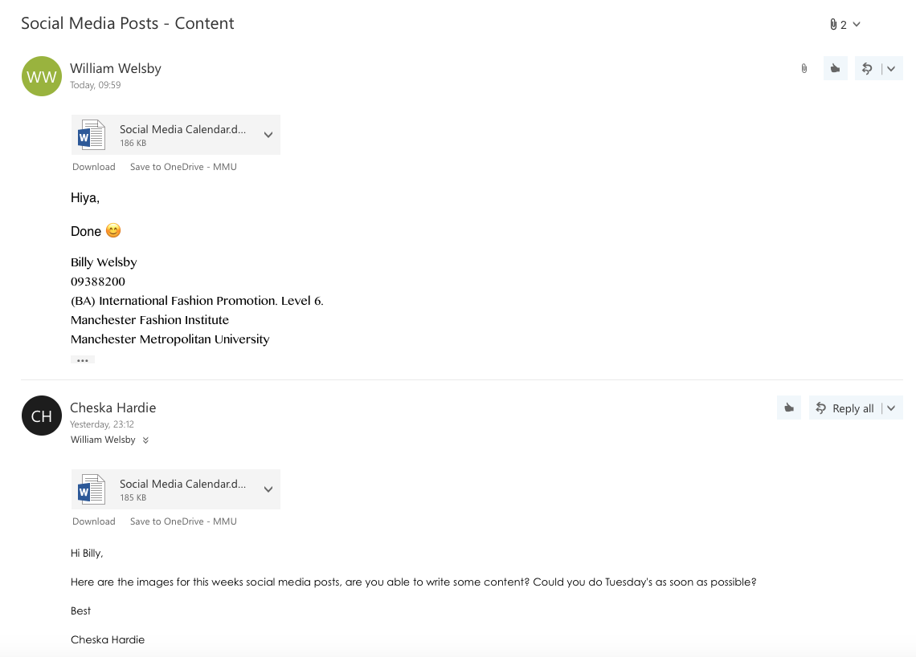

(The edited written content can be found on Billy’s Creative Process)
Social Media Scheduling:

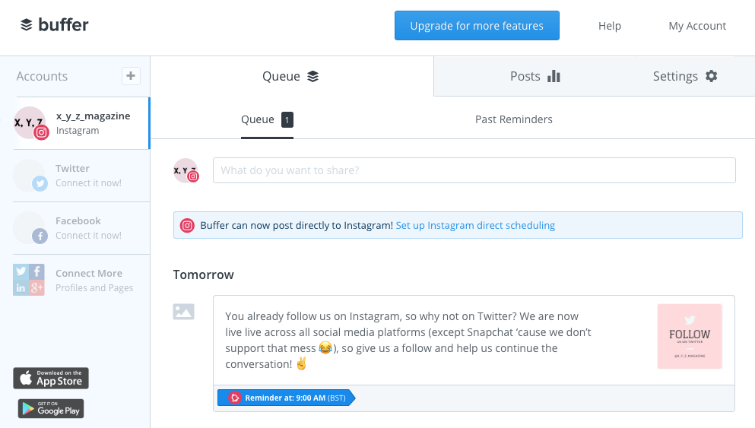

Platforms:

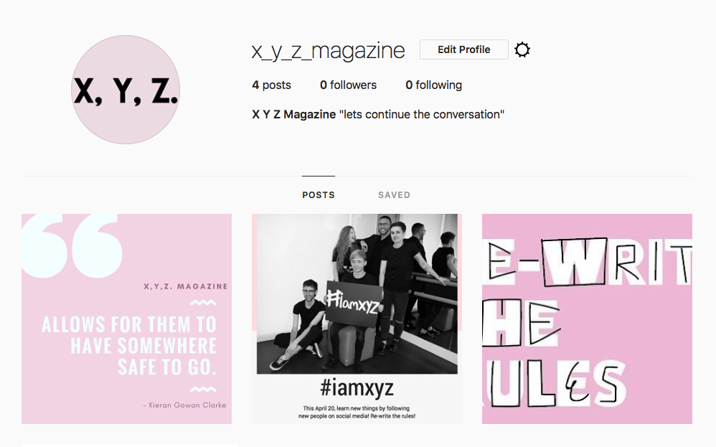

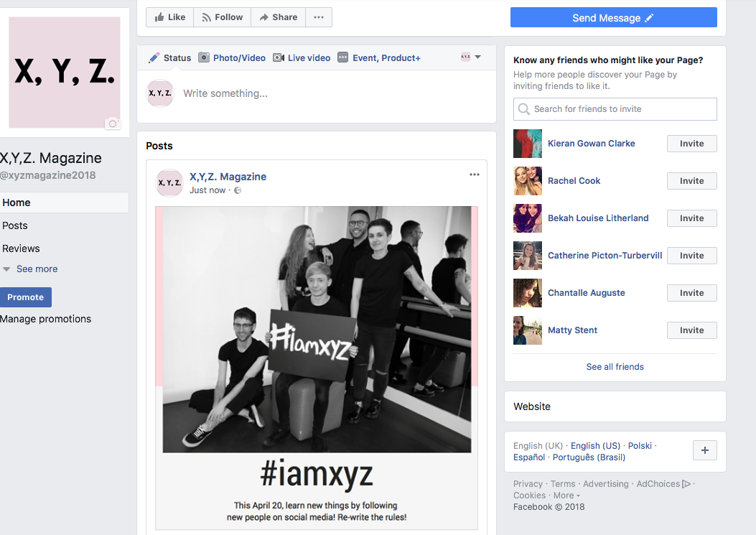

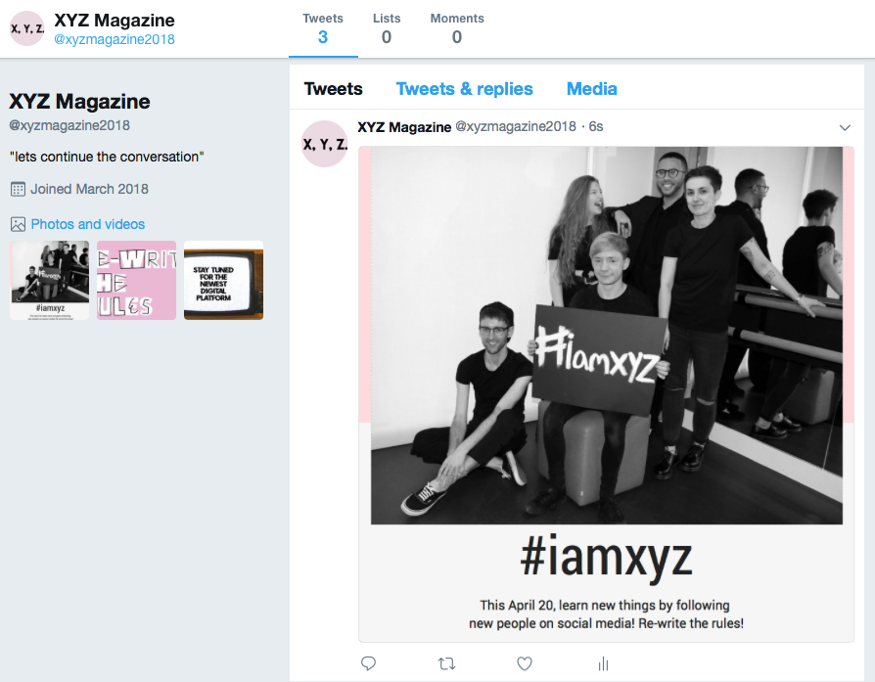

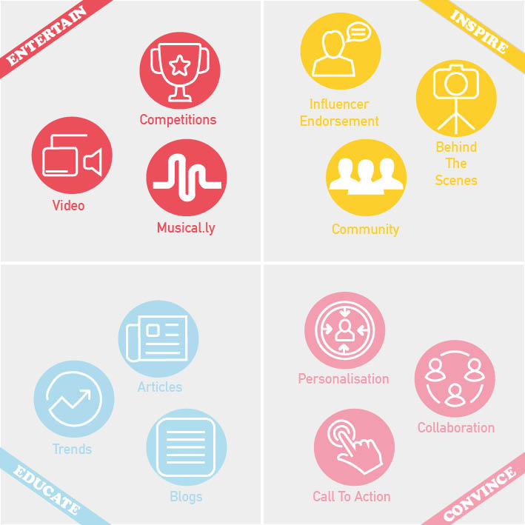
Content Marketing Plan

Final Marketing Plan is on visme:
login – cheska.hardie@stu.mmu.ac.uk / password – Manchester123

